**LABORATORY REPORT**

**MAYANK DEY**

**Email: dey.mayank567@gmail.com**

**COMPUTER NETWORKS**

**June - July 2025**

|  |  |  |  |
| --- | --- | --- | --- |
| **Table of Contents** | | | |
| **Sl. No.** | **Name of the experiment** | **Date** | **Page No** |
| 01 | To build a simple network in Packet Tracer in the Logical Workspace.   1. Part 1: Create a Simple Network 2. Part 2: Configure the End Devices and Verify Connectivity | 30.06.2025 | 1 to 14 |
| 02 | For basic understanding about CPT-Logical and Physical Mode exploration. | 30.06.2025 | 14 to 20 |
| 03 | Cabling in a rack   1. Part 1: Install a Patch Panel in the Wiring Closet 2. Part 2: Attach a Wall Mount in the Office 3. Part 3: Connect an Additional Wall Mount and Cables | 30.06.2025 | 21 to 29 |
| 04 | Connecting Devices Using Wireless Technologies in Packet Tracer  1: Connect a Laptop to the Office WLAN  2: Connect Devices with Bluetooth Technology  3: Tether a Laptop to Use a Cellular Network via the Smartphone | 30.06.2025 | 30 to 40 |
| 05 | Packet Tracer - Identify MAC and IP Addresses | 30.06.2025 | 41 to 48 |
| 06 | Using the ping command to identify an incorrect configuration. | 30.06.2025 | 49 to 56 |
| 07 | Packet Tracer - Using the ipconfig Command | 30.06.2025 | 57 to 63 |
| 08 | PACKET TRACER- FTP SERVICES | 10.07.2025 | 64 to 68 |
| 09 | Packet Tracer – Use Telnet and SSH | 10.07.2025 | 69 to 72 |
| 10 | Even Parity using Python Programming | 10.07.2025 | 73 to 76 |
| 11 | Odd parity using Python Programming | 10.07.2025 | 77 to 80 |
| 12 | 2D parity LRC using Python Programming | 10.07.2025 | 81 to 87 |
| 13 | CRC using Python Programming | 10.07.2025 | 88 to 92 |
| 14 | Checksum using Python Programming | 11.07.2025 | 93 to 96 |
| 15 | Simulate networking devices using CPT | 11.07.2025 | 97 to 110 |
| 16 | Create two LAN networks & configure its IP address | 13.07.2025 | 111 to 117 |
| 17 | To study the basic networking commands:   * ping * traceroute * ipconfig * nslookup * pathping * netstat | 13.07.2025 | 118 to 121 |
| 18 | To study the basic networking commands:   * arp * route * hostname * ftp * ssh * sftp | 13.07.2025 | 122 to 125 |
| 19 | Explore the Wireshark Software to analyse the packets of basic protocols like TCP, UDP, ARP, ICMP etc. | 13.07.2025 | 126 to 133 |
| 20 | Wireshark Packet Analysis: ICMP and HTTP Protocols   * Use PING command to track ICMP protocol packets * Use this website for HTTP protocol packets and identify username and password in the packet   <http://www.vbsca.ca/calendar/login.asp> | 13.07.2025 | 134 to 137 |

|  |  |
| --- | --- |
| **Date: 30/6/25** | **Title** |
| **Exp. No: 01** | **To create a simple network in Packet Tracer in the Logical Workspace.** |

**OBJECTIVE:**

In this activity, we will build a simple network in Packet Tracer in the Logical Workspace.

* Part 1: Create a Simple Network
* Part 2: Configure the End Devices and Verify Connectivity

**Simulation Tool:**

1. Cisco Packet Tracer software (version compatible with your computer)
2. Computer or laptops running Cisco Packet Tracer

## PROCEDURE:

**Part 1: Build a Simple Network**

In this part, you will build a simple network by deploying and connecting the network devices in the Logical Workspace.

**Step 1: Add network devices to the workspace.**

In this step, you will add a PC, laptop, and a cable modem to the Logical Workspace.

A cable modem is a hardware device that allows communications with an Internet Service Provider (ISP). The coaxial cable from the ISP is connected to the cable modem, and an Ethernet cable from the local network is also connected. The cable modem converts the coaxial connection to an Ethernet connection.

Using the Device-Type Selection Box, add the following devices to the workspace. The category and sub-category associated with the device are listed below:

=   **PC**: End Devices > End Devices > PC

=   **Laptop**: End Devices > End Devices > Laptop

=   **Cable Modem**: Network Devices > WAN Emulation > Cable Modem

**Step 2: Change display names of the network devices.**

a.     To change the display names of the network devices, click the device icon in the Logical Workspace.

b.     Click the **Config** tab in the device configuration window.

c.     Enter the new name of the newly added device into the **Display Name** field: PC, Laptop, and Cable Modem.

**Step 3: Add the physical cabling between devices on the workspace.**

Using the Device-Type Selection Box, add the physical cabling between devices on the workspace.

a.     The PC will need a copper straight-through cable to connect to the wireless router. Using the Device-Type Selection Box, click **Connections** (lightning bolt icon). Select the copper straight-through cable in the Device-Specific Selection Box and attach it to the **FastEthernet0** interface of the PC and the **Ethernet 1** interface of the wireless router.

b.     The wireless router will need a copper straight-through cable to connect to the cable modem. Select the copper straight-through cable in the Device-Specific Selection Box and attach it to the internet interface of the wireless router and the **Port 1** interface of the cable modem.

c.     The cable modem will need a Coaxial cable to connect to the internet cloud. Select the Coaxial cable in the Device-Specific Selection Box and attach it to the **Port 0** interface of the cable modem and the **Coaxial 7** interface of the internet cloud.

**Part 2: Configure the End Devices and Verify Connectivity**

In this part, you will connect a PC and a laptop to the Wireless router. The PC will be connected to the network using an Ethernet cable. For the Laptop, you will replace the wired Ethernet network interface card (NIC) with a wireless NIC and connect the Laptop to the router wirelessly.

After both end devices are connected to the network, you will verify connectivity to cisco.srv. The PC and the Laptop will each be assigned an IP (Internet Protocol) address. Internet Protocol is a set of rules for routing and addressing data on the internet. The IP addresses are used to identify the devices on a network and allow the devices to connect and transfer data on a network.

**Step 1: Configure the PC.**

You will configure the PC for the wired network in this step.

a.     Click the **PC**. In the **Desktop** tab, navigate to **IP Configuration** to verify that DHCP is enabled and the PC has received an IP address.

Select **DHCP** for the IP Configuration heading if you do not see an IP address for the IPv4 Address field. Observe the process as the PC is receiving an IP address from the DHCP server.

DHCP stands for dynamic host configuration protocol. This protocol assigns IP addresses to devices dynamically. In this simple network, the Wireless Router is configured to assign IP addresses to devices that request IP addresses. If DHCP is disabled, you will need to assign an IP address and configure all the necessary information to communicate with other devices on the network and the internet.

b.     Close **IP Configuration**. In the **Desktop** tab, click **Command Prompt**.

c.     At the prompt, enter **ipconfig /all** to review the IPv4 addressing information from the DHCP server. The PC should have received an IPv4 address in the 192.168.0.x range.

**Note:** There are two types of IP addresses: IPv4 and IPv6. An IPv4 (internet protocol version 4) address is a string of numbers in the form of x.x.x.x as you have been using in this lab. As the internet grew, the need for more IP addresses became necessary. So IPv6 (internet protocol version 6) was introduced in the late 1990s to address the limitations of IPv4. The details of IPv6 addressing are beyond the scope of this activity.

d.     Test connectivity to the cisco.srv from the PC. From the command prompt, issue the command **ping cisco.srv**. It may take a few seconds for the ping to return. Four replies should be received.

**Step 2: Configure the Laptop.**

In this step, you will configure the Laptop to access the wireless network.

a.     Click **Laptop**, and select the **Physical** tab.

b.     In the **Physical** tab, you will need to remove the Ethernet copper module and replace it with the Wireless WPC300N module.

1)    Power off **Laptop** by clicking the power button on the side of the laptop.

2)    Remove the currently installed Ethernet copper module by clicking on the module on the side of the laptop and dragging it to the **MODULES** pane on the left of the laptop window.

3)    Install the wireless **WPC300N** module by clicking it in the **MODULES** pane and dragging it to the empty module port on the side of the Laptop.

4)    Power on the **Laptop** by clicking the Laptop power button again.

c.     With the wireless module installed, connect the Laptop to the wireless network. Click the **Desktop** tab and select the **PC Wireless**.

d.     Select the **Connect**tab. After a slight delay, the wireless network **HomeNetwork** will be visible in the list of wireless networks. Click **Refresh** if necessary to see the list of available networks. Select the **HomeNetwork**. Click **Connect**.

e.     Close **PC Wireless**. Select **Web Browser** in the Desktop tab.

f.      In the Web Browser, navigate to **cisco.srv**.

**PROCEDURE SCREENSHOT:**

**Step 1: Add network devices to the workspace.**

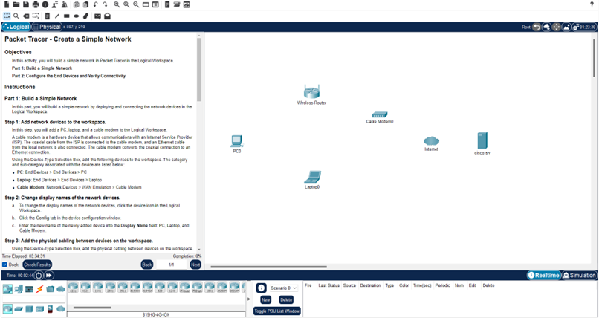

**Step 2: Change display names of the network devices.**

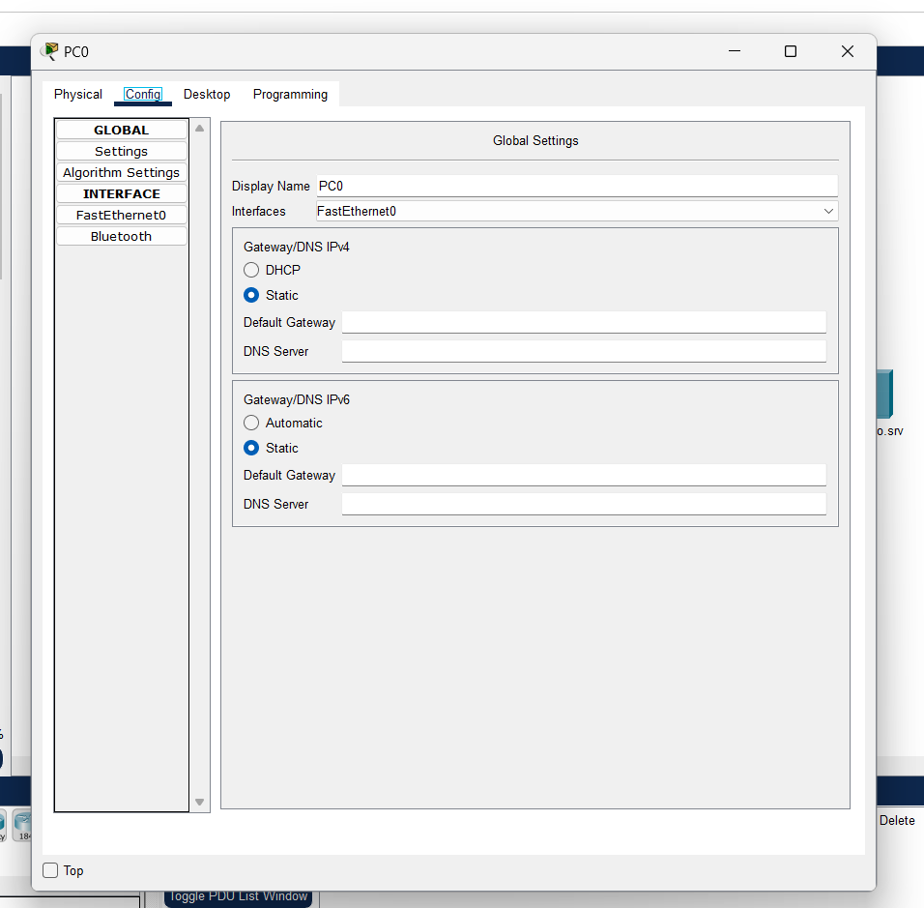

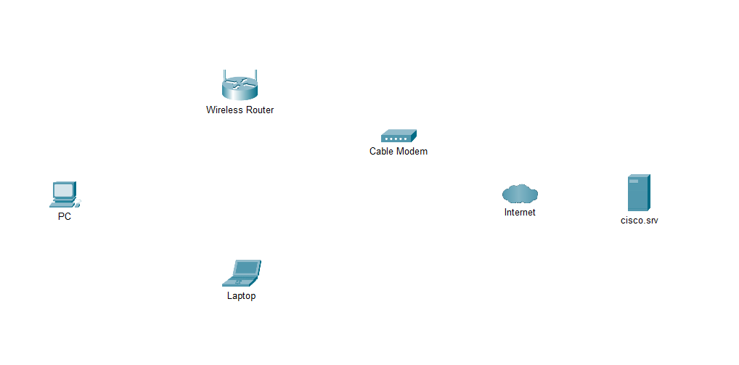

**Step 3: Add the physical cabling between devices on the workspace.**

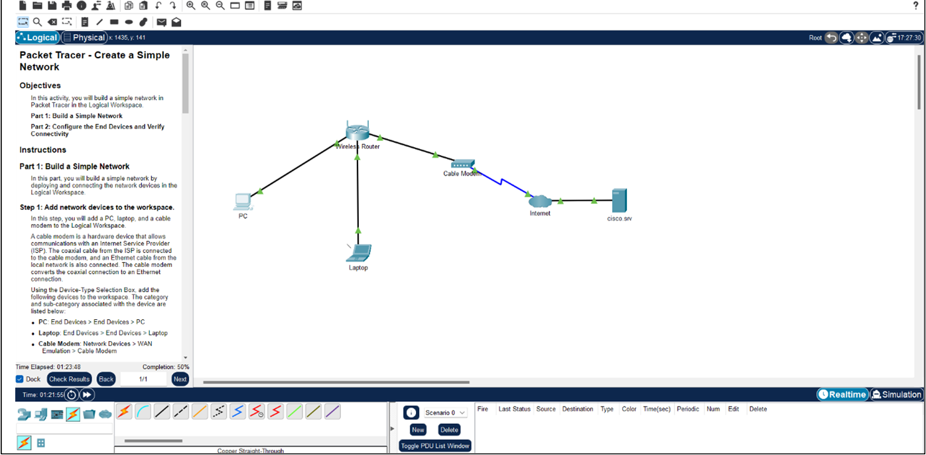

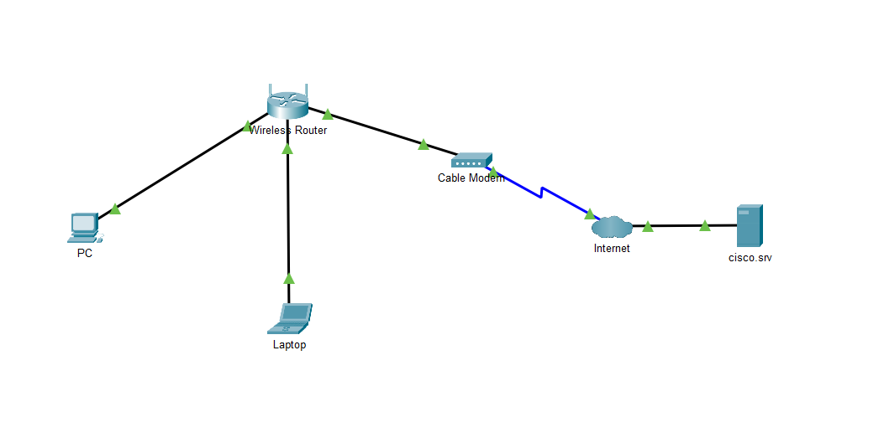

**Part 2: Configure the End Devices and Verify Connectivity**

**Step 1: Configure the PC:**

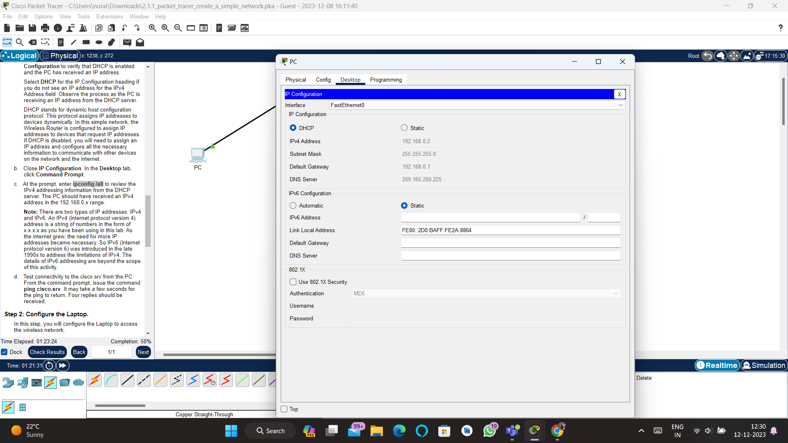

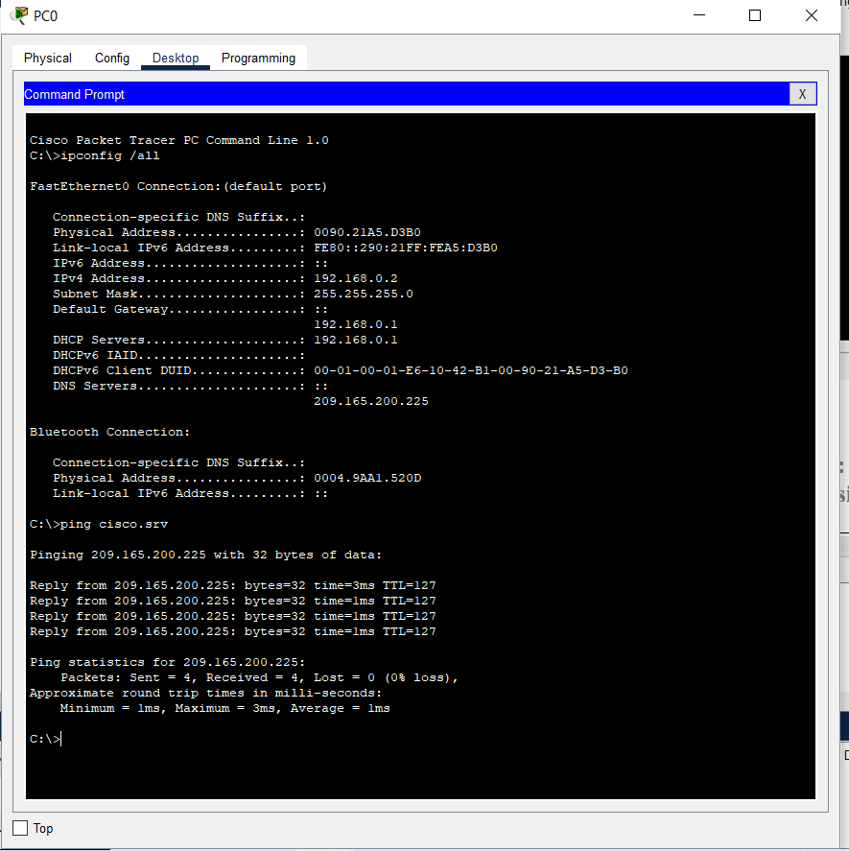

**Step 2: Configure the Laptop.**

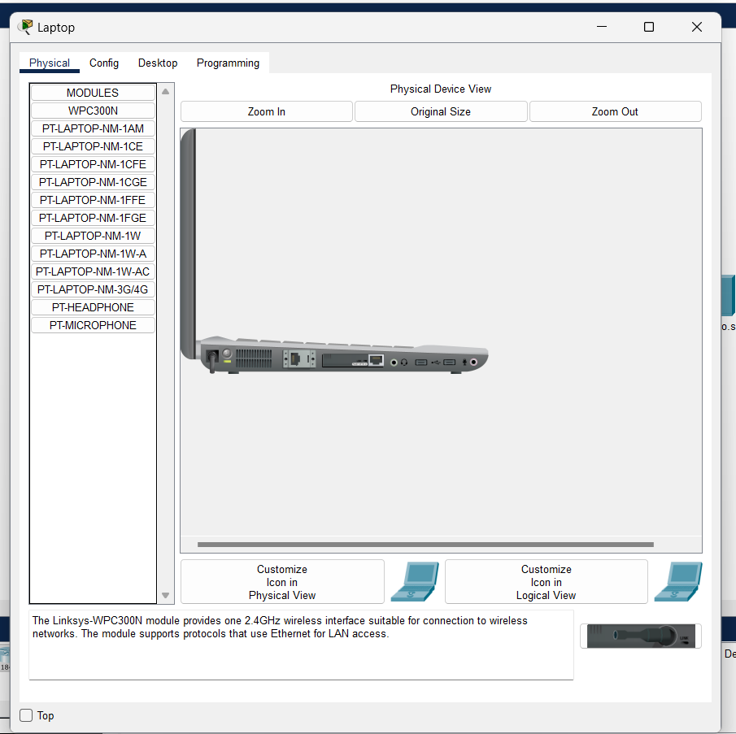 **(Laptop Power ON)**

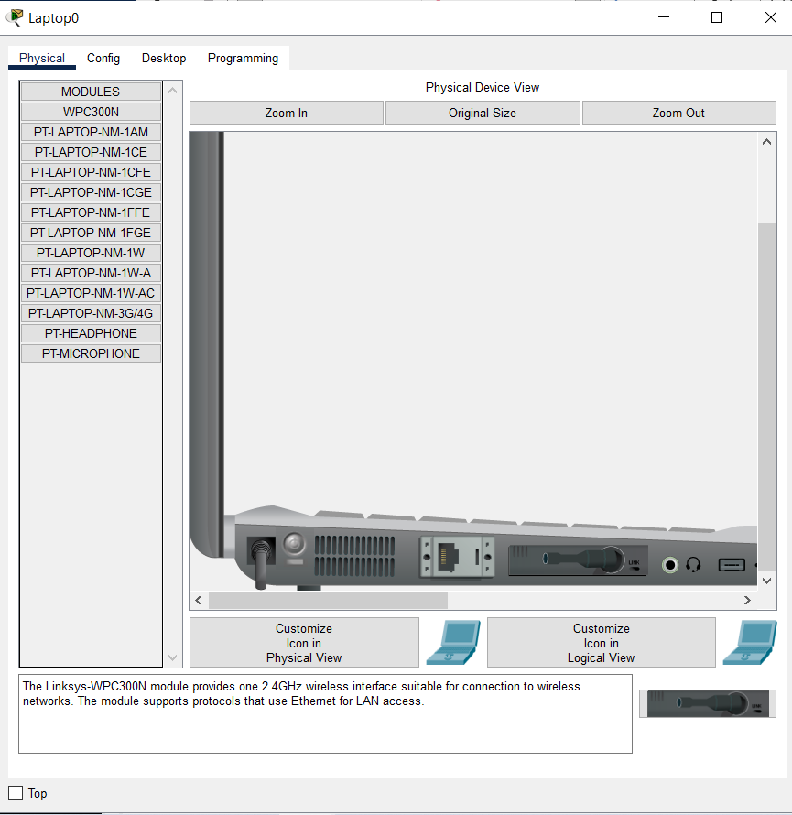 **(Laptop Power OFF)**

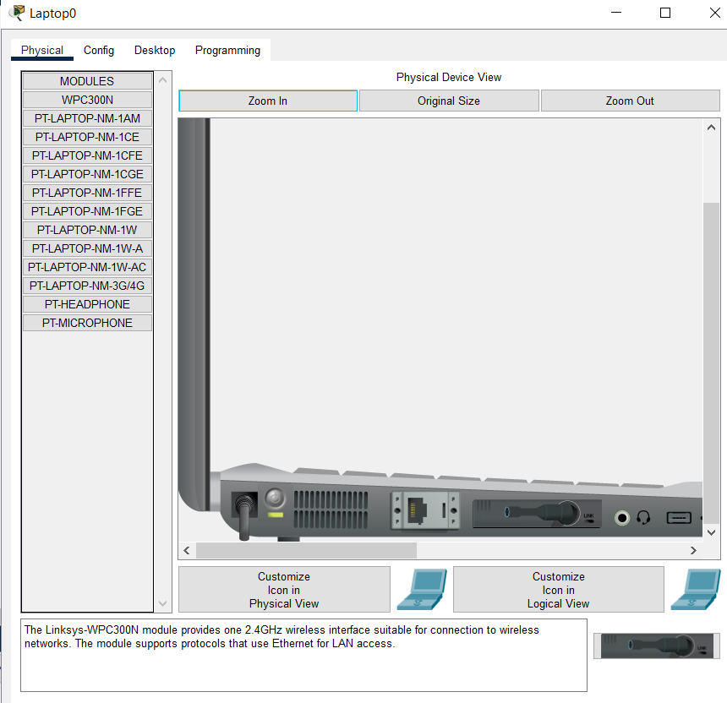

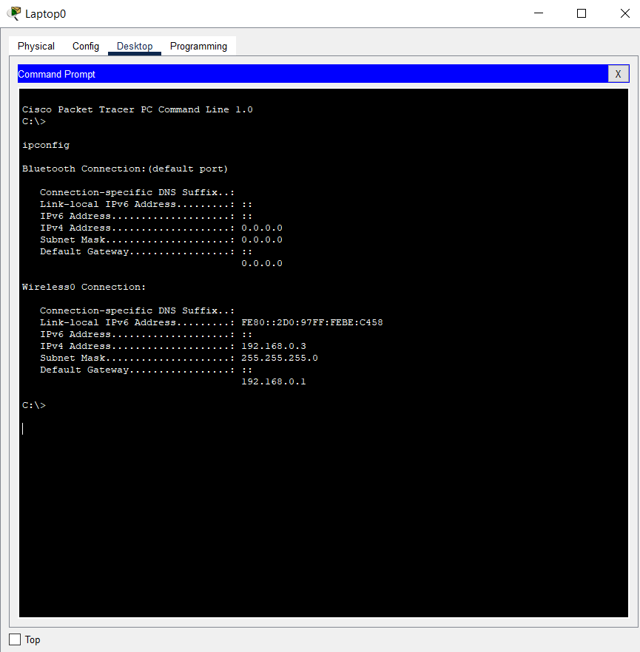

**OBSERVATION:**

**Addressing Table**

Now that you have verified connectivity to cisco.srv, we use the command ipconfig from the Command Prompt to fill out the IP addressing table below:

|  |  |  |  |  |
| --- | --- | --- | --- | --- |
| **Device** | **Interface** | **IP Address** | **Subnet Mask** | **Default Gateway** |
| PC | Ethernet0 | DHCP | 255.255.255.0 | 192.168.0.1 |
| Wireless Router | LAN | 192.168.0.1 | 255.255.255.0 |  |
| Wireless Router | Internet | DHCP | 255.255.255.0 |  |
| Cisco.com Server | Ethernet0 | 208.67.220.220 | 255.255.255.0 |  |
| Laptop | Wireless0 | DHCP | 255.255.255.0 | 192.168.0.1 |

### **RESULT:**

The IP addresses for the end devices can range from 192.168.0.2 - 192.168.0.254. Each NIC will get a unique IP address in the same network.

The subnet mask is used to differentiate the host and the network ID portion of the IP address. You can relate the IP address to your street address. The subnet mask defines the length of the street name. The network part of the address is your street, 192.168.0. The house number is the host port of the IP address. For the IP address 192.168.0.2, the house number is 2 and the street is 192.168.0. If there is more than one house on the same street, for example, house number 3, will have an address 192.168.0.3. The maximum number of houses on this street is 253, ranging from 2 to 254.

The default gateway is analogous to the street intersection. The traffic from the 192.168.0 street has to exit through the intersection to another street. Another street is another network. In this network, default gateway is the wireless router that directs the traffic from the local network to the cable modem, and the traffic is then sent to the ISP.

**CONCLUSION:**

In this lab experiment, we have successfully demonstrated the successful construction of a simple network using Cisco Packet Tracer. The configuration of end devices, namely the PC and laptop, was completed, establishing connectivity between the devices. Through the assignment of IP addresses, the connected computers were able to communicate seamlessly, validating the network setup and functionality.

|  |  |
| --- | --- |
| **Date: 30/6/25** | **Title** |
| **Exp. No: 02** | **For basic understanding about CPT-Logical and Physical Mode exploration.** |

**OBJECTIVE:**

* Investigate Devices in a Wiring Closet
* Connect End Devices to Networking Devices
* Install a Backup Router
* Configure a Hostname

**BACKGROUND/SCENARIO:**

**Step 1:**

The network model in this Packet Tracer Tutored Activity (PTTA) incorporates many of the technologies that you can master in Cisco Networking Academy courses. It represents a simplified version of how a small to medium-sized business network might look.

Most of the devices in the Seward Branch Office (top left) and Warrenton (bottom right) data center are already deployed and configured. You have just been hired to review the devices and networks deployed. It is not important that you understand everything you see and do in this activity. Feel free to explore the network and become familiar with the menus on your own. Hints will also appear after a certain amount of time. You can select a hint level with the slider bar in the bottom left hand corner.

**Note:** There are two way to look at a network in Packet Tracer. **Logical** mode shows you how devices are connected in the network. **Physical** mode shows you where the devices are located in the network. This activity opens in and focuses on **Physical** mode. Many of the Packet Tracer activities you encounter in Cisco Networking Academy courses will use **Logical** mode. You can switch between these modes at any time to compare the differences by clicking the **Logical** (Shift-L) and **Physical** (Shift-P) buttons. However, in other activities in this course you may be locked out of one mode or the other.

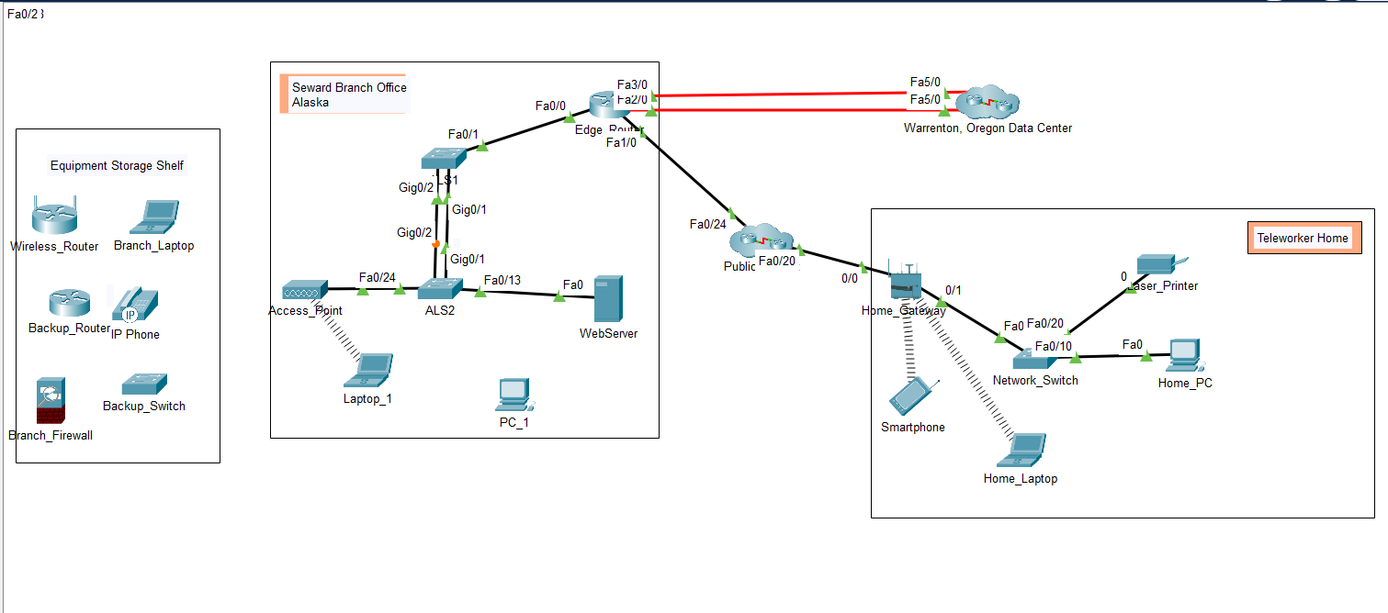

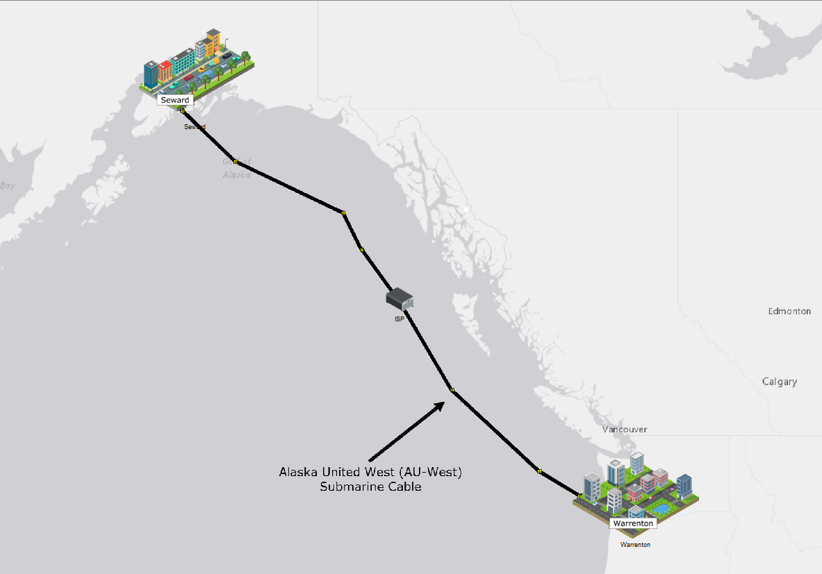

**Step 2:**

Click on the locations to explore the network. Become familiar with the network representations in both **Logical** and **Physical** modes. In **Physical** mode, navigate to other areas such as the **Warrenton Data Center** and **Teleworker Home**. The technologies used in these locations are discussed in greater detail in future courses.  
  
Most of the devices in the Seward branch office and Warrenton data center are already deployed and configured. You can explore the devices and networks. It is not important that you understand everything you see and do in this activity. Feel free to explore the network on your own. Hints will also appear after a certain amount of time. You can select a hint level with the slider bar in the bottom left hand corner. Answer the questions to the best of your ability.  
  
You can switch between these modes at any time to compare the differences by clicking the **Logical** (Shift-L) and **Physical** (Shift-P) buttons.  
  
For now, see what you can discover on your own. Don't worry about breaking anything. You can always reset the activity or close Packet Tracer and open a fresh copy to start exploring again.  
  
When you are done with exploring and answering all the questions, click **Next** to continue.

**In Physical Mode (Shift-P), what are the cities connected?**

The correct answer is Seward and Warrenton.

**In Physical Mode (Shift-P), what is the name of the submarine cable?**

The correct answer is Alaska United West (AU-West).

**In Logical Mode (Shift-L), what are the wireless devices in the Teleworker Home? (Hint: They are not connected with a solid black line.)**

The correct answer is Home_Laptop and Smartphone.

**In Physical Mode (Shift-P), what facility can you enter in the Seward, Alaska location?**

The correct answer is Branch Office.

**Which locations can you enter in the other city?**

The correct answer is Data Center and Teleworker.

**Step 3:**

In this step, you will navigate to the **Branch Office** wiring closet in **Seward**. You will also connect a PC to a switch using an Ethernet cable.

* In the **Intercity**, click **Seward**. While in **Seward**, click the **Branch Office** and then click the **Branch Office Wiring Closet**.
* Connect **PC_1 FastEthernet0** to an empty **FastEthernet** port on **ALS2**.

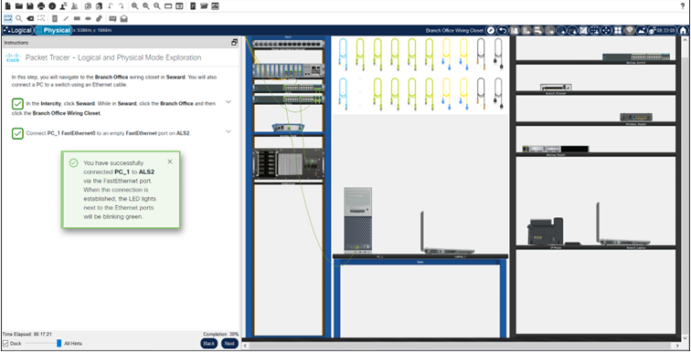

**Step 4:**

PCs and laptops can also be connected to networking devices using a console cable or a USB cable. This connection provides management access. Management access is used to view and change device configurations.

In this step, you will connect a PC to a router using a console cable.

 While in Physical mode, connect **RS232** port on **PC_1** to the **Console** port on the **Edge_Router**.

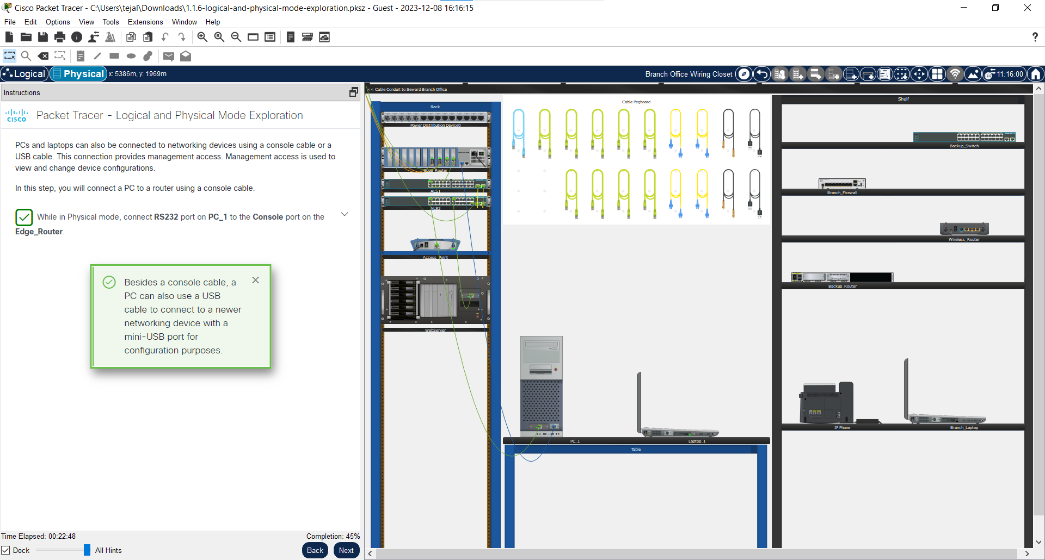

**Step 5:**

Newer models of networking devices can be accessed for management configuration through a USB port. This is necessary because newer laptops and PCs typically do not include an RS232 port for console cable connections.

In this step, you will install and power up a new router in the Rack. You will also connect to this device via the USB console with a USB cable.

In Packet Tracer, an inventory of devices can be stored on the Shelf. These devices are powered off and can be previously configured and deployed to replace or add to the production devices on the Rack.

* Install **Backup_Router** in the **Rack** and turn the power on.
* Connect **Laptop_1** to the **Backup_Router** with a USB cable.

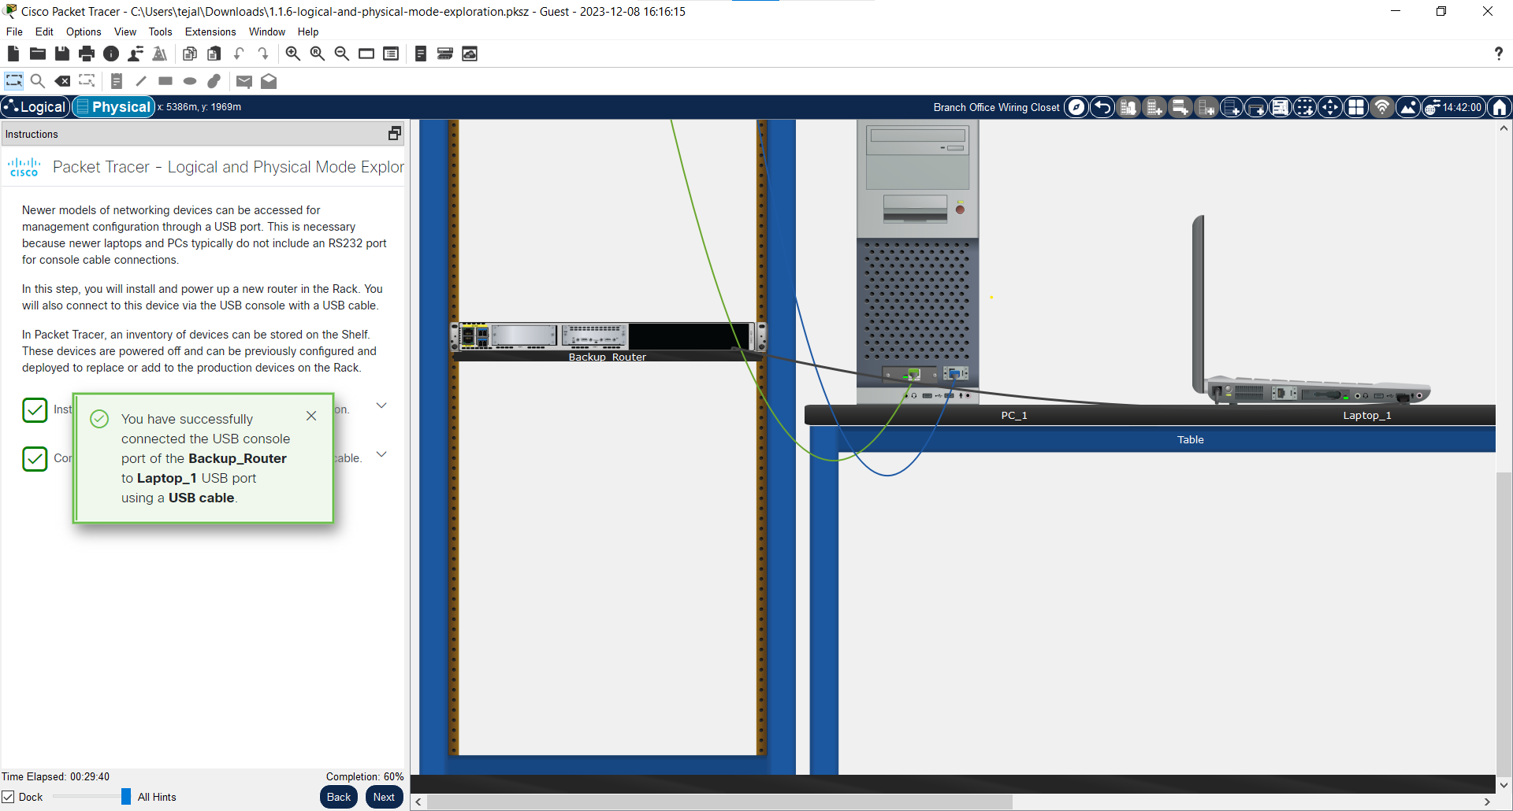

**Step 6:**

You have connected Laptop_1 to Backup_Router via a USB console cable. With the USB console connected, you will access the command line interface (CLI) of Backup_Router via terminal software and configure a hostname.

Every computer, including network devices, such as routers and switches, requires an operating system to function. The operating system allows the device hardware to function and provides an inteface for users to interact.

The Cisco Internetwork Operating System (IOS) is an operating system used in Cisco networking devices. It allows creation of configurations that customize the operation of network devices in different network environments. The CLI is accessible via the device console port using terminal software or remotely via Secure Shell (SSH). Network administrators use a computer to access the device console in order to create or modify the device configuation.

Network administrators typically assign names to networking devices. The host name is used to identify a device when accessing its operating system for configuration. To do this, you will use your console connection to the **Backup_Router**. After the hostname has been configured, the hostname appears as part of the IOS command prompt.

In this step, you will configure the hostname on **Backup_Router**.

* On **Laptop_1**, access the **Desktop** tab and click **Terminal**. The **Terminal Configuration** is already set with the necessary port configuration, and should be used with its default settings. Click **OK** to initiate the terminal connection.
* You are now at the command line for **Backup_Router**and should see the following output from the router.
* [output omitted]
* cisco ISR4331/K9 (1RU) processor with 1795999K/6147K bytes of memory.
* Processor board ID FLM232010G0
* 3 Gigabit Ethernet interfaces
* 2 Serial interfaces
* 32768K bytes of non-volatile configuration memory.
* 4194304K bytes of physical memory.
* 3207167K bytes of flash memory at bootflash:.
* 0K bytes of WebUI ODM Files at webui:.

Answer **no** to the question and then press ENTER to reach the **Router>** command prompt.

--- System Configuration Dialog ---

Would you like to enter the initial configuration dialog? [yes/no]: **no**

* Enter the following commands (in bold) to name the router Edge_Router_Backup. Note that the hostname must match this value exactly.
* Router> **enable**
* Router# **configure terminal**
* Router(config)# **hostname Edge_Router_Backup**
* Edge_Router_Backup(config)# **end**

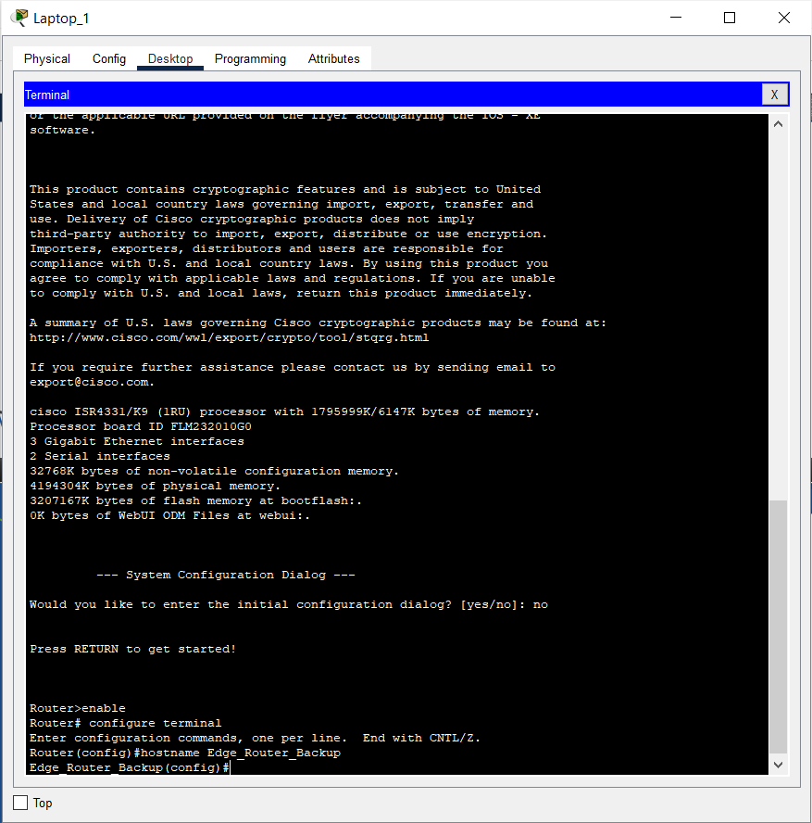

### **RESULT:**

In this activity, we have accomplished the following learning objectives:

* Investigate Devices in a Wiring Closet
* Connect End Devices to Networking Devices
* Install a Backup Router
* Configure a Hostname

|  |  |
| --- | --- |
| **Date:** 30.03.2025 | **Title** |
| **Exp. No: 03** | **Cabling in a rack** |

**OBJECTIVE:**

In this activity, you will install a patch panel and a wall mount. You will then use these to connect network devices in the office to the equipment in the wiring closet.

**Part 1: Install a Patch Panel in the Wiring Closet**

**Part 2: Attach a Wall Mount in the Office**

**Part 3: Connect an Additional Wall Mount and Cables**

**Simulation Tool:**

1. Cisco Packet Tracer software (version compatible with your computer)
2. Computer or laptops running Cisco Packet Tracer

## PROCEDURE:

**Part 1: Install a Patch Panel in the Wiring Closet**

**Step 1: Install a patch panel in the Rack**

**a**.     Click the Equipment Cabinet to access a simulated Wiring Closet.

b.     To install a patch panel, click Connections in the Device-Type Selection Box, and then click Structured Cabling.

c.     In the Device-Specific Selection Box, click the first option, which is Copper Patch Panel.

d.     Click a desired location in the Rack to install the patch panel in the rack.

Note: For accurate grading, make sure the name of the patch panel is Patch Panel0.

**Step 2: Connect the Office-SW1 to the patch panel.**

**a**.     From the Cable Pegboard, select a Copper Straight-Through cable.

b.     On the switch Office-SW1, click the GigabitEthernet 1/0/13 port. Now locate and click Jack13 on the Patch Panel0.

Note: Recall that you can right click the switch and the patch panel, select Inspect Front, and then zoom in to better locate the desired ports. You can also use the global Zoom In tool on the tool bar.

**c.**Use the following table to finish the connections between the Patch Panel0 and Office-SW-1.

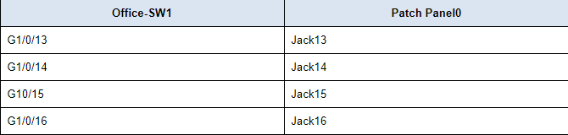

d.     If desired, you could also color code the cables in the rack. Right-click the desired cable, select **Color Cable**. Select or create the desired color, and click **OK**.

e.     If you do not like the cables dangling, you can organize them. Right-click any white space in the rack and select **Manage All Cables on Rack**. Now all your cables are organized on the rack.

f.      Click **Back level** (Alt-Left) to return to the **Office**.

**Part 2: Attach a Wall Mount in the Office**

**Step 1: Install a wall mount.**

a.     To install a wall mount, click **Connections** in the **Device-Type Selection Box**, and then click **Structured Cabling**.

b.     In the **Device-Specific Selection Box**, click **Copper Wall Mount**.

c.     Click the desired location on the wall next to the **Equipment Cabinet**.

**Note**: For accurate grading, make sure the name of the wall mount is **Wall Mount0**.

d.     In the **Device-Type Selection Box**, click **Connections**, and then click **Copper Straight-Through** cable.

e.     Click **Wall Mount0** and select **PunchDown1**. Then click the **Equipment Cabinet** (Wiring Closet) and select **Rack** > **Patch Panel0** > **Punchdown13**.

f.      Repeat for the rest of the available punchdowns on **Wall Mount0**.

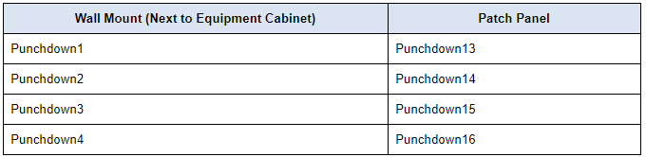

g.     Connect the PC **Office-Admin** and **Printer0** to any available jacks in the wall mount using **Copper Straight-Through** cables. After a minute or two, both devices will receive IP addressing information from the DHCP service running on the **Office-Server** inside the **Equipment Closet**.

h.     Verify connectivity by navigating to the web site http://office.srv. Click **Office-Admin** > **Desktop** > **Web Browser**. Enter**office.srv** in the URL field. This may take up to a minute. You can click **Go** to refresh the web page request.

**Step 2: Organize the cables.**

In the Physical mode, you can organize the cables so that they are spanning across the entire room.

a.     Right-click the desired cable, select **Create BendPoint**.

b.     Drag the black square to the wall. Continue to create bendpoints and drag the bend points into the walls or floor until the cable no longer goes across the middle of the room

Using the bendpoints has the same effects as running the cables into the walls in an office.

c.     Repeat the steps until you are satisfied with the results.

**Part 3: Connect an Additional Wall Mount and Cables**

Now that you have connected **AdminOffice** and **Printer0** to the network, connect more cables to the patch panel, add another wall mount, and connect the **Office-User** **PC**.

a.     Return to the **Equipment Closet** and make the following connections:

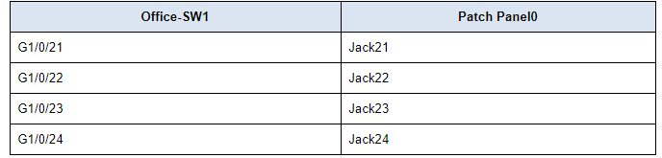

b.     In the **Office**, add another **Wall Mount** next to the window and connect the wall mount to the patch panel using the following connections.

**Note**: For accurate grading, make sure the name of the wall mount is **Wall Mount1**.

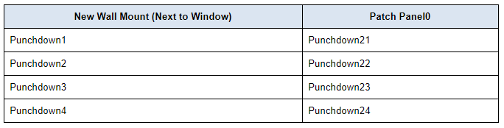

c.     Connect the **Office-User PC** to your new wall mount.

d.     After a minute or two, verify the **Office-User** PC received IP addressing information and then verify connectivity to the web site **office.srv**.

e.     If desired, create bend points in the cables and organize them.

**PROCEDURE SCREENSHOT:**

**Part 1: Install a Patch Panel in the Wiring Closet**

**Step 1: Install a patch panel in the Rack**

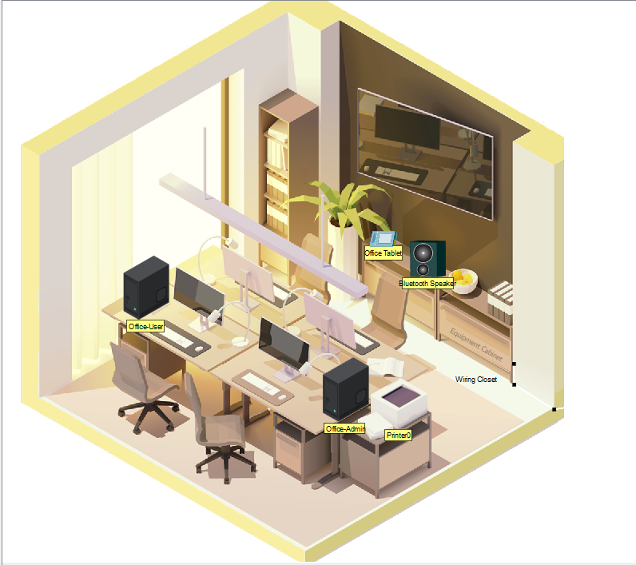

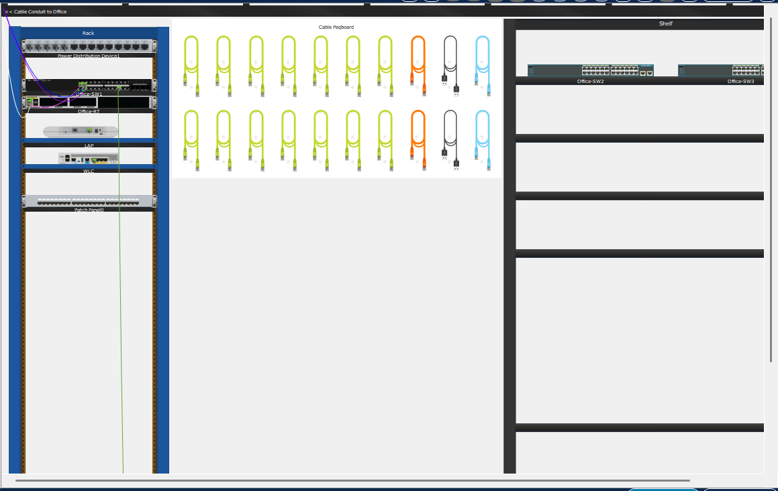

**Step 2: Connect the Office-SW1 to the patch panel**

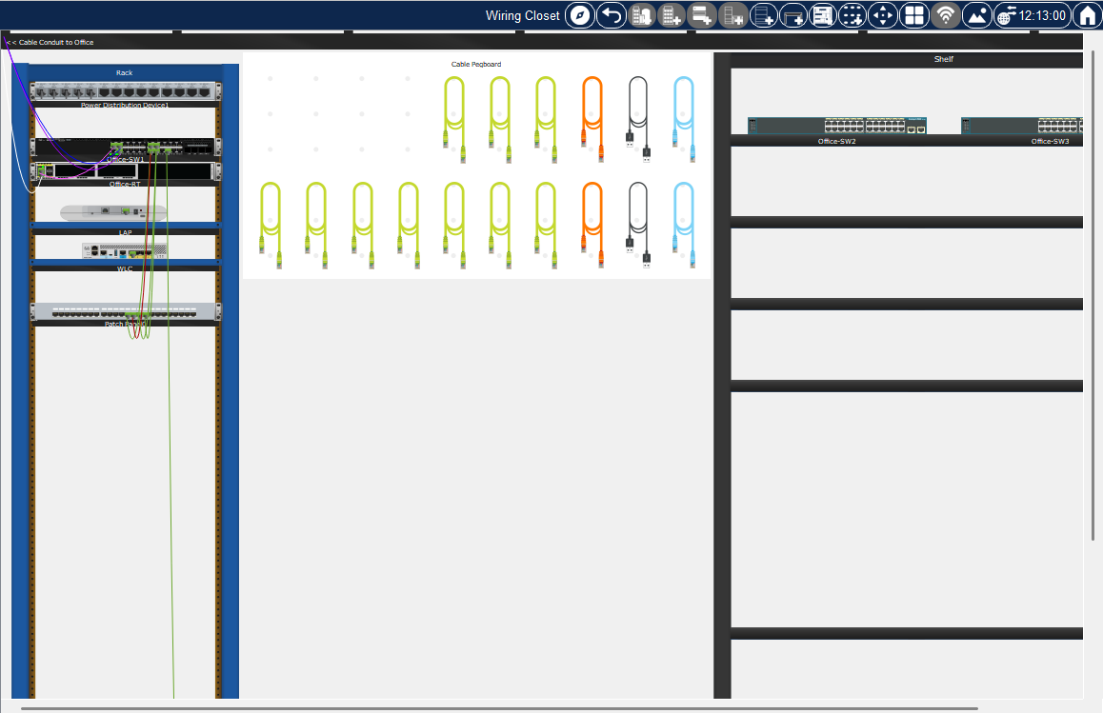

**Part 2: Attach a Wall Mount in the Office**

**Step 1: Install a wall mount.**

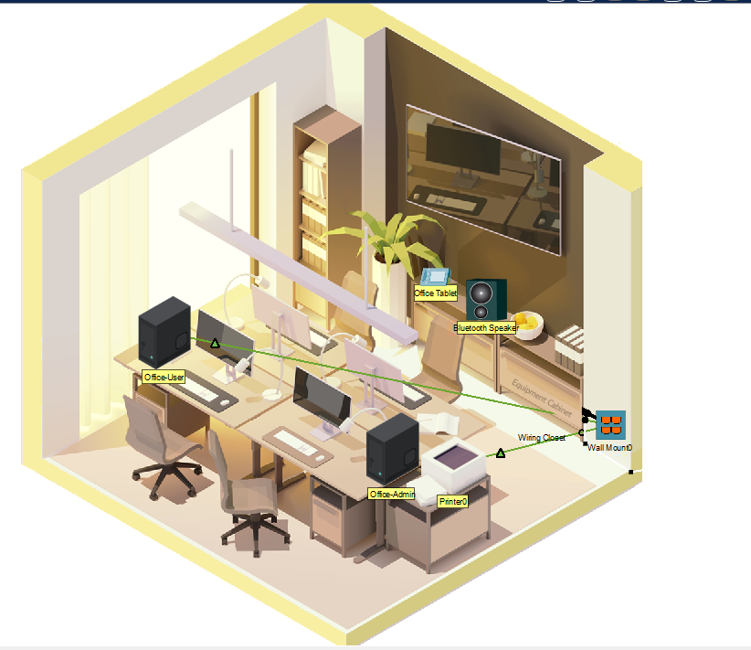

**Step 2: Organize the cables**

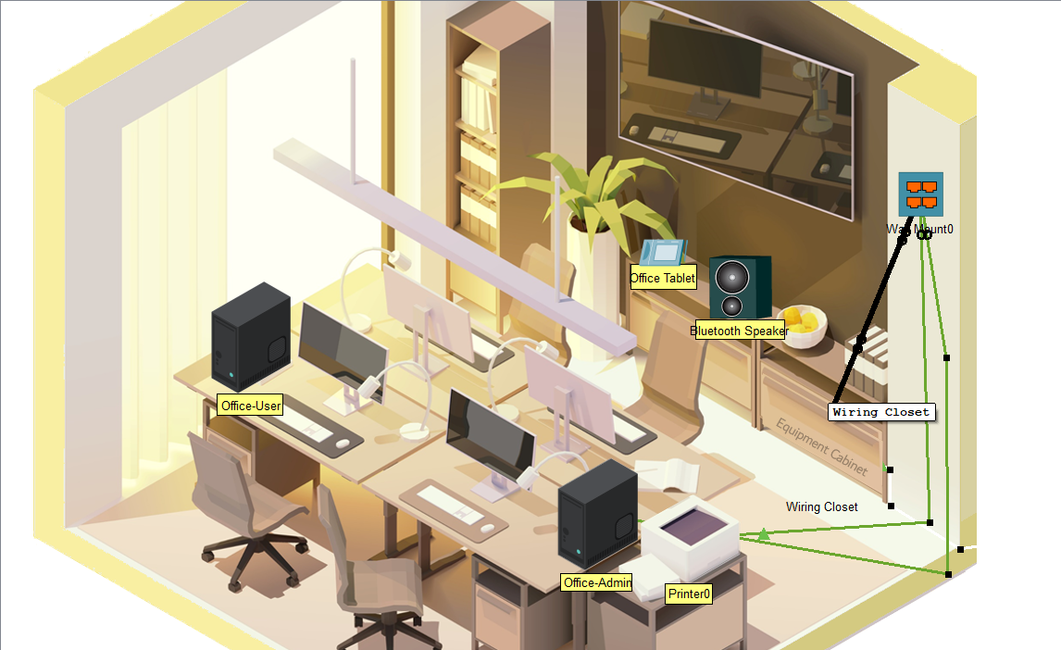

**Part 3: Connect an Additional Wall Mount and Cables**

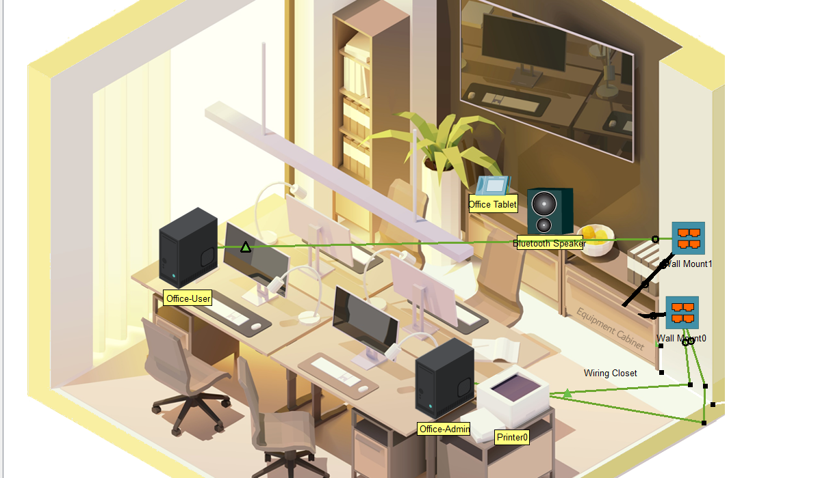

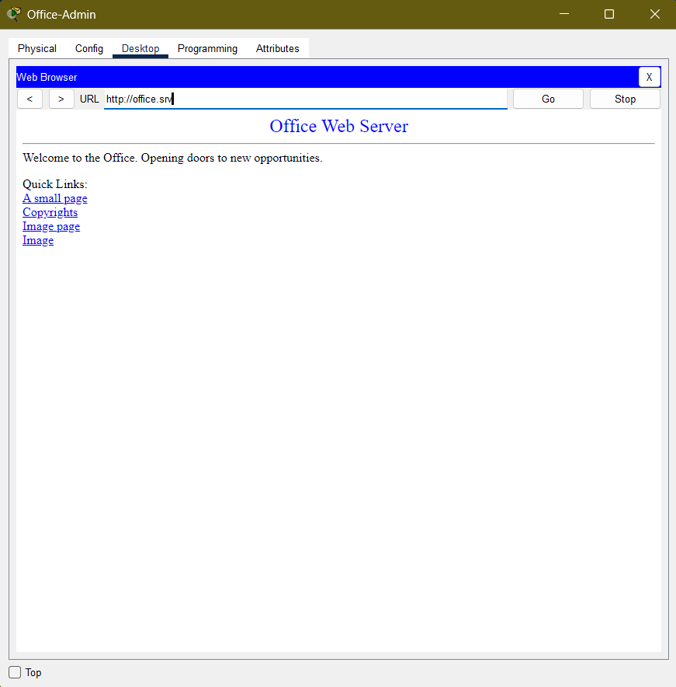

### **RESULT:**

The patch panel, wall mounts, and network cabling were successfully installed and configured, ensuring a well-structured office network. The **Patch Panel0** was mounted in the Equipment Cabinet, and **Office-SW1** was connected to it using Copper Straight-Through cables. A **Wall Mount0** was installed next to the Equipment Cabinet and linked to **Patch Panel0**, allowing the **Office-Admin PC** and **Printer0** to connect seamlessly to the network. Additionally, an **extra wall mount (Wall Mount1)** was installed near the window, connected to **Patch Panel0**, and used to connect the **Office-User PC**. All devices successfully received IP addresses from the DHCP server and verified connectivity by accessing [**http://office.srv**](http://office.srv). Furthermore, cables were efficiently organized using bendpoints, ensuring a tidy and professional setup.

**CONCLUSION:**

The successful installation of the **patch panel, wall mounts, and network cabling** ensures a structured and efficient office networking environment. All network devices, including **Office-SW1, Office-Admin PC, Printer0, and Office-User PC**, were able to connect to the network and access the office server. Proper **cable management** was maintained to ensure an organized and professional setup. This setup will enhance network reliability, ease troubleshooting, and ensure smooth communication between office devices.

|  |  |
| --- | --- |
| **Date:** 30.03.2025 | **Title** |
| **Exp. No: 04** | **Connecting Devices Using Wireless Technologies in Packet Tracer**  **1: Connect a Laptop to the Office WLAN**  **2: Connect Devices with Bluetooth Technology**  **3: Tether a Laptop to Use a Cellular Network via the Smartphone** |

**OBJECTIVE:**

**Part 1: Connect a Laptop to the Office WLAN**

**Part 2: Connect Devices with Bluetooth Technology**

**Part 3: Tether a Laptop to Use a Cellular Network via the Smartphone**

**PROCEDURE:**

**Part 1: Connect a Laptop to the Office WLAN**

**Step 1: Install a wireless module to a Laptop.**

a.     Click the **Laptop** to open the configuration window.

b.     Under the **Physical** tab, power off the **Laptop** by clicking the power button.

c.     Remove the Ethernet module **PT-LAPTOP-NM-1CFE** from the laptop by dragging it from the **Laptop** to the list on the left.

d.     Insert the wireless module **WPC300N**by dragging it from the list on the left to the**Laptop**.

e.     Power on the **Laptop**.

**Step 2: Connect Laptop to the office WLAN.**

a.     Click the **Desktop** tab and select the **PC Wireless** tool.

b.     Click the **Connect** tab and wait until the **Employee SSID WLAN** is displayed. Note that you may have to click **Refresh**.

c.     Click the **Employee** **SSID** to select it. Click **Connect**.

d.     Enter **Cisco123** as the pre-shared key and click **Connect**.

e.     After connecting to the wireless network, close the **PC Wireless** window.

f.      Click the **Config** tab and select **Wireless0** in the left pane to verify in the **IP Configuration** sectionthat the **Laptop** has been assigned an IP address.

g.     Open the **Web Browser** from the **Desktop**. Navigate to **office.srv** to verify that the **Laptop** has connectivity.

h.     Close the **Laptop** window.

**Part 2: Connect Devices with Bluetooth Technology**

In this part, you will connect a Bluetooth speaker to a tablet installed with a music player via Bluetooth.

**Step 1: Enable Bluetooth ports on devices.**

a.     Click the **Bluetooth**Speaker.

b.     Click the **Config** tab.

c.     Click **Bluetooth** on the left pane and check that the Port Status is **On**. Note that the speaker is not paired with the **Office Tablet**.

**Step 2: Connect Bluetooth devices.**

a.     Open the **Office Tablet**.

b.     Click the **Config tab**.

c.     Click **Bluetooth** in the left pane and check the **On** box for Port Status.

d.     Click **Discover** and the **Bluetooth Speaker** device should be discovered.

e.     Select the **Bluetooth Speaker** in the **Devices** list and click **Pair**. The status should change to "Paired, Connected". If prompted for permission to connect, click **Yes**.

f.      To test the Bluetooth connection, click the **Desktop** tab and select **Music Player**. Click **Play/Stop** to start the music. **Note**: Make sure your speaker is on.

g.     Click **Play/Stop** again to stop the sound.

**Part 3: Tether a Laptop to Use a Cellular Network via the Smartphone**

In this part, you will tether a laptop to a smartphone via Bluetooth. The laptop will use the cellular network to access a website.

**Step 1: Enable Bluetooth on the Laptop.**

a.     Click the **User-Laptop**. Select the **Config** tab.

b.     Click **Bluetooth** on the left panel. Click **On** for the Port Status.

c.     Leave the **User-Laptop** Bluetooth window open.

**Step 2: Connect a smartphone to the Cellular network and enable Bluetooth.**

a.     Click the **Smartphone** to open the configuration window.

b.     Click the **Config** tab. Check the **On** box for the Cellular Tethering setting in the **Global Settings**.

c.     Click the **3G/4G Cell1**interface. Verify that the **Smartphone** has an IP address from the cellular network.

d.     Click **Bluetooth** in the left pane and check the **On** box for the Port status on the **Smartphone**.

**Step 3: Connect Bluetooth devices and tethering to laptop**

a.     On the Bluetooth configuration for the **Smartphone**, click **Discover** to search for nearby Bluetooth enabled-devices.

**Note**: If **Smartphone** does not appear after a while, move **Smartphone** closer to **User-Laptop** and click **Discover** again.

b.     Select**User-Laptop** and click **Pair**. A pop-up window appears and asks for permission. Click **Yes**. The two devices are connected via Bluetooth.

c.     Return to the **User-Laptop**. In the Bluetooth panel of the **Config** tab, highlight **Smartphone** and click **Tether**.

d.     At the bottom pane of the Bluetooth configuration, notice that **User-Laptop** has now obtained an IP address.

e.     To test connectivity, navigate to **office.srv**. Click **Desktop** > **Web Browser**. Enter **office.srv** in the URL field. You can fast forward time to speed up the process.

**PROCEDURE SCREENSHOT:**

**Step1**

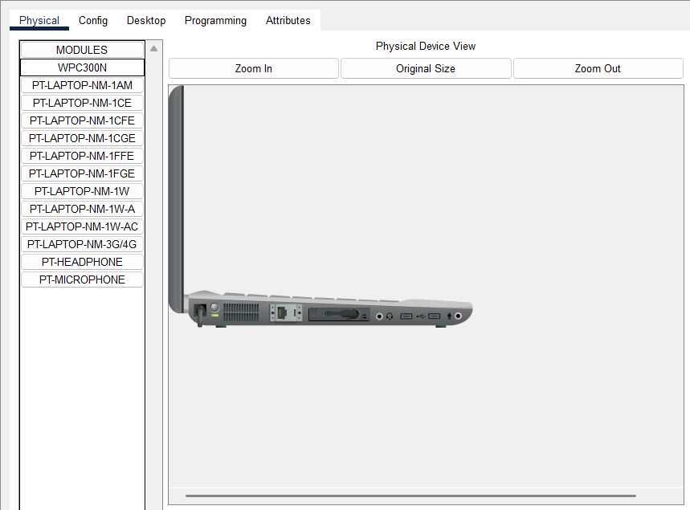

**Step 2**

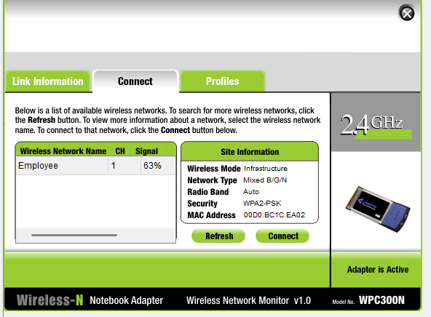

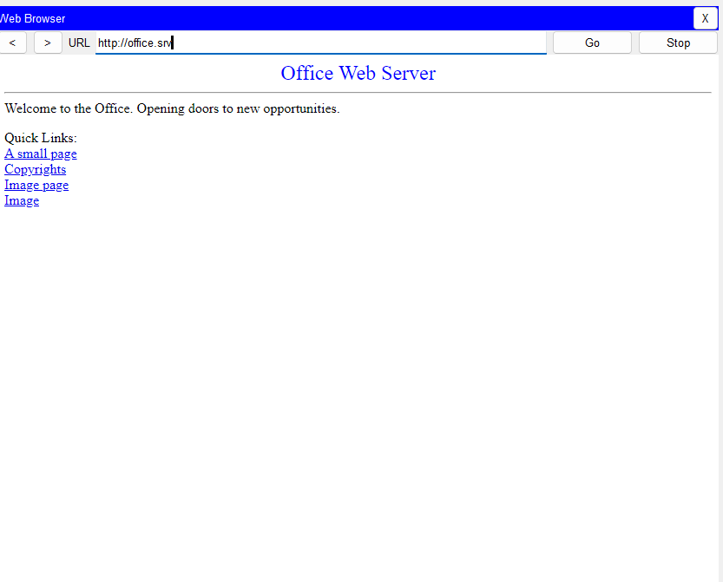

**Part 2: Connect Devices with Bluetooth Technology**

**Step 1**

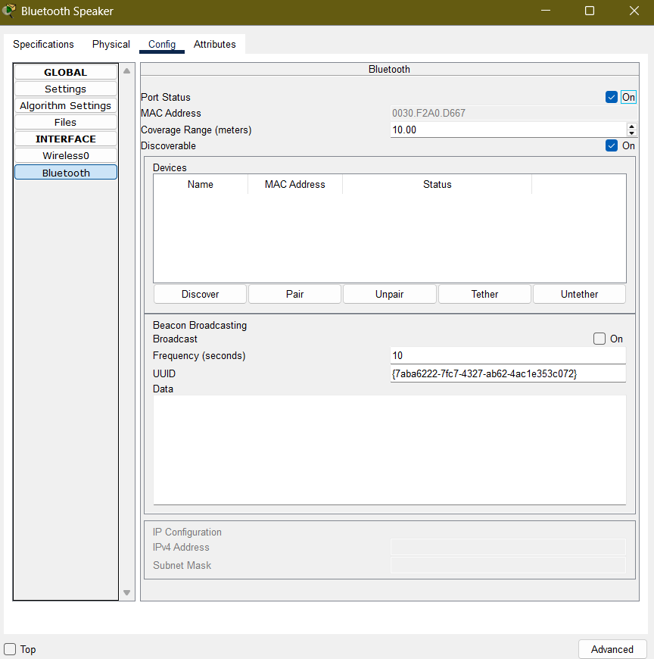

**Step 2**

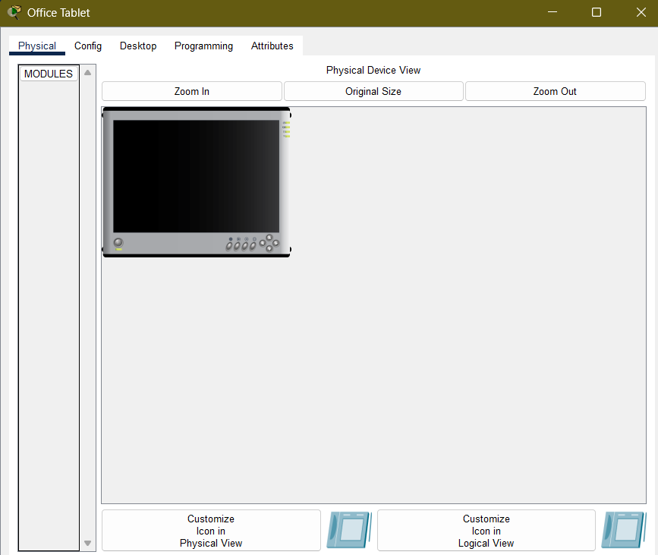

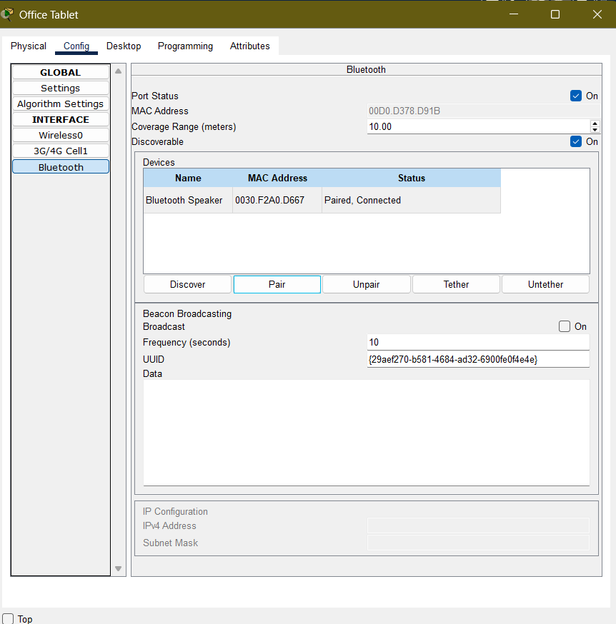

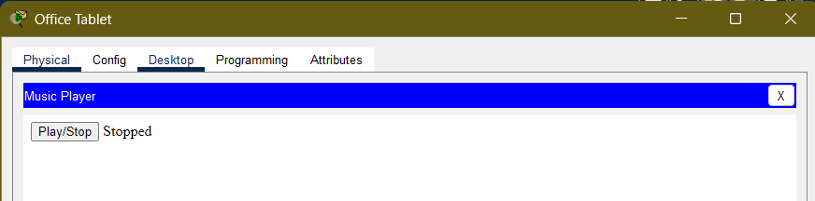

**Part 3: Tether a Laptop to Use a Cellular Network via the Smartphone**

**Step 1:**

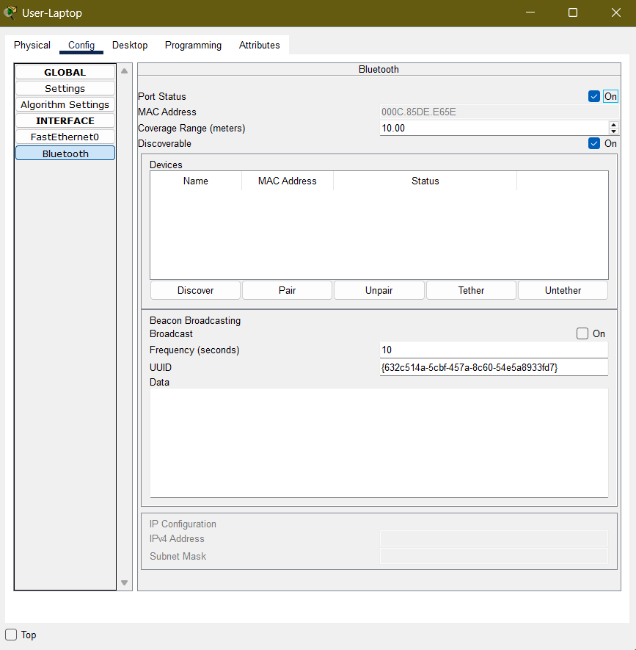

**Step 2:**

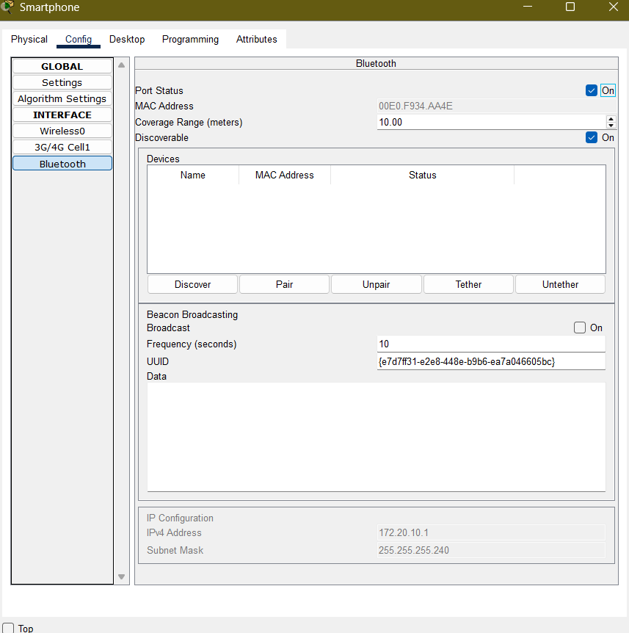

**Step 3:**

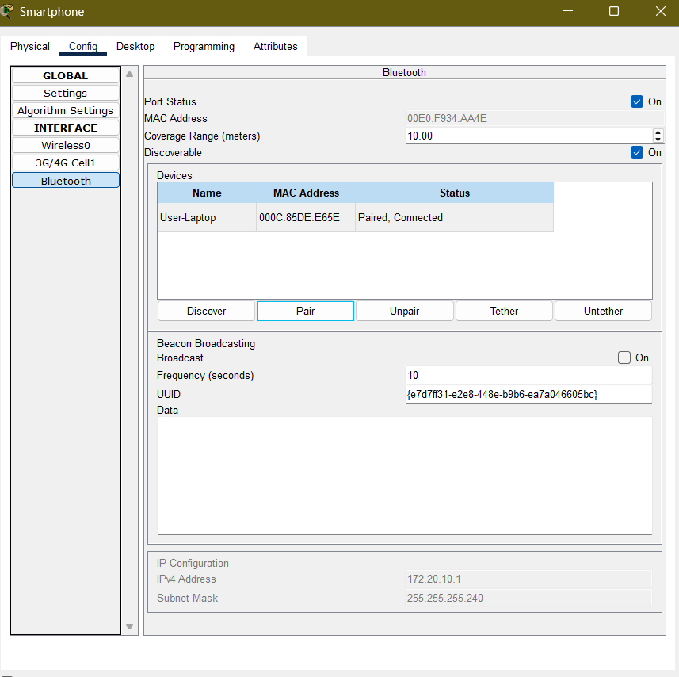

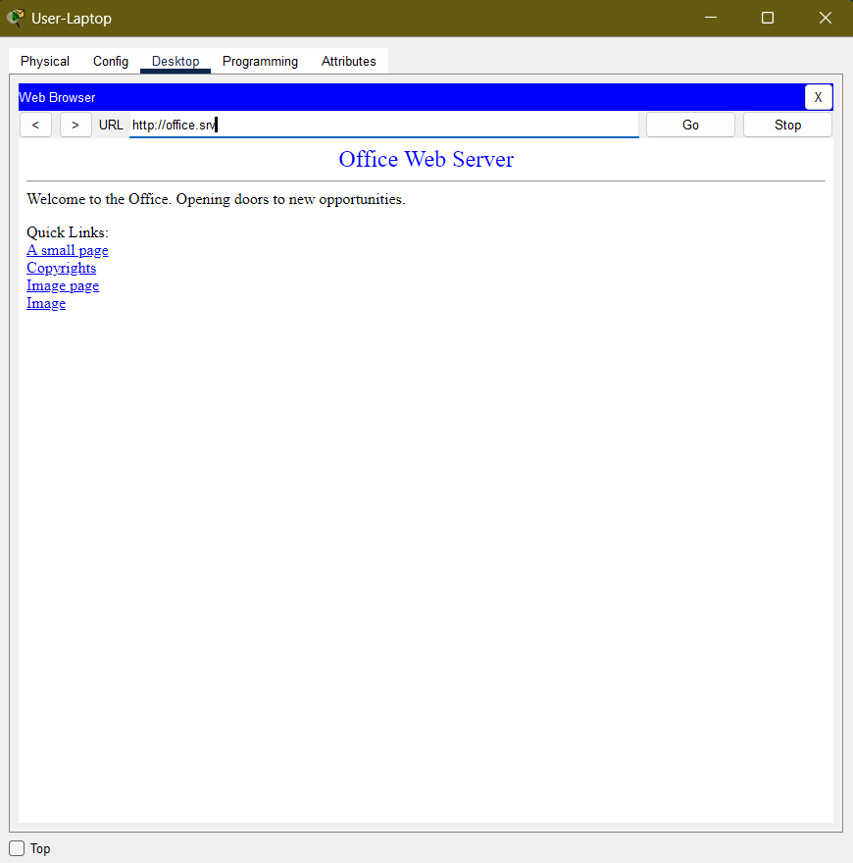

### **RESULT:**

The laptop was successfully connected to the **office WLAN** after installing the **wireless module (WPC300N)** and entering the correct **pre-shared key (Cisco123)**. The laptop obtained an IP address via DHCP and verified network connectivity by accessing **office.srv** through a web browser. Next, a **Bluetooth speaker** was paired with the **Office Tablet** using Bluetooth technology. The devices were successfully discovered, paired, and connected, allowing the **Music Player** on the tablet to play sound through the speaker. Finally, a **User-Laptop** was tethered to a **Smartphone** using Bluetooth, enabling the laptop to use the smartphone’s **cellular network** for internet access. The laptop received an IP address from the **cellular network**, and connectivity was confirmed by successfully navigating to **office.srv**. All wireless connections, including **Wi-Fi, Bluetooth pairing, and Bluetooth tethering**, functioned as expected, demonstrating efficient integration of different wireless technologies in the office network.

|  |  |
| --- | --- |
| **Date: 30/6/25** | **Title** |
| **Exp. No: 05** | Packet Tracer - Identify MAC and IP Addresses |

**Packet Tracer - Identify MAC and IP Addresses**

**Objectives**

**Part 1: Gather PDU Information for a Local Network Communication**

**Part 2: Gather PDU Information for a Remote Network Communication**

**Background**

If you are interested in a career in network administration or network security, it is important to understand normal network communication processes. In this Packet Tracer activity, you will inspect Ethernet frames and IP packets at different points in the network as they travel from source to destination. You will focus on the way that the MAC and IP addresses change depending on the destination (local or remote) and the place where the PDUs are captured.

Packet Tracer has a simulation mode which will enable you to investigate details about how PDUs travel on networks. It enables you to check the Layer 2 MAC addressing and Layer 3 IPv4 addressing of the PDUs at different locations in the network as the PDUs flow from source to destination.

This activity is optimized for viewing PDUs as they travel on local and remote networks. You will gather PDU information in PT simulation mode and answer a series of questions about the data you collect. No device configuration is required.

**Instructions**

**Part 1: Gather PDU Information for a Local Network Communication**

In this part, you will study how a device on a local network does not need a default gateway to communicate with another device on the same local network.

Note: Review the Reflection Questions in Part 3 before proceeding with this part. It will give you an idea of the type of information you will need to gather.Click host 172.16.31.3 and open the Command Prompt.

a. Enter the ping 172.16.31.2 command. This command will issue a series of ICMP echo request packets to the destination. If the packets reach the destination, it will send echo-reply messages pack to the source of the ping requests.

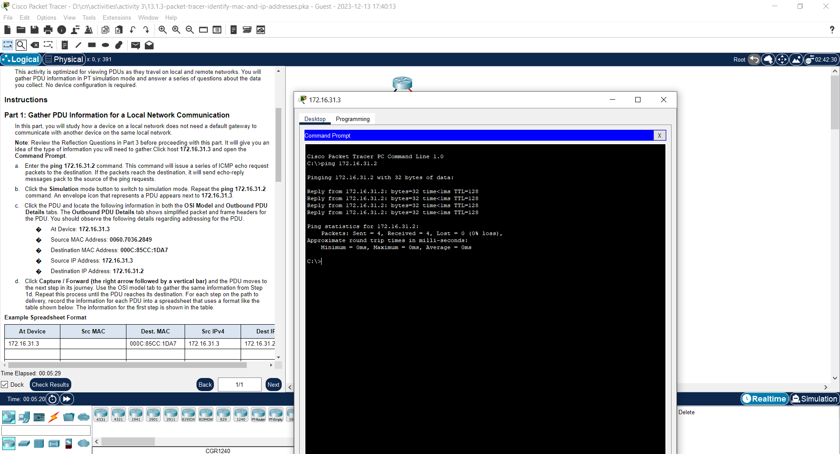

b. Click the Simulation mode button to switch to simulation mode. Repeat the ping 172.16.31.2 command. An envelope icon that represents a PDU appears next to 172.16.31.3.

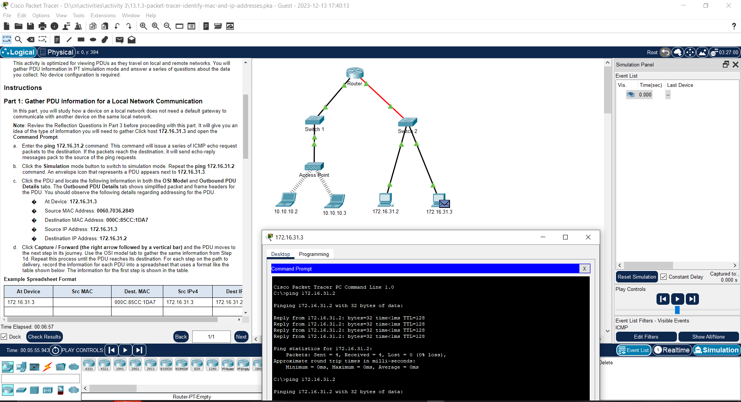

c. Click the PDU and locate the following information in both the OSI Model and Outbound PDU Details tabs. The Outbound PDU Details tab shows simplified packet and frame headers for the PDU. You should observe the following details regarding addressing for the PDU.

� At Device: 172.16.31.3

� Source MAC Address: 0060.7036.2849

� Destination MAC Address: 000C:85CC:1DA7

� Source IP Address: 172.16.31.3

� Destination IP Address: 172.16.31.2

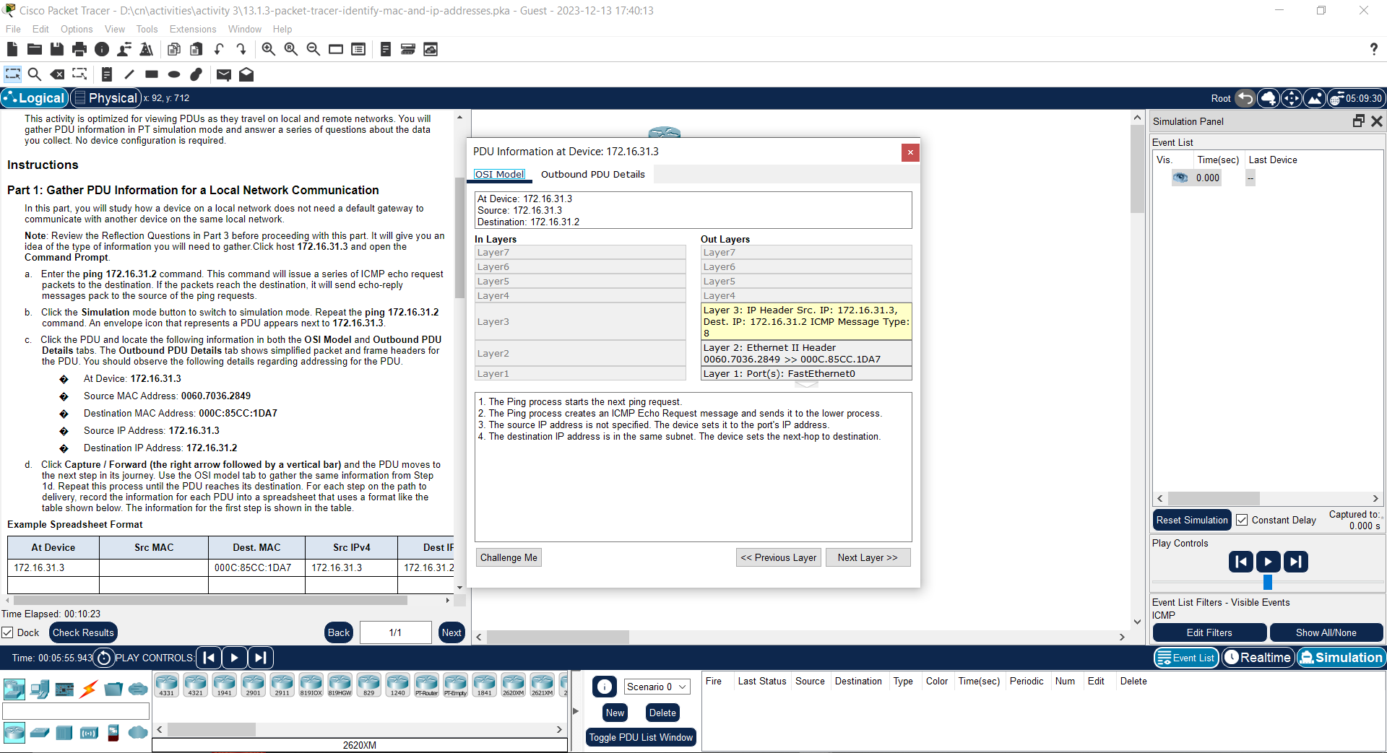

d. Click Capture / Forward (the right arrow followed by a vertical bar) and the PDU moves to the next step in its journey. Use the OSI model tab to gather the same information from Step 1d. Repeat this process until the PDU reaches its destination. For each step on the path to delivery, record the information for each PDU into a spreadsheet that uses a format like the table shown below. The information for the first step is shown in the table.

**Example Spreadsheet Format**

|  |  |  |  |  |
| --- | --- | --- | --- | --- |
| **At Device** | **Src MAC** | **Dest. MAC** | **Src IPv4** | **Dest IPv4** |
| **172.16.31.3** |  | 000C:85CC:1DA7 | **172.16.31.3** | **172.16.31.2** |
| **Switch2** |  | **000C.85CC.1DA7** | **172.16.31.3** | **172.16.31.2** |
| **172.16.31.3** |  | **0060.7036.2849** | **172.16.31.3** | **172.16.31.2** |
| **Switch2** |  | **0060.7036.2849** | **172.16.31.3** | **172.16.31.2** |

e. You will notice that the information for the inbound PDU is unchanged.

In the PDU information window, click the tab for the outbound PDU. How does the addressing differ, and why? Record the addressing in your table.

f. Return to Realtime mode.

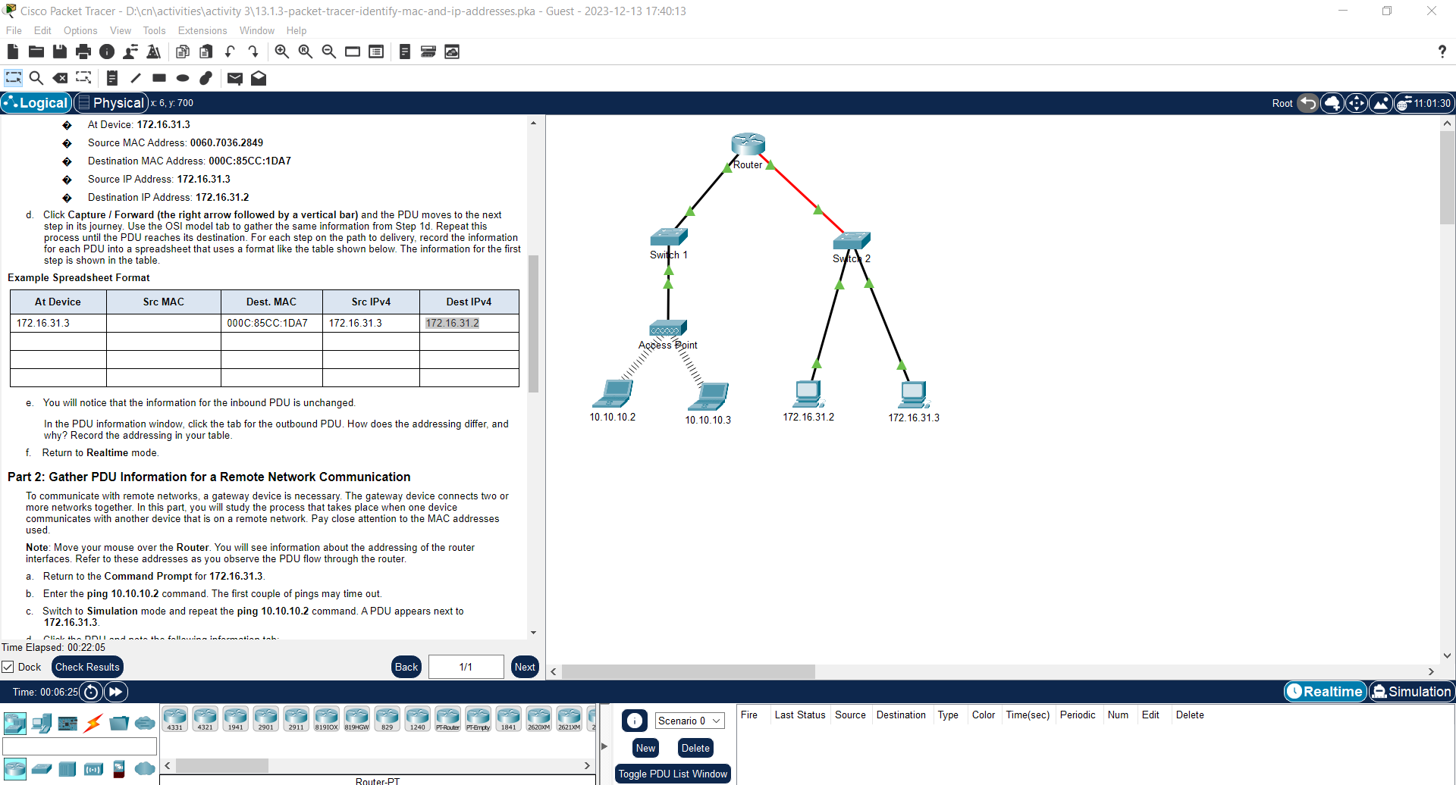

**Part 2: Gather PDU Information for a Remote Network Communication**

To communicate with remote networks, a gateway device is necessary. The gateway device connects two or more networks together. In this part, you will study the process that takes place when one device communicates with another device that is on a remote network. Pay close attention to the MAC addresses used.

Note: Move your mouse over the Router. You will see information about the addressing of the router interfaces. Refer to these addresses as you observe the PDU flow through the router.

a. Return to the Command Prompt for 172.16.31.3.

b. Enter the ping 10.10.10.2 command. The first couple of pings may time out.

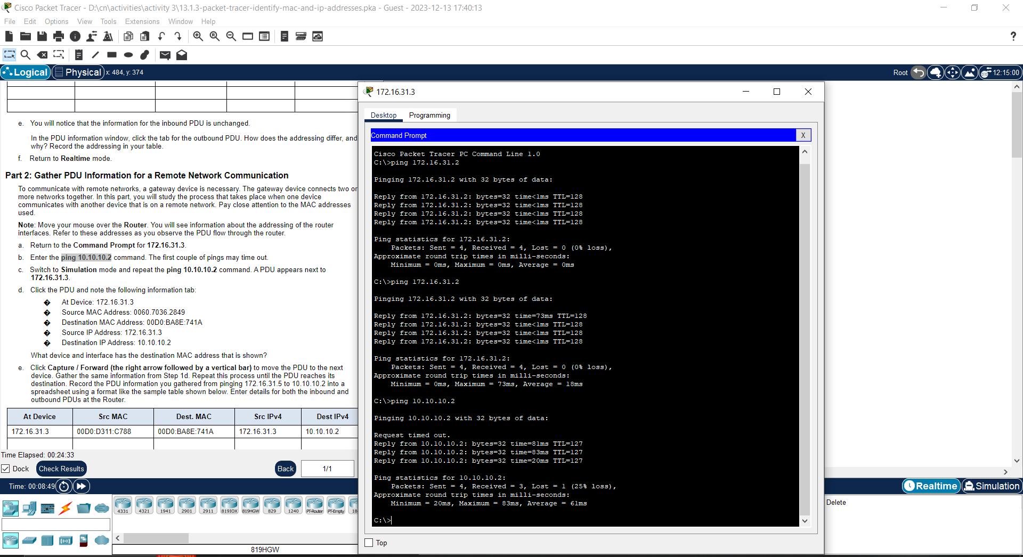

c. Switch to Simulation mode and repeat the ping 10.10.10.2 command. A PDU appears next to 172.16.31.3.

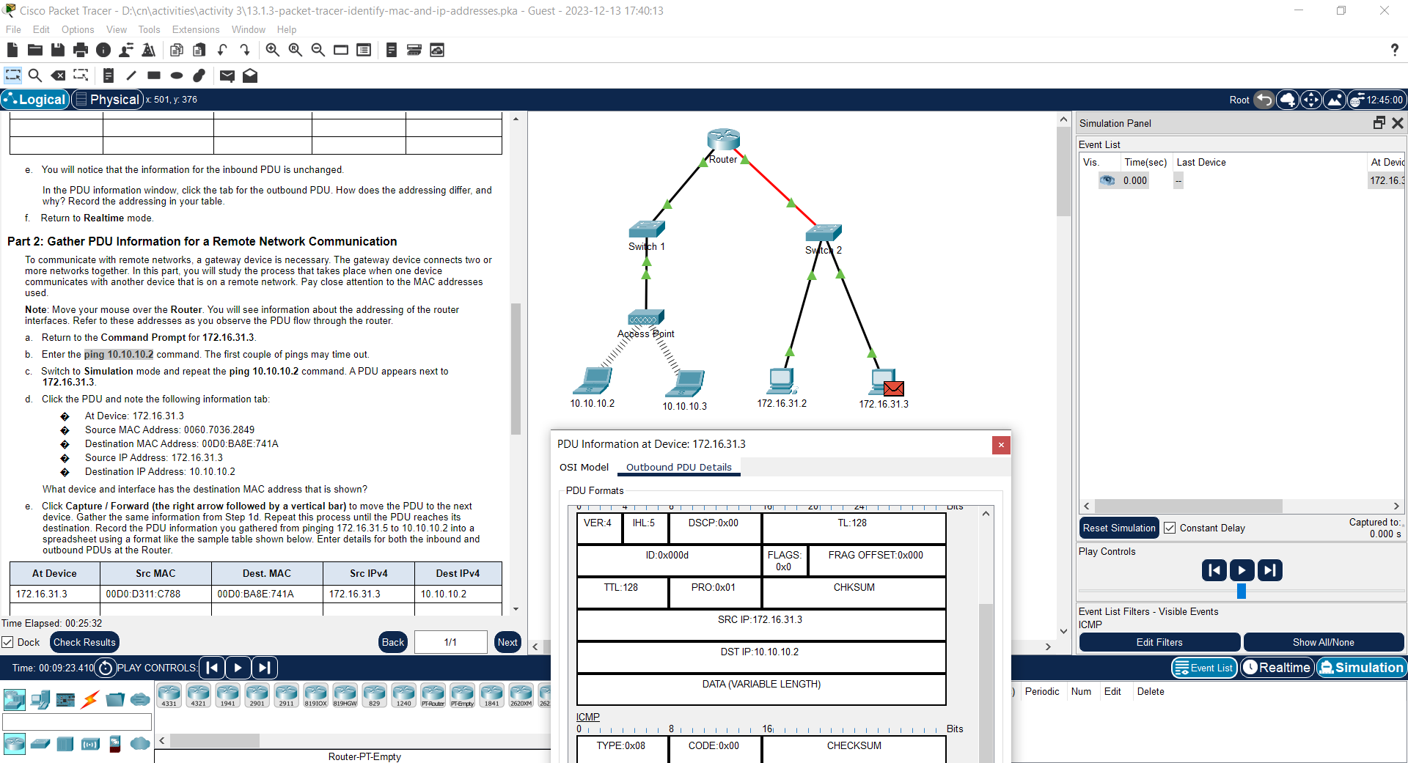

d. Click the PDU and note the following information tab**:**

� At Device: 172.16.31.3

� Source MAC Address: 0060.7036.2849

� Destination MAC Address: 00D0:BA8E:741A

� Source IP Address: 172.16.31.3

� Destination IP Address: 10.10.10.2

What device and interface has the destination MAC address that is shown?

Ans ;- Device 10.10.10.2

e. Click Capture / Forward (the right arrow followed by a vertical bar) to move the PDU to the next device. Gather the same information from Step 1d. Repeat this process until the PDU reaches its destination. Record the PDU information you gathered from pinging 172.16.31.5 to 10.10.10.2 into a spreadsheet using a format like the sample table shown below. Enter details for both the inbound and outbound PDUs at the Router.

|  |  |  |  |  |
| --- | --- | --- | --- | --- |
| At Device | Dest. MAC | Src MAC | Src IPv4 | Dest IPv4 |
| **172.16.31.5** | **00D0:BA8E:741A** | **00D0:D311:C788** | **172.16.31.5** | **10.10.10.2** |
| **Switch1** | **00D0:BA8E:741A** | **00D0:D311:C788** | **N/A** | **N/A** |
| **Router** | **0060:2F84:4AB6** | **00D0:588C:2401** | **172.16.31.5** | **10.10.10.2** |
| **Switch0** | **0060:2F84:4AB6** | **00D0:588C:2401** | **N/A** | **N/A** |
| **Access Point** | **N/A** | **N/A** | **N/A** | **N/A** |
| **10.10.10.2** | **00D0:588C:2401** | **0060:2F84:4AB6** | **10.10.10.2** | **172.16.31.5** |

### Reflection Questions

**Answer the following questions regarding the captured data:**

1. Were there different types of wires used to connect devices? Yes, copper and fiber
2. Did the wires change the handling of the PDU in any way? No
3. Did the Hub lose any of the information given to it? No
4. What does the Hub do with MAC addresses and IP addresses? Nothing
5. Did the wireless Access Point do anything with the information given to it? Yes. It repackaged it as wireless 802.11
6. Was any MAC or IP address lost during the wireless transfer? No
7. What was the highest OSI layer that the Hub and Access Point used? Layer 1
8. Did the Hub or Access Point ever replicate a PDU that was rejected with a red “X”? Yes
9. When examining the PDU Details tab, which MAC address appeared first, the source or the destination? Destination
10. Why would the MAC addresses appear in this order? A switch can begin forwarding a frame to a known MAC address more quickly if the destination is listed first
11. 16. Did the sending and receiving IPv4 addresses switch in any of the PDUs? No
12. 17. If you follow the reply to a ping, sometimes called a pong, do the sending and receiving IPv4 addresses switch? Yes
13. 18. What is the pattern to the IPv4 addressing in this simulation? Each port of a router requires a set of non-overlapping addresses
14. 19. Why do different IP networks need to be assigned to different ports of a router? The function of a router is to inter-connect different IP networks.
15. 20. If this simulation was configured with IPv6 instead of IPv4, what would be different? The IPv4 addresses would be replaced with IPv6 addresses, but everything else would be the same.

|  |  |
| --- | --- |
| Date:  30.03.2025 | Title |
| Exp. No: 06 | Using the ping command to identify an incorrect configuration. |

**OBJECTIVE:**

In this activity, Use the **ping**command to identify an incorrect configuration on a PC.

* Part 1: Use the ping Command
* Part 2: Configure the End Devices and Verify Connectivity

**Simulation Tool:**

1. Cisco Packet Tracer software (version compatible with your computer)
2. Computer or laptops running Cisco Packet Tracer

**PROCEDURE:**

**Part 1: Verify connectivity.**

Access the Desktop tab > Web Browser of each PC and enter the URL www.cisco.pka. Identify any PCs that are not connecting to the web server.

Note: All the devices require time to complete the boot process. Please allow up to one minute before receiving a web response.

**Step 1: Initial connectivity verification.**

Test Web Access on All PCs:

* + Open each PC (PC1, PC2, PC3)
  + Navigate to Desktop tab → Web Browser
  + Enter http://www.cisco.pka
* **PC3(Connected to Server)**

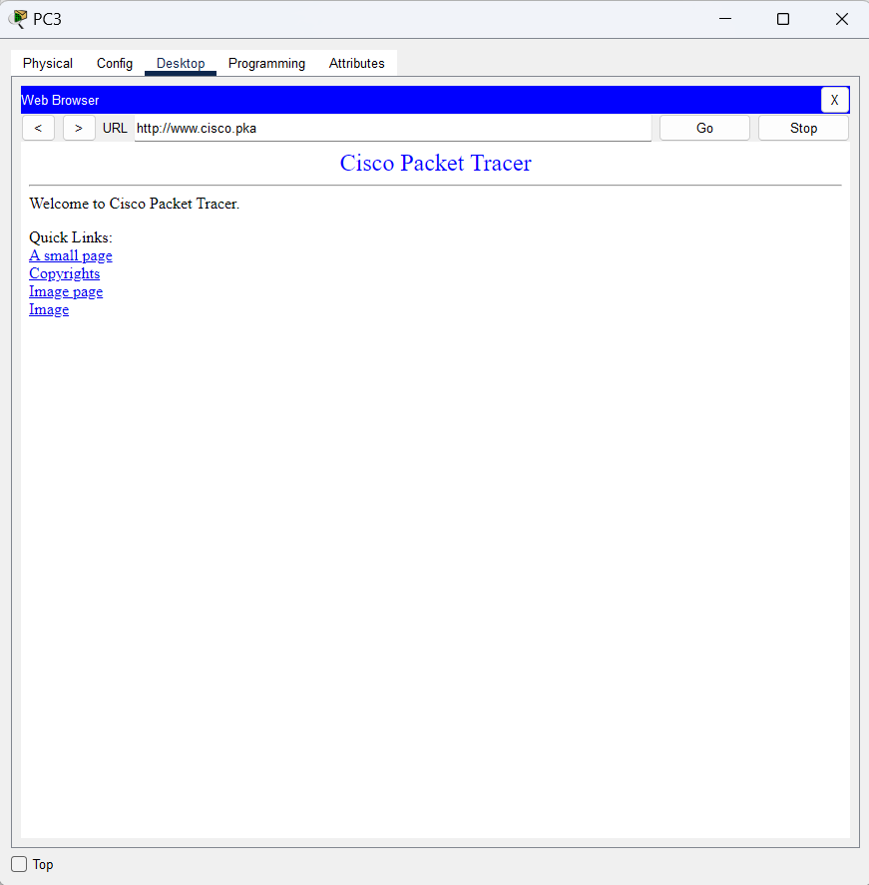

**Part 2: Ping the web server from PC with connectivity issues.**

a.     On the PC, access the **Command Prompt**from the **Desktop**tab.

b.     At the prompt, enter **ping** [**www.cisco.pka**](http://www.cisco.pka).

* **PC2(FAULTY PC-Not connected to server)**

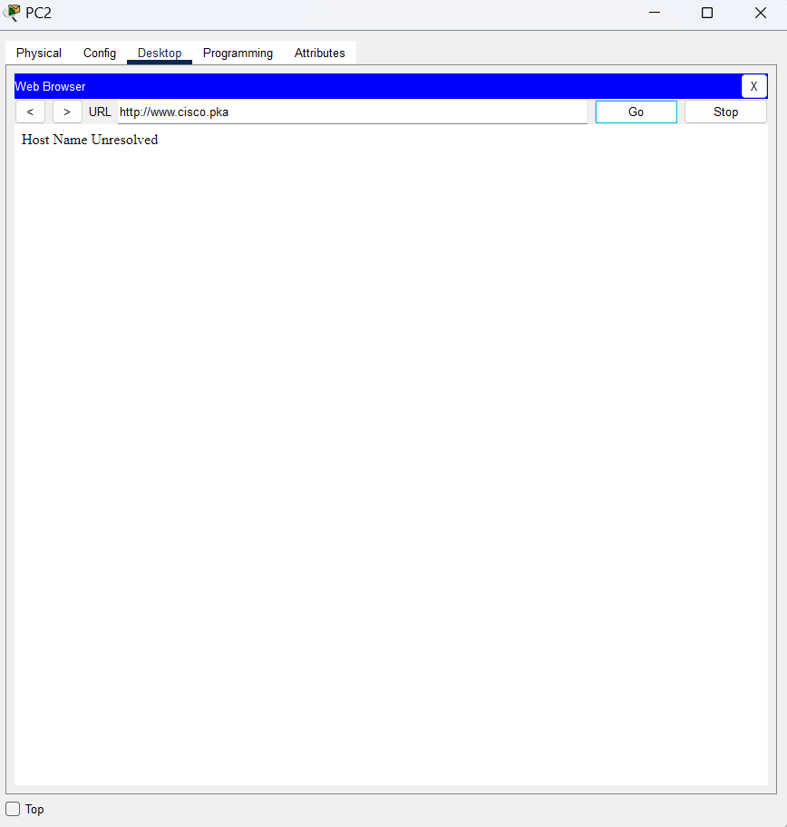

**Part 3: Ping the web server from correctly configured PCs.**

a.     On the PC, access the **Command Prompt**from the **Desktop**tab.

b.     At the prompt, enter **ping www.cisco.pka**.

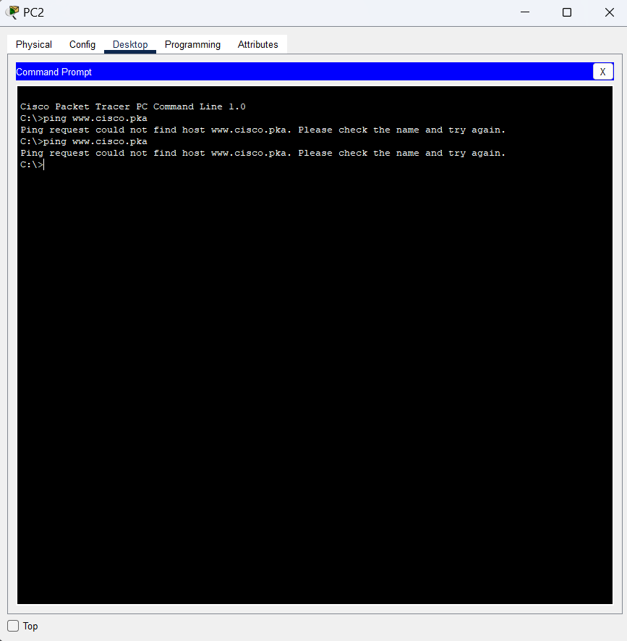

**Part 4: Ping the IP address of the web server from PCs with connectivity issues.**

a.     On the PC, access the **Command Prompt**from the **Desktop** tab.

b.     Attempt to reach the IP address of the web server with the **ping** command.

**On PC1 (faulty PC):**

* + Command Prompt
  + Enter: ping 192.15.2.10

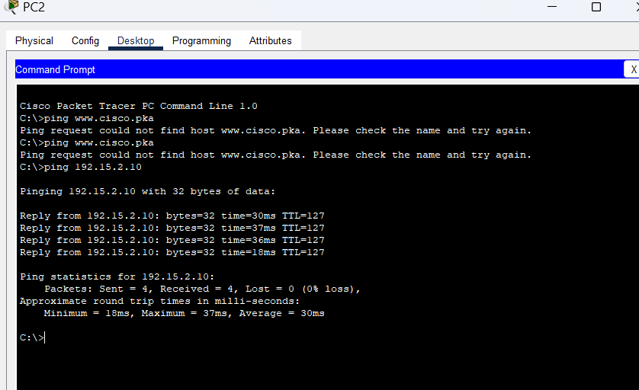

**Part 5: Compare the DNS server information on the PCs.**

a.     Access the **Command Prompt**of the PCs without any issues.

b.     Using the command **ipconfig /all**, examine the DNS server configuration on the PCs without any issues.

c.     Access the **Command Prompt** of the PCs with connectivity issues.

d.     Using the command **ipconfig /all**, examine the DNS server configuration on the PCs with misconfigurations. Do the two configurations match?

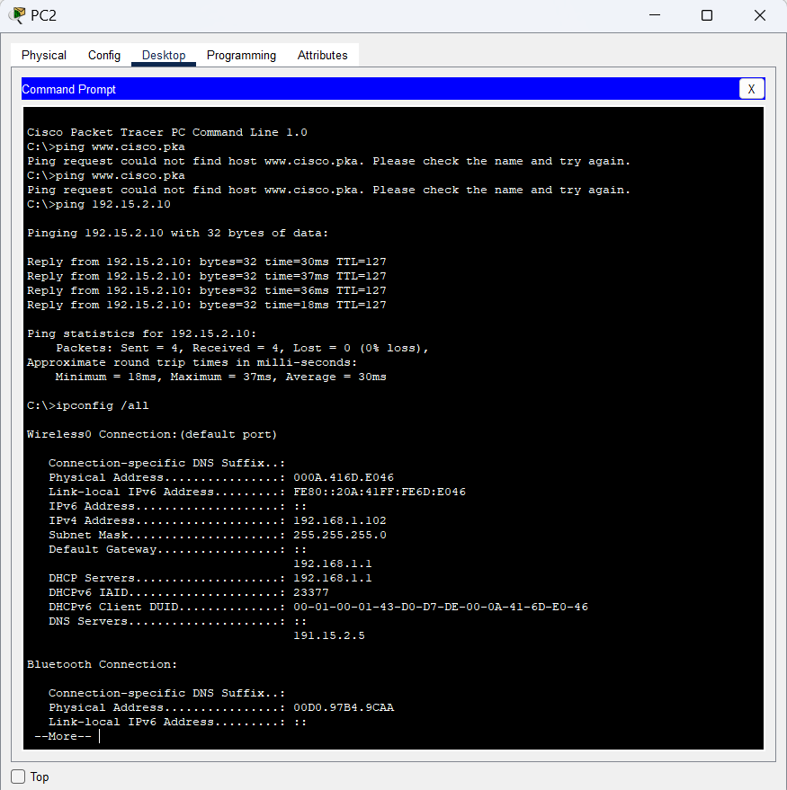

* **Check necessary ipconfig**

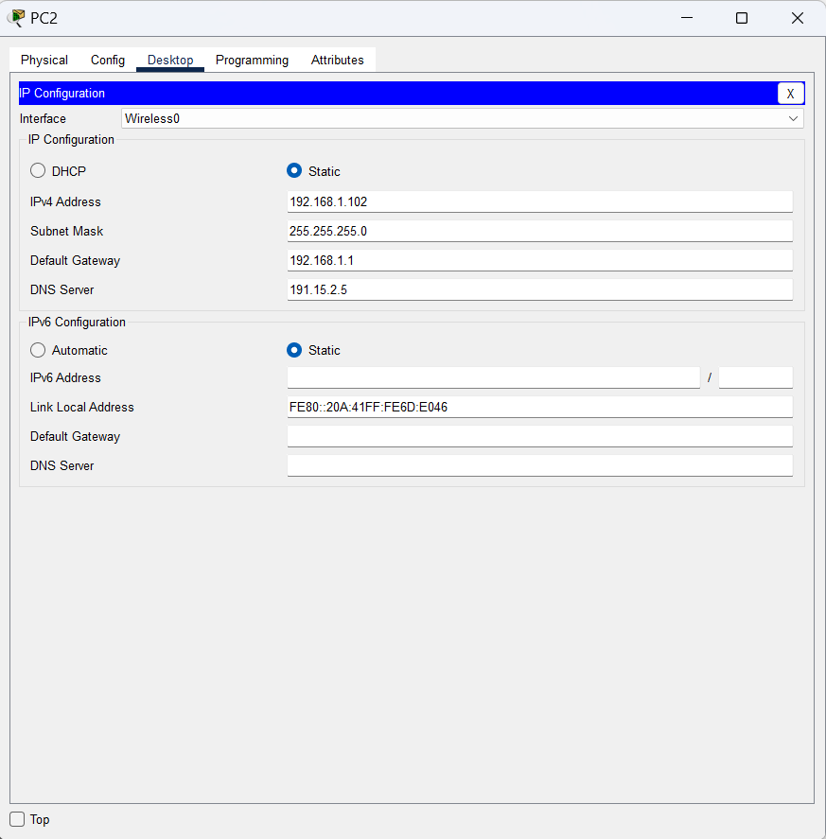

**Part 6: Make any necessary configuration changes on the PCs.**

a.     Navigate to the **Desktop**tab of the PCs with issues, make any necessary configuration changes in **IP Configuration**.

b.     Using the **Web Browser**within the **Desktop**tab, connect to **www.cisco.pka**to verify that the configuration changes resolved the problem.

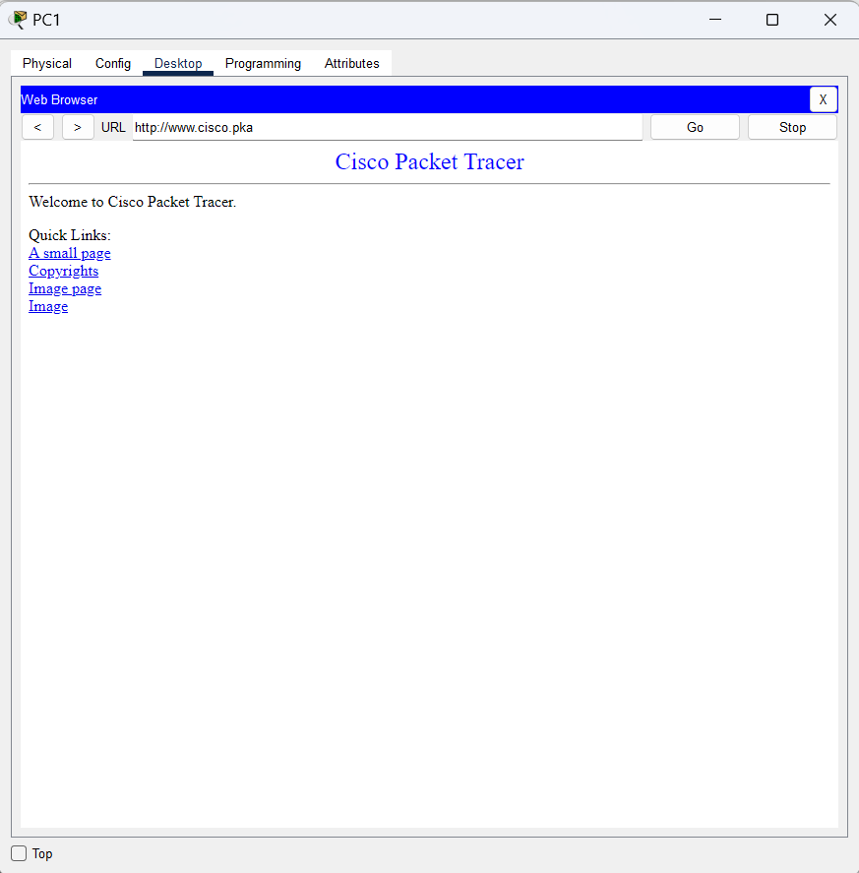

**RESULT**

**Findings:**

* PC2 worked (correct DNS: 192.15.2.5)
* PC1 & PC3 failed – could ping 192.15.2.10 but not www.cisco.pka (missing DNS).

**Fix Applied:**

* Added DNS server 192.15.2.5 to faulty PCs.

**CONCLUSION:**

All PCs resolved domains and accessed the web.

|  |  |
| --- | --- |
| **Date:**  **30.03.2025** | **Title** |
| **Exp. No: 07** | Packet Tracer - Using the **ipconfig** Command |

**OBJECTIVE**

Use the ipconfig command to identify and correct incorrect network configurations on a PC.

**Simulation Tool**

1. Software: Cisco Packet Tracer (version compatible with your computer)
2. Devices: Four PCs connected in a network

**BACKGROUND/SCENARIO**

A small business owner cannot connect to the internet with one of the four PCs in the office. All PCs are configured with static IP addressing using the 192.168.1.0/24 network. The PCs should be able to access the www.cisco.pka webserver.

**PROCEDURE**

**Part 1: Verify Configurations**

* Access the Command Prompt on each PC:
* Click on a PC in Packet Tracer.
* Navigate to the Desktop tab > Command Prompt.
* Run ipconfig /all on each PC:
* Type ipconfig /all and press Enter.
* Record the following details for each PC:
  + IPv4 Address
  + Subnet Mask
  + Default Gateway
  + DNS Server
* Compare configurations:
* Ensure all PCs are in the 192.168.1.0/24 subnet.
* Verify that the Default Gateway is set to 192.168.1.1.
* Check that the DNS Server is correctly configured (e.g., 192.15.2.5).

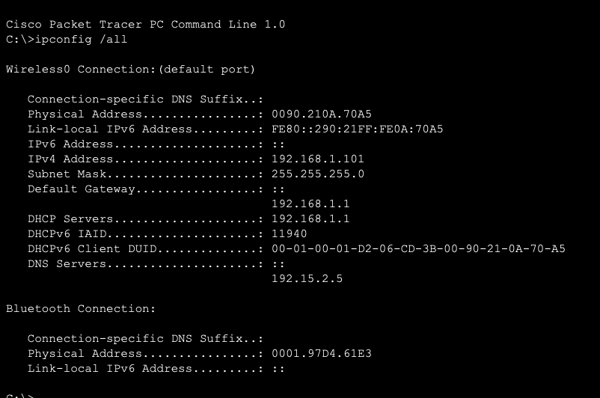

PC1

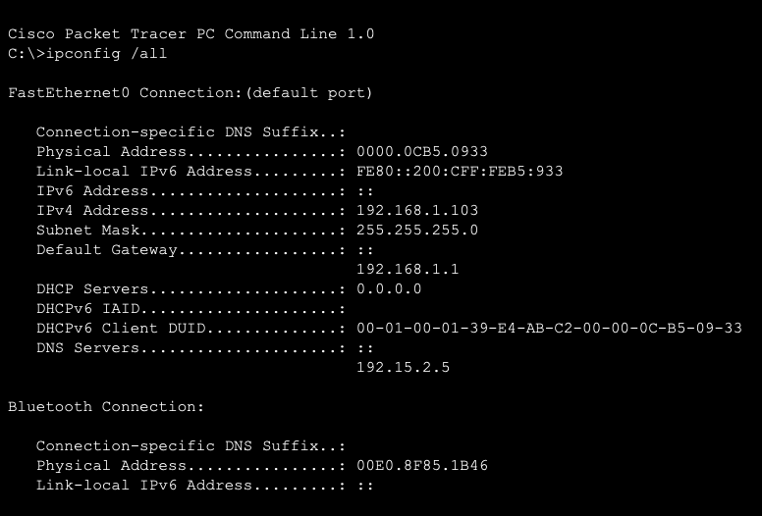

PC2

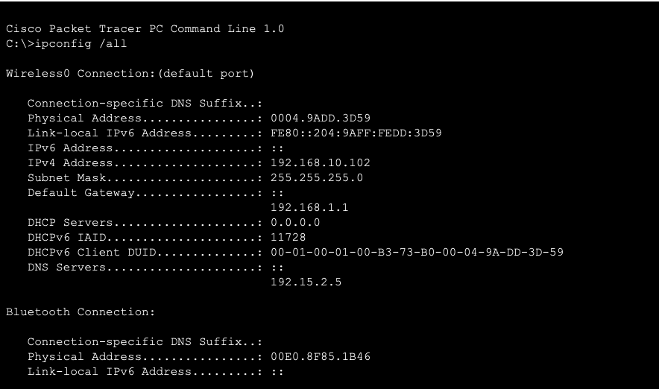

PC3

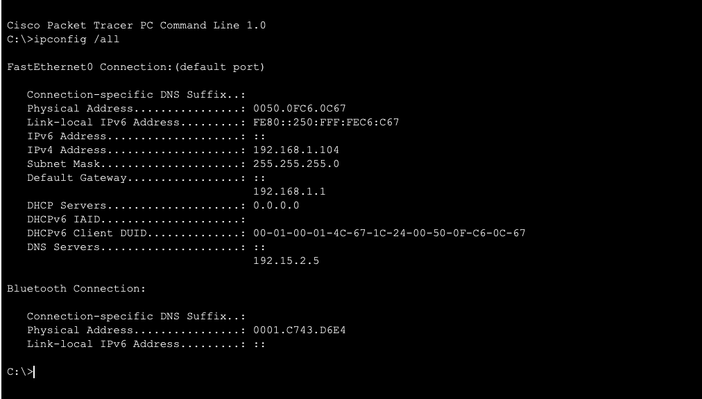

PC4

**Part 2: Correct Any Misconfigurations**

* Identify the misconfigured PC:
* Look for a PC with:
  + An IP address outside 192.168.1.0/24 (e.g., 192.168.10.102).
  + A missing or incorrect Default Gateway or DNS Server.
* Fix the misconfiguration:
* Select the misconfigured PC.
* Go to the Desktop tab > IP Configuration.
* Change the incorrect settings:
  + IPv4 Address: Set to an available IP in 192.168.1.0/24 (e.g., 192.168.1.102).
  + Subnet Mask: 255.255.255.0
  + Default Gateway: 192.168.1.1
  + DNS Server: 192.15.2.5
  + 
  + Incorrect PC2 Configuration
* Verify connectivity:
  + After correction, test internet access by pinging the gateway (ping 192.168.1.1) or accessing www.cisco.pka.
  + 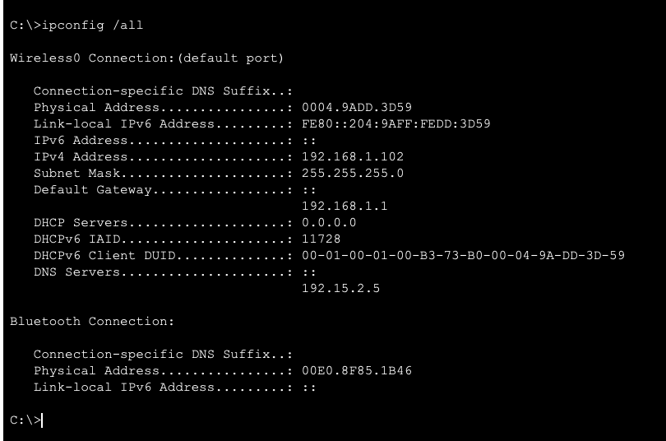

Corrected PC2 configuration

* Expected Outcome
  + All PCs should now have:
    - Correct IP addresses within 192.168.1.0/24.
    - Proper Default Gateway (192.168.1.1) and DNS (192.15.2.5).

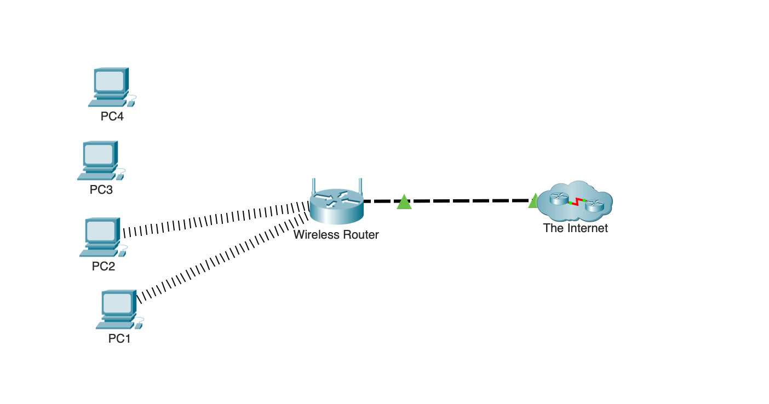

* The previously non-functional PC should now access the internet and [www.cisco.pka](http://www.cisco.pka).
* 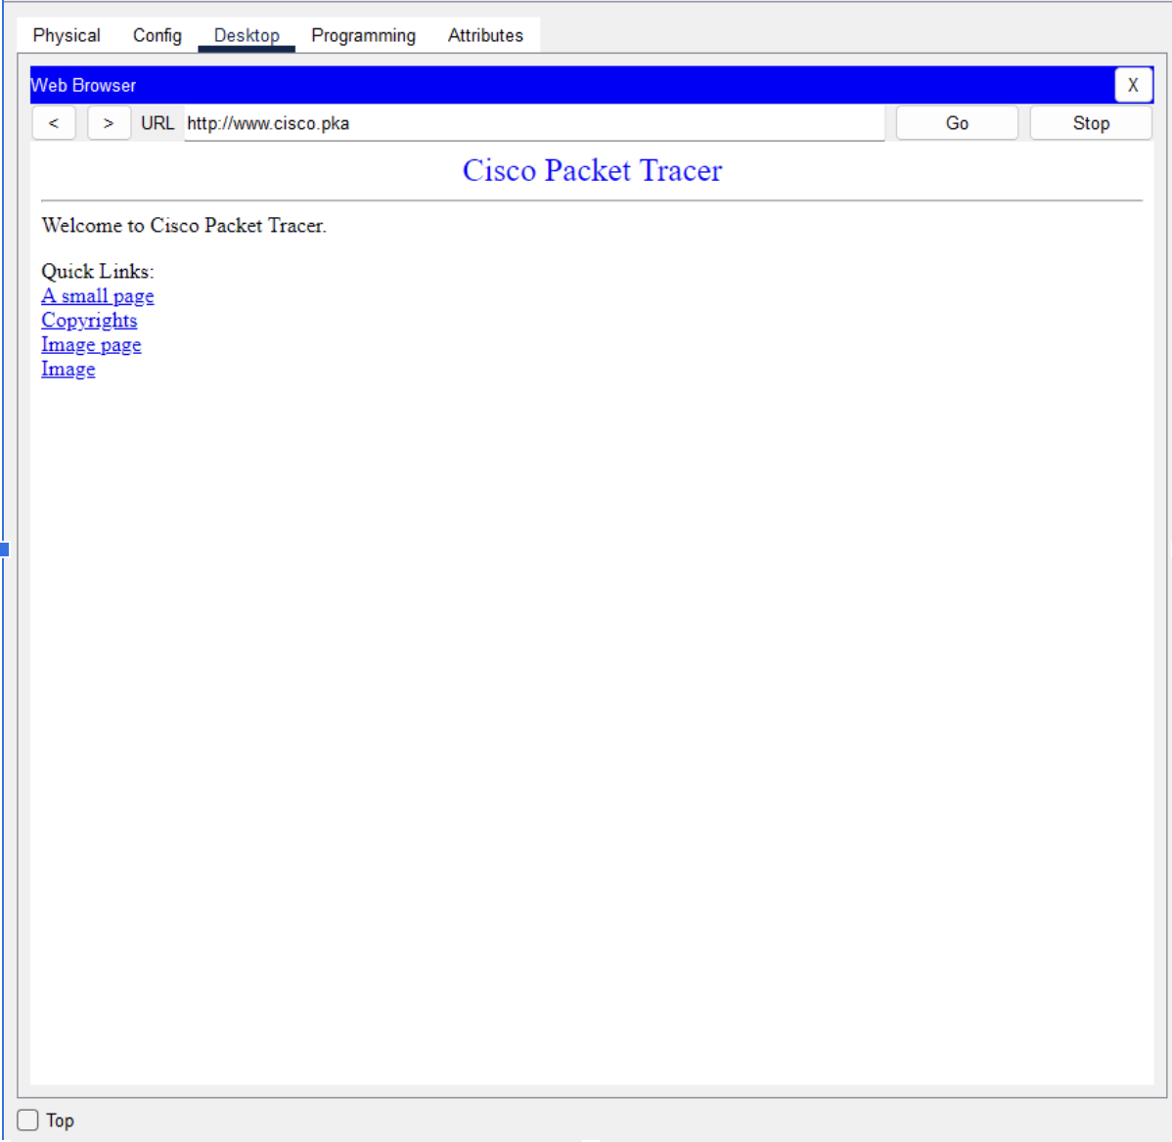

**EXPERIMENT RESULT**

**Objective Achieved:** Successfully identified and corrected the misconfigured PC (PC2) using the ipconfig /all command.

**Issue Found:**

PC2 had an incorrect IP (192.168.10.102) instead of an address in the 192.168.1.0/24 range.

**Correction Applied:**

Changed PC2’s IP to 192.168.1.102 with the correct subnet mask (255.255.255.0) and gateway (192.168.1.1).

**Outcome:**

After correction, all PCs were on the same subnet, ensuring proper network communication and internet access. Verified by testing connectivity (ping and web access).

**Conclusion:**

The ipconfig command effectively helped diagnose and fix network misconfigurations.

|  |  |
| --- | --- |
| **Date: 30/4/25** | **Title** |
| **Exp. No: 08** | **PACKET TRACER- FTP SERVICES** |

### Addressing Table

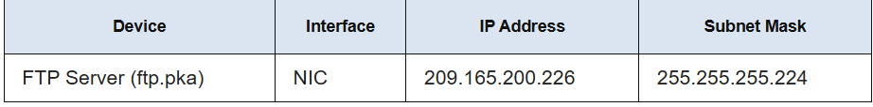

### Objectives

* Upload a file to an FTP server.
* Download a file from an FTP server.

### Background / Scenario

File Transfer Protocol (FTP) is a commonly used application to transfer files between clients and servers on the network. The server is configured to run the service where clients connect, login, and transfer files. FTP uses port 21 as the server command port to create the connection. FTP then uses port 20 for data transfer.

In this activity, you will upload a file to an FTP server. You will also download a file from an FTP server.

### Instructions

#### Part 1: Upload a file to an FTP server.

In this part, you will locate the file **sampleFile.txt** and upload it to an FTP server.

##### **Step 1: Locate the file.**

a. Click **PC-A**.

b. Click **Desktop**.

c. Click **Command Prompt**.

d. At the prompt, click ? to list the available commands.

e. Enter dir to see the files on the PC. Notice that there is a **sampleFile.txt** file in the C:\ directory.

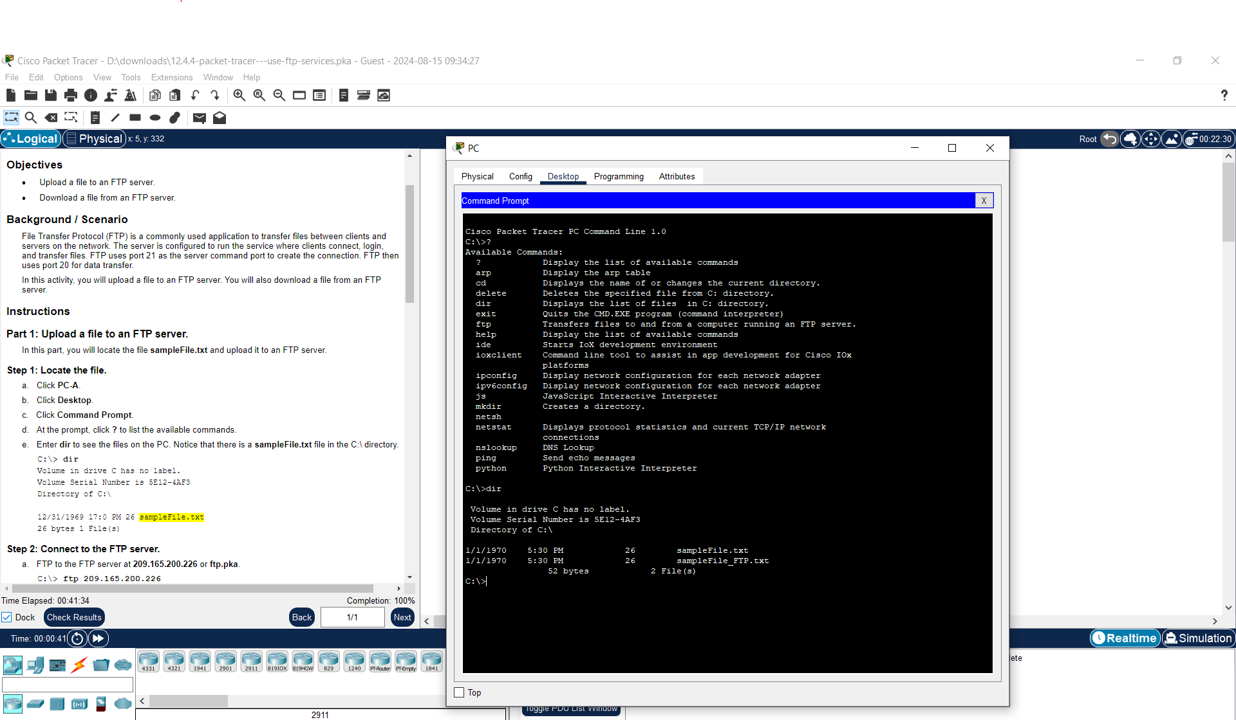

.**Step 2: Connect to the FTP server.**

a. FTP to the FTP server at **209.165.200.226** or **ftp.pka**.

b. Enter the username **student** and password **class** to gain access.

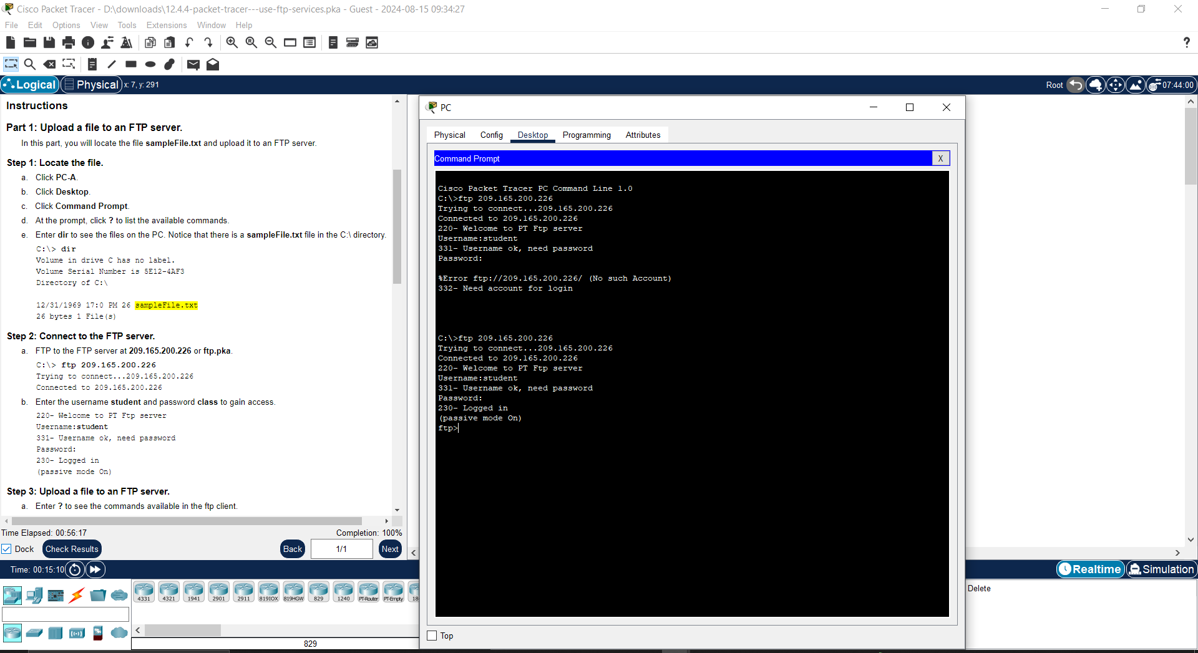

##### **Step 3: Upload a file to an FTP server.**

a. Enter ? to see the commands available in the ftp client.

b. Enter **dir** to see the files available on the server.

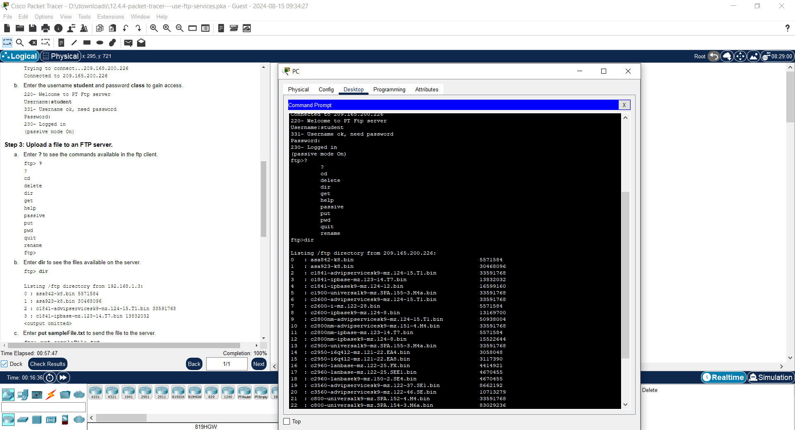

c. Enter **put sampleFile.txt** to send the file to the server.

d. Use the dir command again to list the contents of the FTP server to verify that the file has been uploaded to the FTP server.

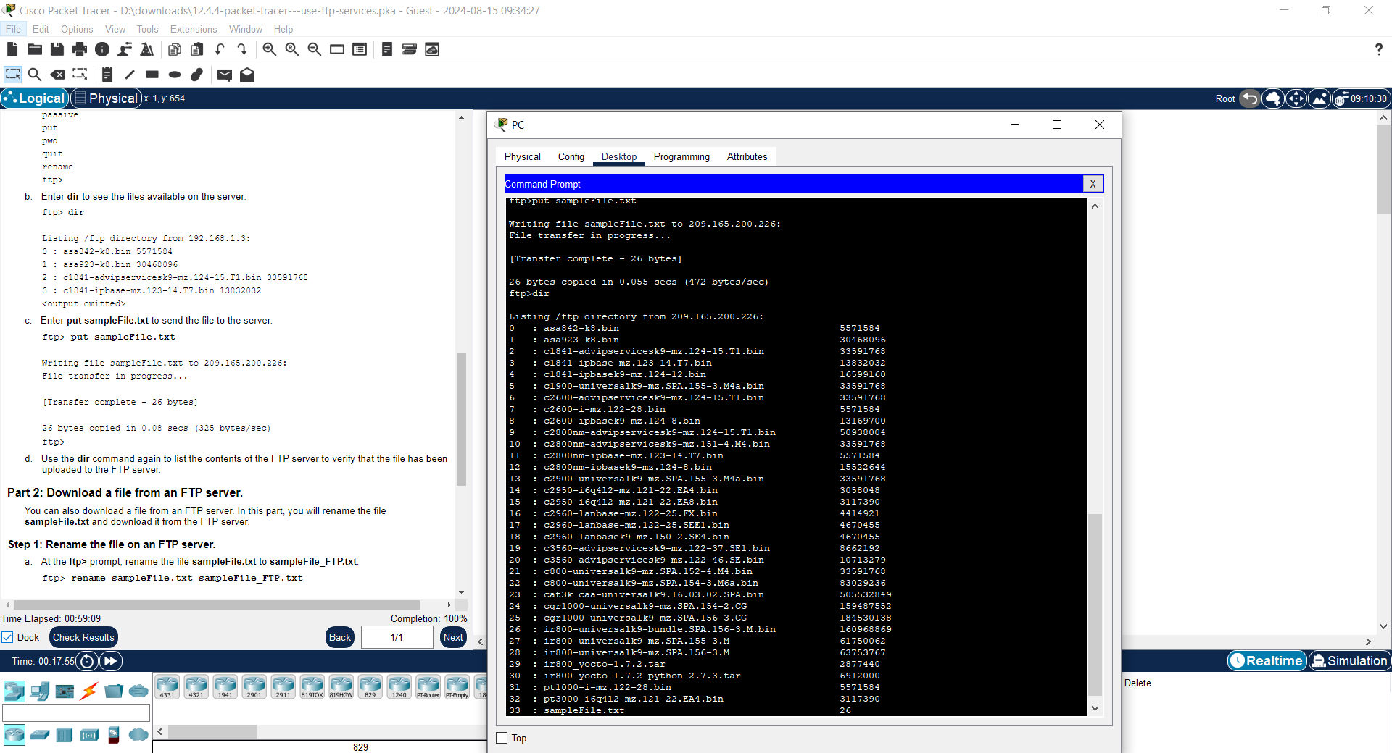

#### 

#### Part 2: Download a file from an FTP server.

You can also download a file from an FTP server. In this part, you will rename the file **sampleFile.txt** and download it from the FTP server.

##### **Step 1: Rename the file on an FTP server.**

a. At the **ftp>** prompt, rename the file **sampleFile.txt** to **sampleFile_FTP.txt**.

b. At the **ftp>** prompt, enter **dir** to verify the file has been renamed.

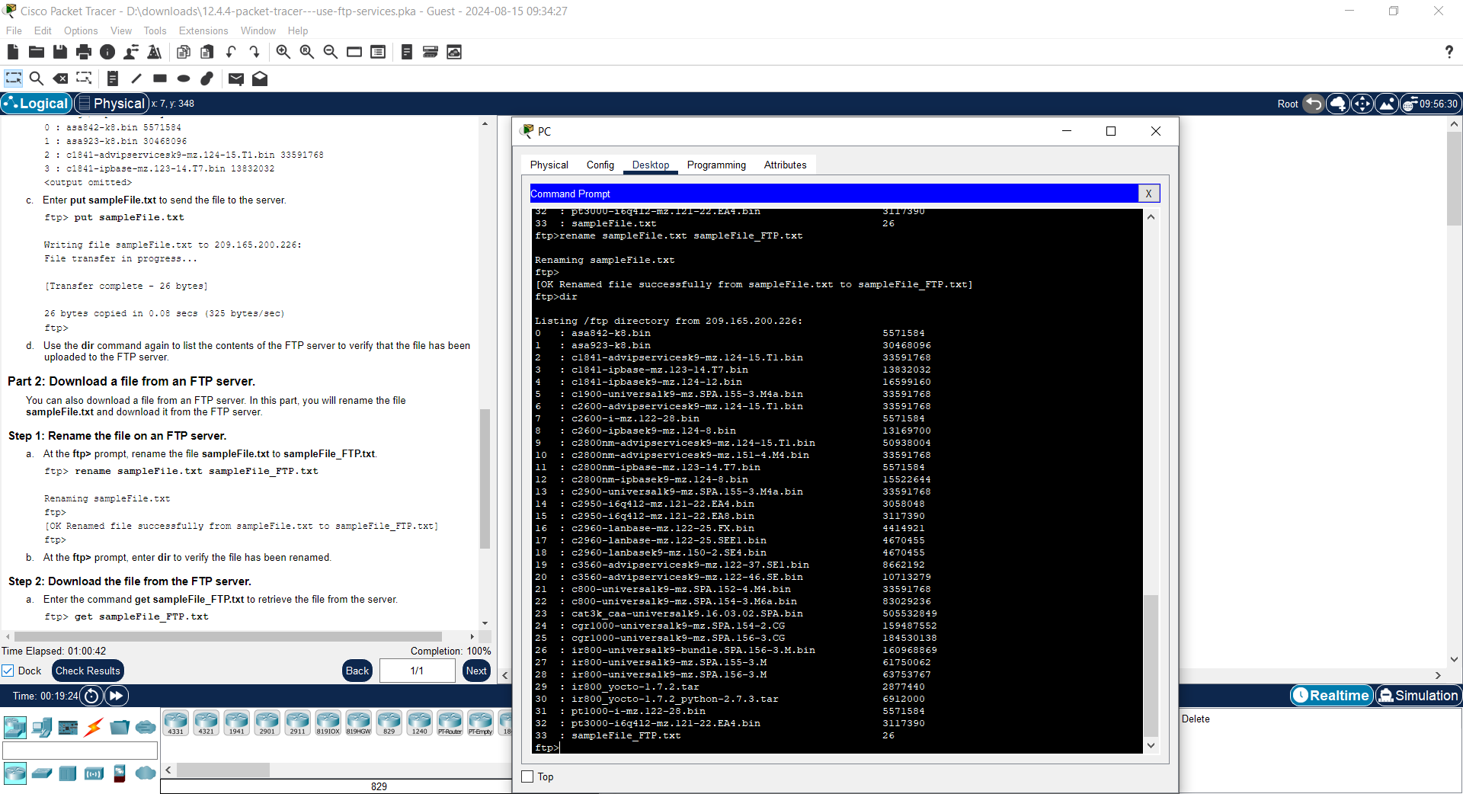

##### **Step 2: Download the file from the FTP server.**

a. Enter the command get **sampleFile_FTP.txt** to retrieve the file from the server.

b. Enter quit to exit the FTP client when finished.

c. Display the contents of the directory on the PC again to see the image file from the FTP server.

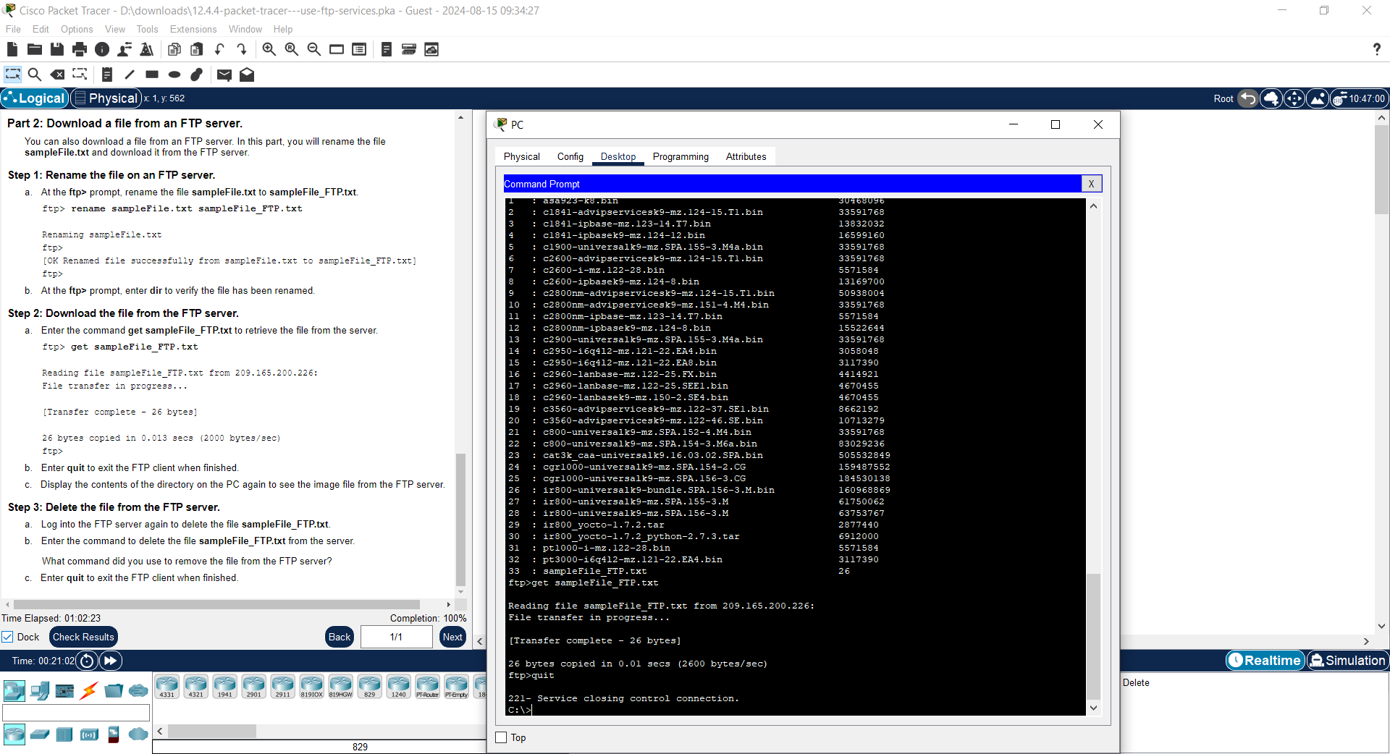

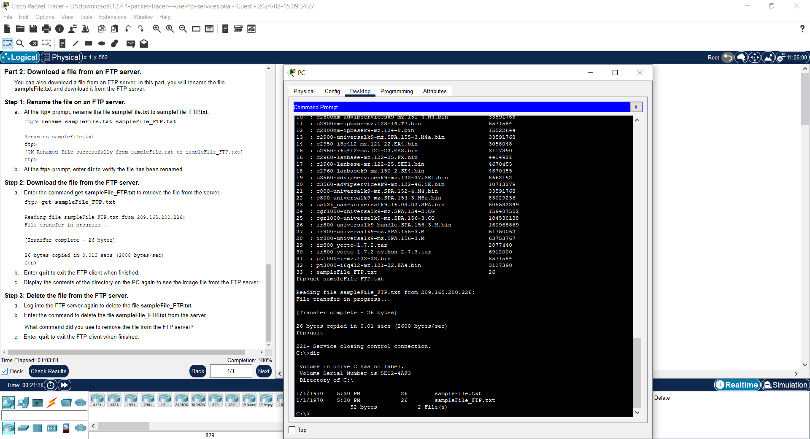

##### **Step 3: Delete the file from the FTP server.**

a. Log into the FTP server again to delete the file **sampleFile_FTP.txt**.

b. Enter the command to delete the file **sampleFile_FTP.txt** from the server.

What command did you use to remove the file from the FTP server?

ftp> delete sampleFile_FTP.txt

c. Enter **quit** to exit the FTP client when finished.

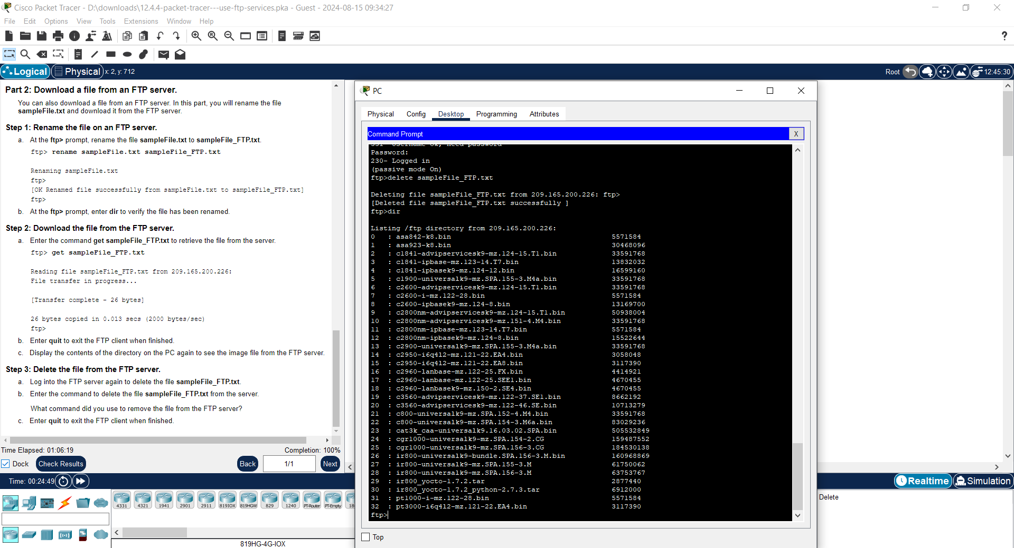

|  |  |
| --- | --- |
| **Date: 10/7/25** | **Title** |
| **Exp. No: 09** | **Packet Tracer – Use Telnet and SSH Answers** |

Addressing Table

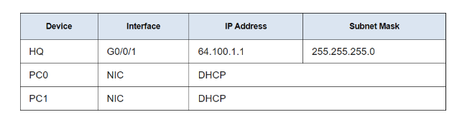

Objectives

In this activity, you will establish a remote connection to a router using Telnet and

SSH.

● Verify connectivity

● Access a remote device

Instructions

Part 1: Verify Connectivity

In this part, you will verify that the PC has IP addressing and can ping the remote

router.

Step 1: Verify IP address on a PC.

a. From a PC, click Desktop. Click Command Prompt.

b. At the prompt, verify that the PC has an IP address from DHCP.

What command did you use to verify the IP address from DHCP?

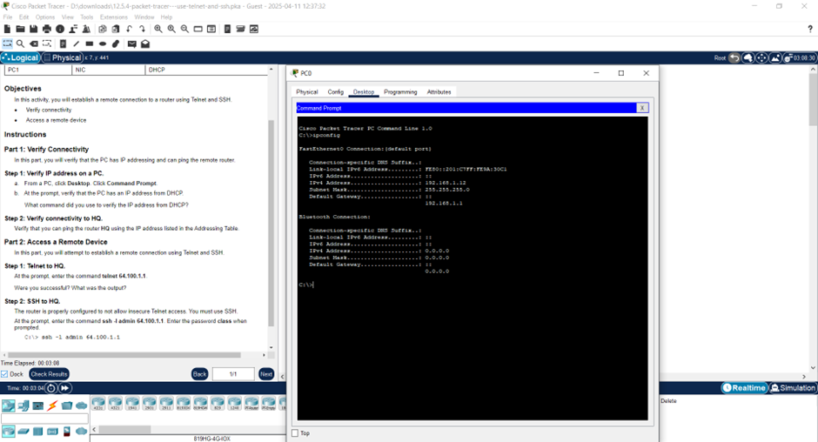

Step 2: Verify connectivity to HQ.

Verify that you can ping the router HQ using the IP address listed in the Addressing

Table.

Part 2: Access a Remote Device

In this part, you will attempt to establish a remote connection using Telnet and SSH.

Step 1: Telnet to HQ.

At the prompt, enter the command telnet 64.100.1.1.

Were you successful?

No

What was the output?

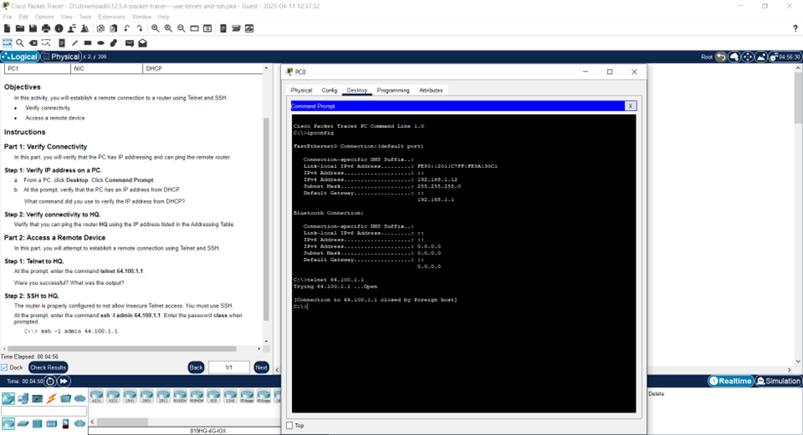

Step 2: SSH to HQ.

The router is properly configured to not allow insecure Telnet access. You must use

SSH. At the prompt, enter the command ssh -l admin 64.100.1.1. Enter the password

class when prompted.

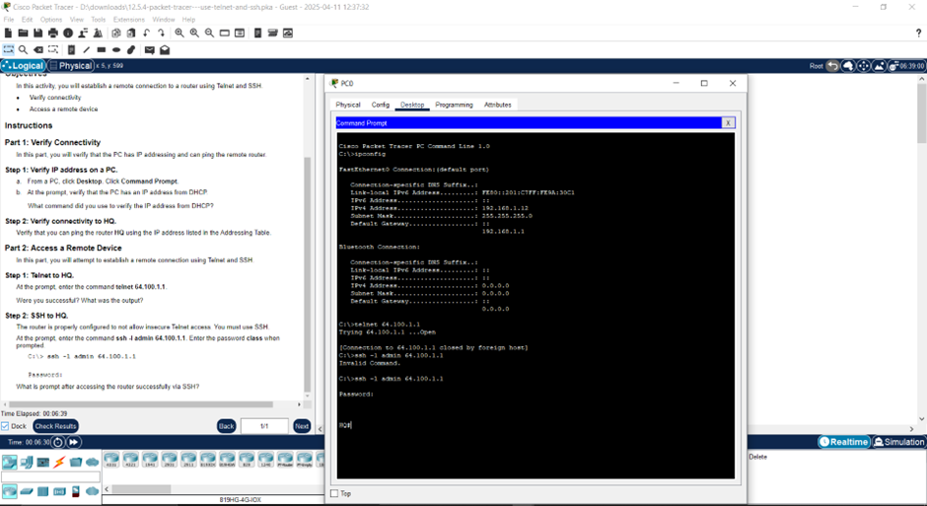

.What is prompt after accessing the router successfully via SSH?

HQ#

|  |  |
| --- | --- |
| Date: 10/7/25 | Title |
| Exp. No: 10 | Even Parity using Python Programming. |

Even Parity using Python Programming

Objectives:

To implement even parity bit generation and error detection using Python programming,

simulating the error detection mechanism used in computer networks to ensure data integrity

during transmission.

Procedure:

1. Input Phase:

o Accept a binary string as input from the user, which represents the original

data to be transmitted.

2. Parity Bit Calculation:

o Count the number of 1s in the binary string.

o If the number of 1s is even, assign a parity bit of 0.

o If the number of 1s is odd, assign a parity bit of 1.

o Append the calculated parity bit to the original binary string to form the

transmitted data.

3. Transmission Simulation:

o Accept another binary string as the received data (this can be manually entered

or simulated).

4. Error Detection:

o Count the number of 1s in the received binary string (including the parity bit).

o If the count is even, the data is considered valid (no error detected).

o If the count is odd, it indicates an error occurred during transmission.

**Code:**

def calculate_even_parity(data):

ones_count = data.count('1')

parity_bit = '0' if ones_count % 2 == 0 else '1'

return data + parity_bit

def check_even_parity(data_with_parity):

ones_count = data_with_parity.count('1')

return ones_count % 2 == 0

data = input("Enter binary data (e.g. 10101): ")

encoded_data = calculate_even_parity(data)

print("Data with even parity bit added:", encoded_data)

received_data = input("Enter received data: ")

if check_even_parity(received_data):

print("No error detected. Data is valid.")

else:

print("Error detected in received data.")

**Output:**

With error:

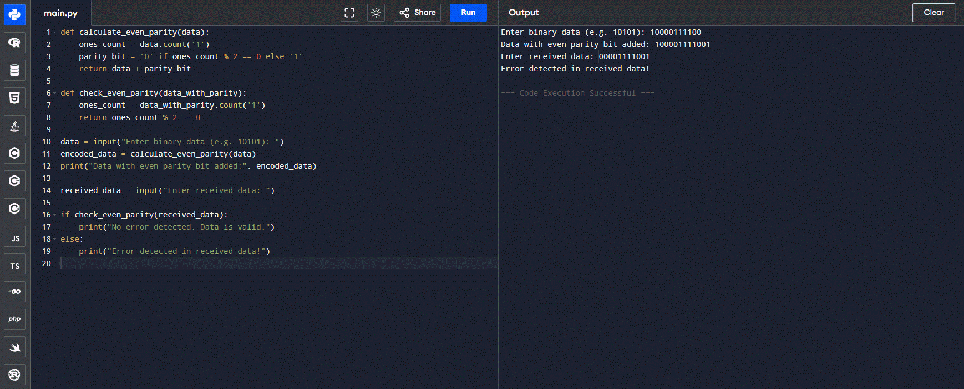

Without error:

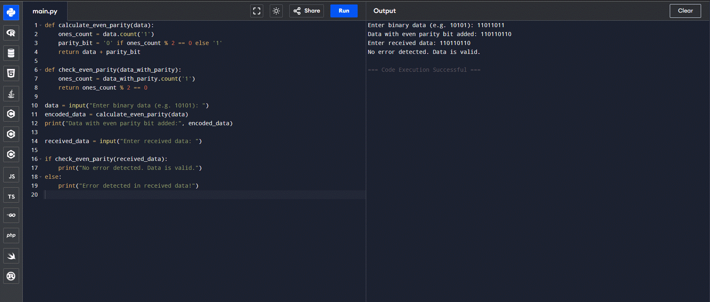

**Observation:**

Original Data: 11011011

Step 1 – Count the number of 1s:

* 1 + 1 + 0 + 1 + 1 + 0 + 1 + 1 = 6 ones

Step 2 – Determine Even Parity Bit:

* Since the number of 1s is already even (6), the parity bit = 0

Step 3 – Transmitted Data with Parity Bit:

* 11011011 + 0 = 110110110

Case A – Received Correctly (No Error):

* Received Data: 110110110
* Number of 1s: 6 → Even
* Result: No error detected. Data is valid.

Case B – Error in Transmission (e.g., 100110110):

* Received Data: 100110110
* Number of 1s: 5 → Odd
* Result: Error detected in received data.

**Result:**

The program successfully implemented even parity bit generation and error detection. It was able to identify whether the received binary data contained an error based on the parity condition.

**Conclusion:**

Even parity is a simple and effective error detection technique that can be implemented using basic Python operations. This program demonstrates how even parity can be used to detect single-bit errors in binary data transmission

|  |  |
| --- | --- |
| Date: 10/7/25 | Title |
| Exp. No: 11 | Odd Parity using Python Programming |

**Title:**

Odd Parity using Python Programming

**Objectives**:

To implement odd parity bit generation and error detection using Python programming, simulating the error detection mechanism used in computer networks to verify data integrity during transmission.

**Procedure:**

**Input Phase:**

* Accept a binary string from the user representing the data to be transmitted.

**Parity Bit Calculation:**

* Count the number of 1s in the binary string.
* If the number of 1s is **odd**, append a parity bit of 0 to maintain odd parity.
* If the number of 1s is **even**, append a parity bit of 1 to make the total count odd.

**Transmission Simulation:**

* Accept a binary string simulating the received data (manually or programmatically).

**Error Detection:**

* Count the number of 1s in the received string (including the parity bit).
* If the total count of 1s is odd, it means the data is valid.
* If the total count of 1s is even, an error is detected in the transmission.

**Code:**

def calculate_odd_parity(data):

ones_count = data.count('1')

parity_bit = '0' if ones_count % 2 != 0 else '1'

return data + parity_bit

def check_odd_parity(data_with_parity):

ones_count = data_with_parity.count('1')

return ones_count % 2 != 0

data = input("Enter binary data (e.g. 1101): ")

encoded_data = calculate_odd_parity(data)

print("Data with odd parity bit added:", encoded_data)

received_data = input("Enter received data: ")

if check_odd_parity(received_data):

print("No error detected. Data is valid.")

else:

print("Error detected in received data.")

**Output:**

With error:

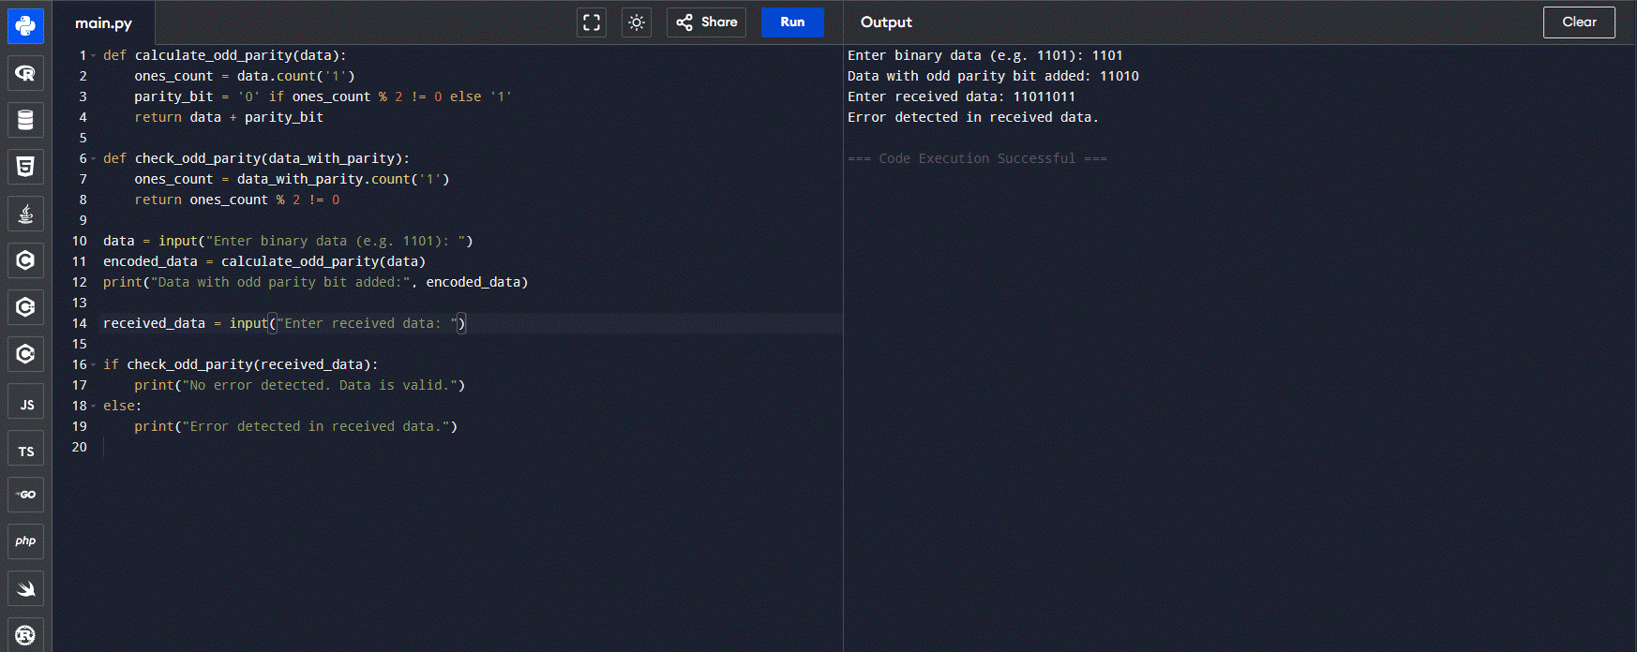

Without error:

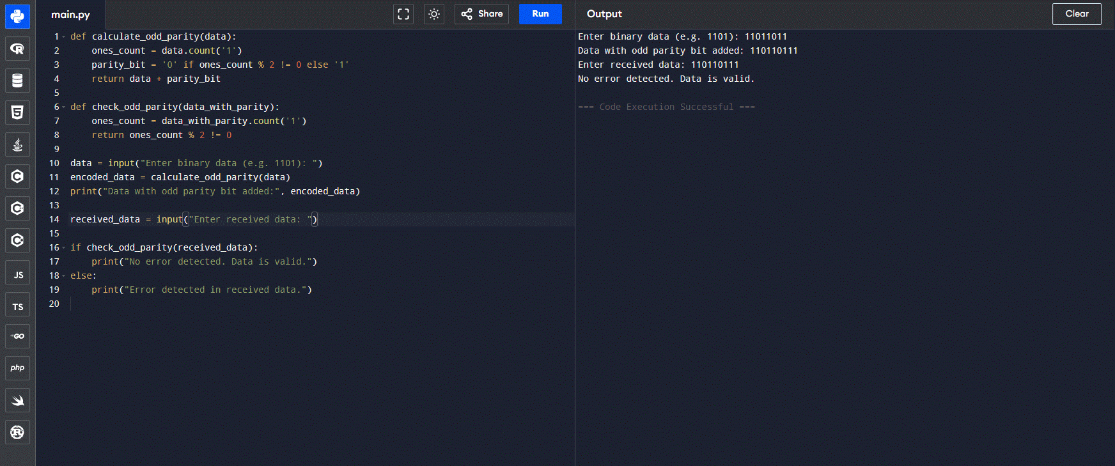

**Observation:**

**Input Data:** 1101

* Number of 1s = 3 (odd)
* Parity bit = 0 (to maintain odd count)
* Transmitted Data = 11010

**Case A – Received as 11010:**

* Number of 1s = 3 → Odd
* Result: No error detected

**Case B – Received as 10010:**

* Number of 1s = 2 → Even
* Result: Error detected

**Result:**

The program successfully generated odd parity bits and detected transmission errors based on odd parity checking.

**Conclusion:**

Odd parity is a basic and reliable method for detecting single-bit transmission errors in computer networks. This Python program demonstrates the process of appending parity bits and validating received data

|  |  |
| --- | --- |
| Date: 10/7/25 | Title |
| Exp. No: 12 | 2D Parity/LRC using Python Programming |

**Title:**

2D Parity/LRC using Python Programming

**Objectives**:

To implement 2D Parity or Longitudinal Redundancy Check (LRC) using Python programming to detect transmission errors in blocks of binary data by applying parity bits both row-wise and column-wise.

**Procedure:**

1. **Input Phase:**
   * Accept a block of binary data as multiple binary strings (rows), each of equal length.
2. **Row-wise Parity Calculation:**
   * For each row, calculate the number of 1s.
   * If the count is even, append 0 (even parity); if odd, append 1 (to make it even).
3. **Column-wise Parity Calculation (LRC):**
   * For each bit position across all rows (i.e., column-wise), count the number of 1s.
   * If the count is even, append 0; if odd, append 1 — this forms the **LRC row**.
4. **Transmission:**
   * The transmitted data includes the original data with row parities and the final LRC row.
5. **Error Detection:**
   * At the receiver's end, the parity of all rows and all columns (including LRC) is checked.
   * If any row or column has odd parity, an error is detected.

**Code:**

def calculate_row_parity(matrix):

return [row + ['0'] if row.count('1') % 2 == 0 else row + ['1'] for row in matrix]

def calculate_column_parity(matrix):

num_cols = len(matrix[0])

lrc_row = []

for col in range(num_cols):

col_bits = [matrix[row][col] for row in range(len(matrix))]

lrc_bit = '0' if col_bits.count('1') % 2 == 0 else '1'

lrc_row.append(lrc_bit)

return lrc_row

def display_matrix(matrix):

for row in matrix:

print(' '.join(row))

def check_parity(matrix):

rows = len(matrix)

cols = len(matrix[0])

row_error = False

col_error = False

for i in range(rows - 1):

if matrix[i].count('1') % 2 != 0:

print(f"Row {i+1} has parity error.")

row_error = True

for j in range(cols):

col_bits = [matrix[i][j] for i in range(rows)]

if col_bits.count('1') % 2 != 0:

print(f"Column {j+1} has parity error.")

col_error = True

if not row_error and not col_error:

print("No error detected. Data is valid.")

else:

print("Error detected in received data.")

rows = int(input("Enter number of data rows: "))

cols = int(input("Enter number of bits per row: "))

data_matrix = []

print("Enter binary data row by row:")

for i in range(rows):

row = list(input(f"Row {i+1}: ").strip())

data_matrix.append(row)

data_with_row_parity = calculate_row_parity(data_matrix)

lrc_row = calculate_column_parity(data_with_row_parity)

data_with_row_parity.append(lrc_row)

print("\nTransmitted Data (with row and column parity):")

display_matrix(data_with_row_parity)

print("\nEnter received data (including row and column parity):")

received_matrix = []

for i in range(rows + 1):

row = list(input(f"Row {i+1}: ").strip())

received_matrix.append(row)

print("\nReceived Matrix:")

display_matrix(received_matrix)

print("\nChecking for errors...")

check_parity(received_matrix)

**Output:**

With error:

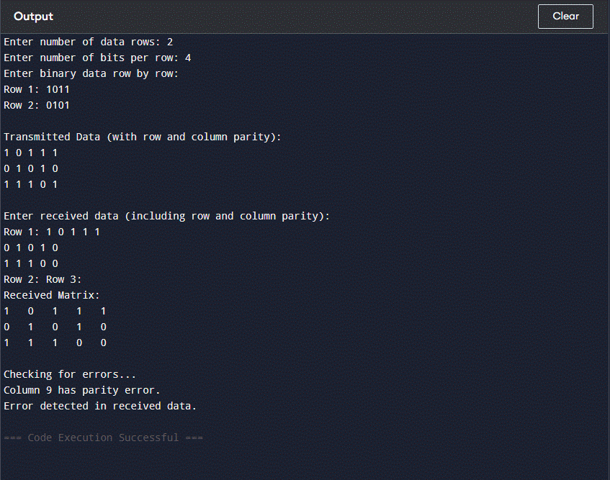

Without error:

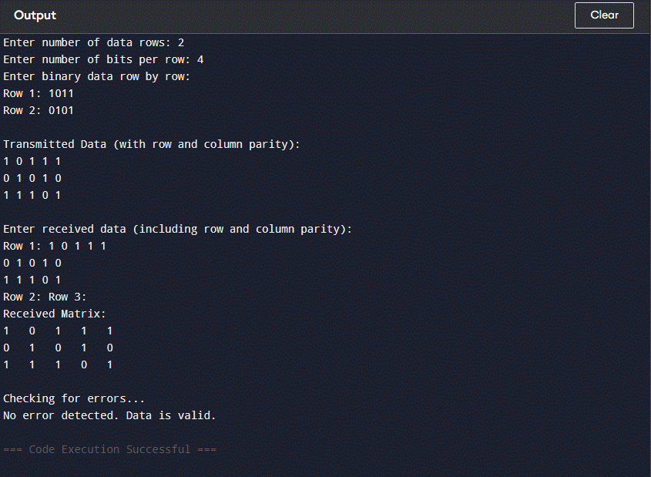

**Observation:**

Input Data (Without Parity):

Row 1: 1 0 1 1

Row 2: 0 1 0 1

After Adding Row Parity (Even Parity):

* Row 1: Number of 1s = 3 → odd → Append 1 to make even
* Row 2: Number of 1s = 2 → even → Append 0

Row 1: 1 0 1 1 1

Row 2: 0 1 0 1 0

Column Parity (LRC Row – Even Parity for Each Column):

* Column 1: 1 + 0 = 1 → odd → Parity bit = 1
* Column 2: 0 + 1 = 1 → odd → Parity bit = 1
* Column 3: 1 + 0 = 1 → odd → Parity bit = 1
* Column 4: 1 + 1 = 2 → even → Parity bit = 0
* Column 5: 1 + 0 = 1 → odd → Parity bit = 1

LRC: 1 1 1 0 1

Final Transmitted Matrix with 2D Parity:

Row 1: 1 0 1 1 1

Row 2: 0 1 0 1 0

LRC: 1 1 1 0 1

**Result:**

The program successfully implemented 2D parity (LRC) by appending parity bits row-wise and column-wise to the data matrix, allowing detection of single-bit errors during transmission.

**Conclusion:**

2D Parity or Longitudinal Redundancy Check (LRC) is an effective method for detecting single-bit and some multi-bit errors in transmitted data blocks. This Python program demonstrates how to generate parity bits row-wise and column-wise, helping ensure data integrity in communication systems.

|  |  |
| --- | --- |
| Date: 10/7/25 | Title |
| Exp. No: 13 | CRC using Python Programming |

**Title:**

CRC using Python Programming

**Objectives**:

To implement a CRC (Cyclic Redundancy Check) error detection algorithm using Python to verify data integrity during transmission and identify transmission errors.

**Procedure:**

**Input:**

* **Accept the data bits (binary string) to be transmitted.**
* **Accept the generator polynomial (also as a binary string).**

**Appending Zeros:**

* **Append (length of generator polynomial - 1) zeros to the data bits to prepare for CRC computation.**

**Modulo-2 Division:**

* **Perform bitwise XOR (mod-2 division) of the appended data and the generator polynomial.**
* **The XOR operation is repeated until the entire data is processed.**

**Remainder (CRC):**

* **The remainder after division is the CRC.**
* **Append this remainder to the original data bits to form the final transmitted codeword.**

**Error Checking:**

* **Accept the received codeword from the user.**
* **Perform the same XOR division with the generator polynomial.**
* **If the remainder is all zeros, no error is detected; otherwise, an error is present.**

**Code:**

def xor(a, b):

result = ''

for i in range(1, len(b)):

result += '0' if a[i] == b[i] else '1'

return result

def mod2div(dividend, divisor):

pick = len(divisor)

tmp = dividend[0:pick]

while pick < len(dividend):

if tmp[0] == '1':

tmp = xor(divisor, tmp) + dividend[pick]

else:

tmp = xor('0'*pick, tmp) + dividend[pick]

pick += 1

if tmp[0] == '1':

tmp = xor(divisor, tmp)

else:

tmp = xor('0'*pick, tmp)

return tmp

def encodeData(data, key):

l_key = len(key)

appended_data = data + '0'*(l_key-1)

remainder = mod2div(appended_data, key)

codeword = data + remainder

return codeword

data = input("Enter data bits: ")

key = input("Enter generator polynomial: ")

codeword = encodeData(data, key)

print("Transmitted codeword:", codeword)

received = input("Enter received codeword: ")

remainder = mod2div(received, key)

if '1' in remainder:

print("Error detected in received data.")

else:

print("No error detected. Data is correct.")

**Output:**

With error:

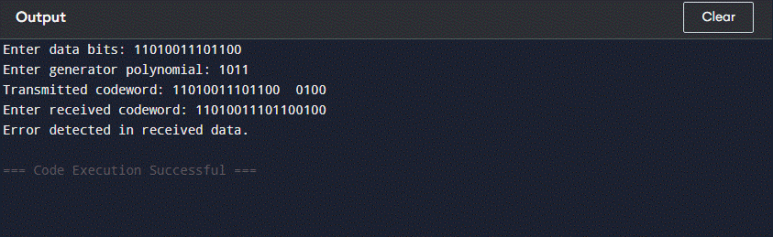

Without error:

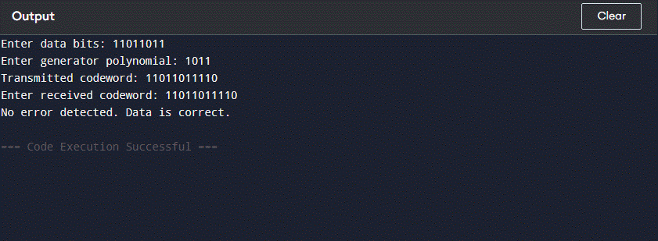

**Observation:**

Inputs:  
 Data Bits: 11010011101100

Generator Polynomial: 1011

Step 1 – Appending Zeros:

Appended Data: 11010011101100000

Step 2 – Mod-2 Division:

* Performing binary division yields the remainder: 100

Step 3 – Final Transmitted Codeword:

Codeword: 11010011101100100

Received: 11010011101100100

Remainder: 000 → No error detected

Received: 11011011101100100

Remainder: Non-zero → Error detected

**Result:**

The CRC algorithm was successfully implemented using Python. It generated a reliable codeword by appending a CRC checksum to the original data. The receiver was able to detect whether the data received was error-free or corrupted using the same generator polynomial.

**Conclusion:**

The Cyclic Redundancy Check method is a highly effective error-detection technique used in digital communications. Through Python implementation, the concept of polynomial division (mod-2 arithmetic) was demonstrated, ensuring data integrity in transmission. The CRC method successfully detected errors in altered codewords.

|  |  |
| --- | --- |
| Date: 11/7/25 | Title |
| Exp. No: 14 | Checksum using Python Programming |

**Checksum using Python Programming**

**Objectives**:

To implement the checksum error detection technique using Python to ensure data integrity and detect errors during transmission.

**Procedure:**

1. **Input Data:**
   * Enter the binary data string to be transmitted.
   * Specify the block size for segmentation.
2. **Padding (if needed):**
   * Pad the data with leading zeros so that its length becomes a multiple of the block size.
3. **Block-wise Addition:**
   * Divide the data into blocks of the given size.
   * Add all blocks using binary addition.
   * If a carry occurs beyond the block size, wrap it around and add again.
4. **Checksum Calculation:**
   * Perform bitwise 1's complement on the final sum to get the checksum.
   * Append the checksum to the original data for transmission.
5. **Verification:**
   * At the receiver's end, perform the same procedure (including checksum).
   * If the final sum (including checksum) results in all zeros after complementing, the data is considered error-free.

**Code:**

def calculate_checksum(data, block_size):

n = len(data)

if n % block_size != 0:

data = data.zfill(n + (block_size - n % block_size))

blocks = [data[i:i+block_size] for i in range(0, len(data), block_size)]

result = 0

for block in blocks:

result += int(block, 2)

while result >> block_size:

result = (result & ((1 << block_size) - 1)) + (result >> block_size)

checksum = ''.join('1' if bit == '0' else '0' for bit in bin(result)[2:].zfill(block_size))

return checksum

def verify_checksum(data, checksum, block_size):

full_data = data + checksum

return calculate_checksum(full_data, block_size) == '0' * block_size

data = input("Enter binary data: ")

block_size = int(input("Enter block size: "))

checksum = calculate_checksum(data, block_size)

print("Calculated Checksum:", checksum)

received = input("Enter received data (without checksum): ")

received_checksum = input("Enter received checksum: ")

if verify_checksum(received, received_checksum, block_size):

print("No error detected. Data is correct.")

else:

print("Error detected in the received data.")

**Output:**

With error:

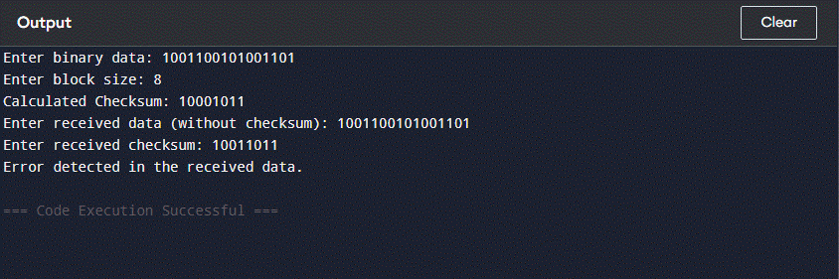

Without error:

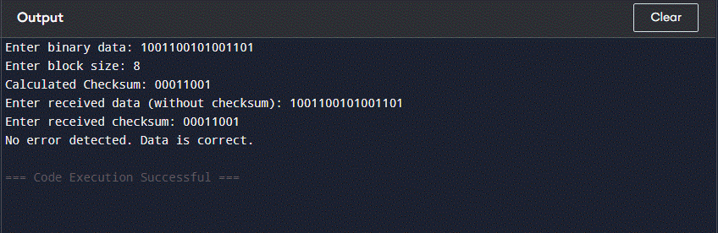

**Observation:**

Inputs:

Data: 1001100101001101

Block Size: 8

Step 1 – Data Blocks:

Block 1: 10011001

Block 2: 01001101

Sum: 11100110

Step 2 – Checksum (1’s complement of sum):

Checksum: 00011001

Transmitted Data + Checksum:

100110010100110100011001

Receiver Side – Verification: Add all three 8-bit blocks. Resulting sum = 11111111 → Complement = 00000000 → No error detected

**Result:**

The checksum technique was successfully implemented. The program calculated the checksum at the sender side, and verified it at the receiver side. Errors in transmission were accurately detected by comparing the recalculated checksum.

**Conclusion:**

The **Checksum error detection method** is a simple yet effective way to detect errors in digital data transmission. Through Python programming, it was demonstrated that the checksum detects errors by checking the integrity of the transmitted data, ensuring reliable communication.

|  |  |
| --- | --- |
| Date:11/7/25 | Title |
| Exp. No: 15 | Simulate Networking Devices using CPT |

### Objectives

* To understand the working of different networking devices: **Hub**, **Switch**, **Bridge**, **Router**, and **Repeater**.
* To simulate these devices using **Cisco Packet Tracer (CPT)** and analyze their behaviors.

### Theory

#### 1. Hub

A **Hub** is a basic networking device that connects multiple computers in a LAN. It operates at the **physical layer** (Layer 1) of the OSI model and simply forwards incoming data to all other ports without any intelligence or filtering.

#### 2. Switch

A **Switch** operates at the **data link layer** (Layer 2). It is more intelligent than a hub and forwards data only to the destination device based on MAC addresses.

#### 3. Bridge

A **Bridge** is used to divide a network into segments and reduce traffic. It operates at **Layer 2** and filters traffic based on MAC addresses. Bridges are mostly replaced by modern switches.

#### 4. Router

A **Router** operates at the **network layer** (Layer 3). It connects different networks together and routes data based on **IP addresses**.

#### 5. Repeater

A **Repeater** amplifies and retransmits the signal to extend the range of a network. It works at **Layer 1** and is commonly used in long-distance connections.

### Instructions

#### Part 1: Simulating Hub

#### Open Packet Tracer.

#### Drag and drop 4 PCs and a Hub.

#### Connect all PCs to the Hub using copper straight-through cables.

#### Assign IP addresses (e.g., 192.168.1.1 to 192.168.1.4).

#### 

#### 

#### Test communication with ping command between PCs.

1. Click **PC0** → Desktop → Command Prompt.
2. Type the following command and press **Enter**:

ping 192.168.0.2

ping 192.168.0.3

ping 192.168.0.4

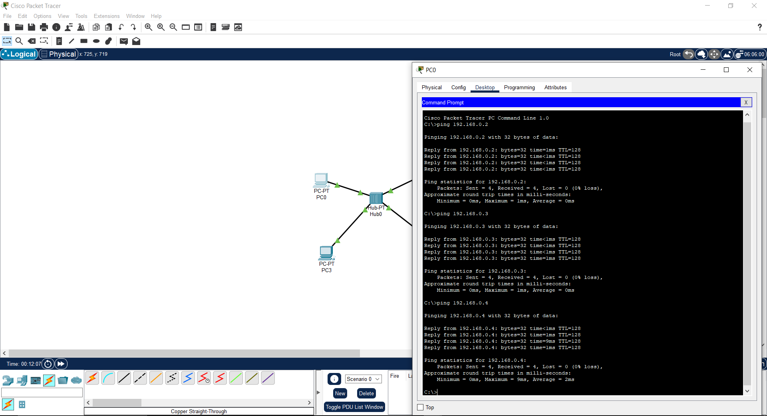

#### Part 2: Simulating a Switch

#### Topology Objective

Connect multiple PCs via a switch and verify how the switch filters frames and sends them only to the destination MAC.

#### Steps

1. **Open Packet Tracer**.
2. **Drag and drop:**
   * 1 Switch (e.g., 2960)
   * 3 PCs
3. **Connect PCs to Switch**:  
   * PC0 → Switch Port FastEthernet0/1
   * PC1 → Switch Port FastEthernet0/2
   * PC2 → Switch Port FastEthernet0/3

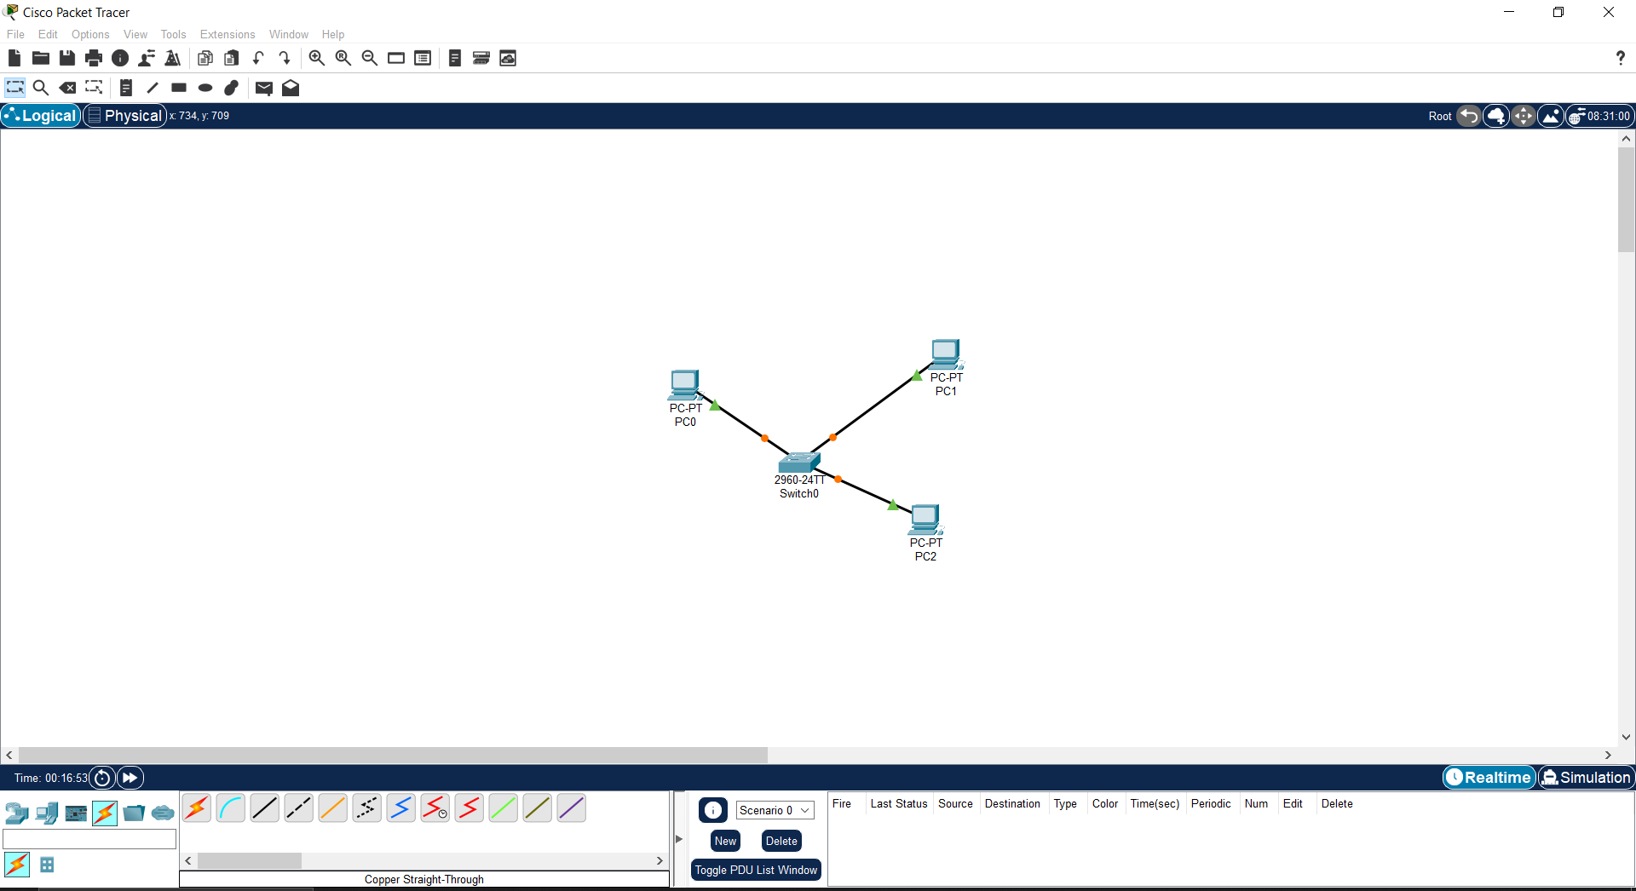

1. **Assign IP Addresses** (same subnet as before):  
   * PC0: 192.168.0.1
   * PC1: 192.168.0.2
   * PC2: 192.168.0.3

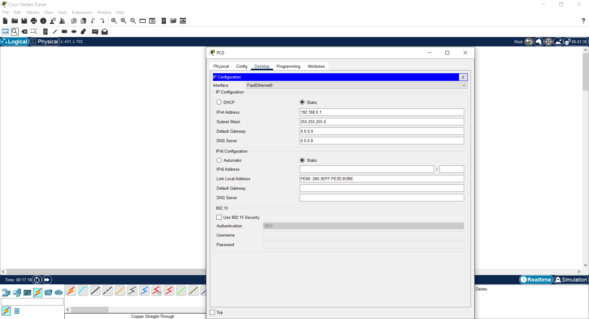

1. **Test with Ping**:  
   * Use PC0’s terminal to ping PC1 and PC2.
   * Observe **only targeted PCs** receive the frame — no broadcasting like a hub.

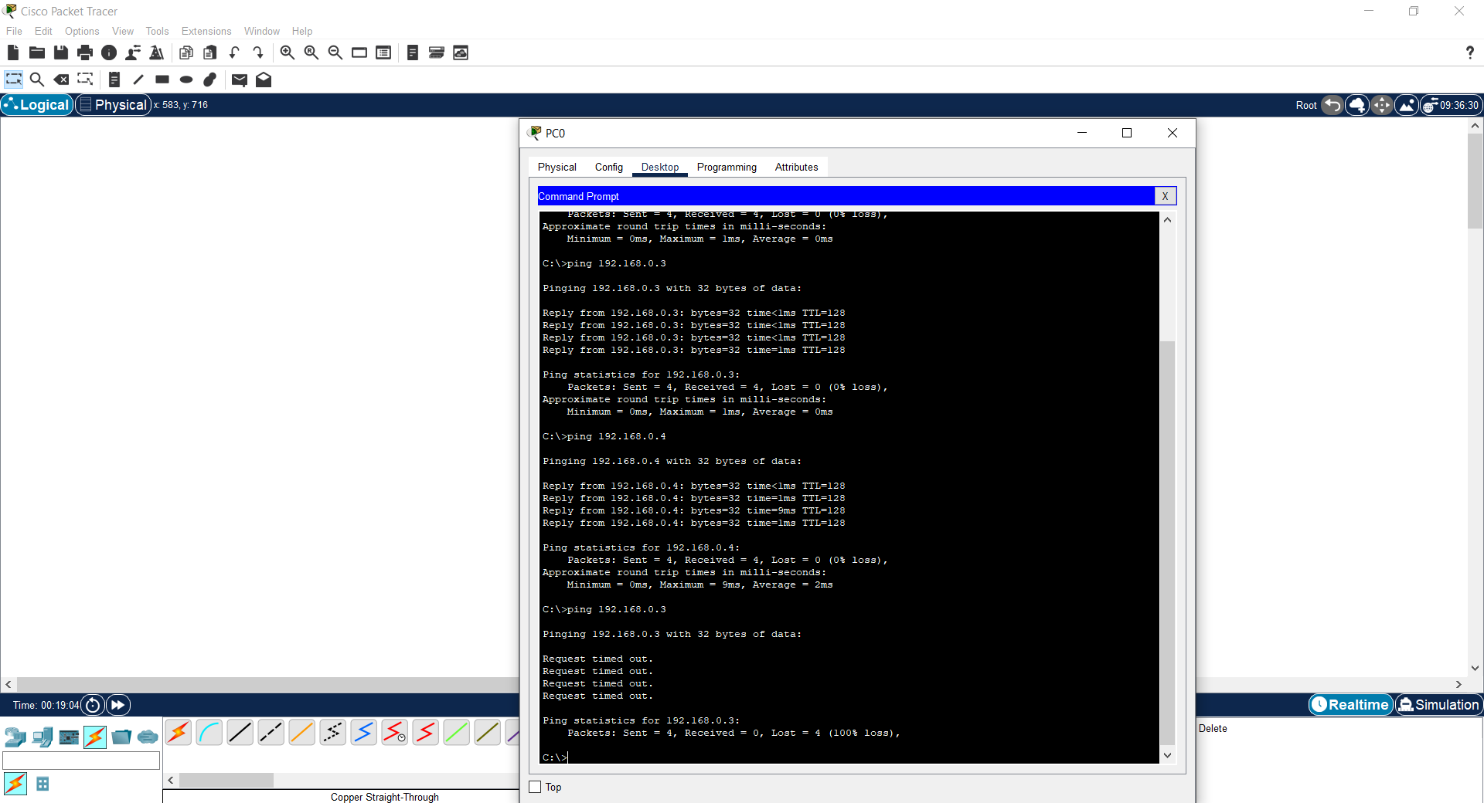

#### Part 3: Simulating a Bridge

#### Topology Objective

Create two segments connected by a bridge to filter traffic between them.

#### Steps

1. **Open Packet Tracer**.
2. **Drag and drop:**
   * 2 Switches
   * 4 PCs (2 on each side)
3. **Connections:**
   * PC0 → Switch1
   * PC1 → Switch1
   * PC2 → Switch2
   * PC3 → Switch2
   * Connect Switch0 Port FastEthernet0/24 → Switch1 Port FastEthernet0/24 (this is your **bridge link**)

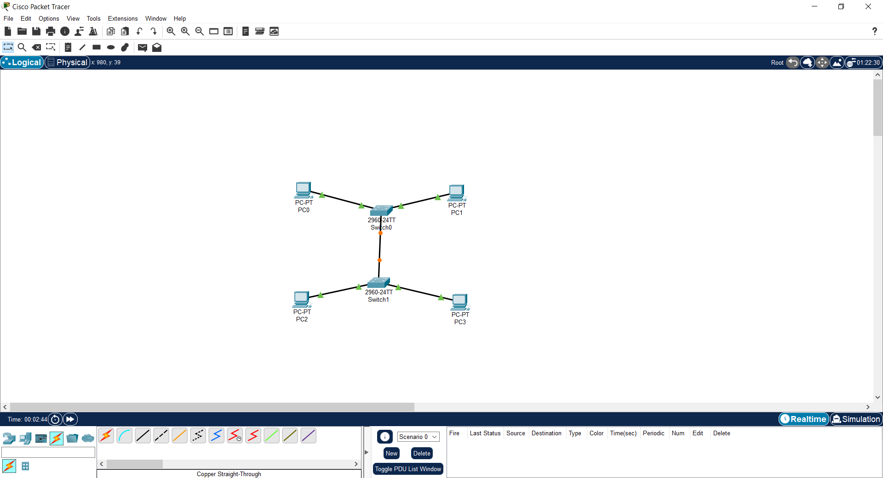

1. **IP Configuration**:  
   * All PCs on same network: 192.168.1.x

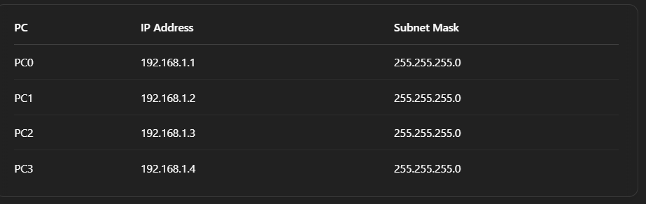

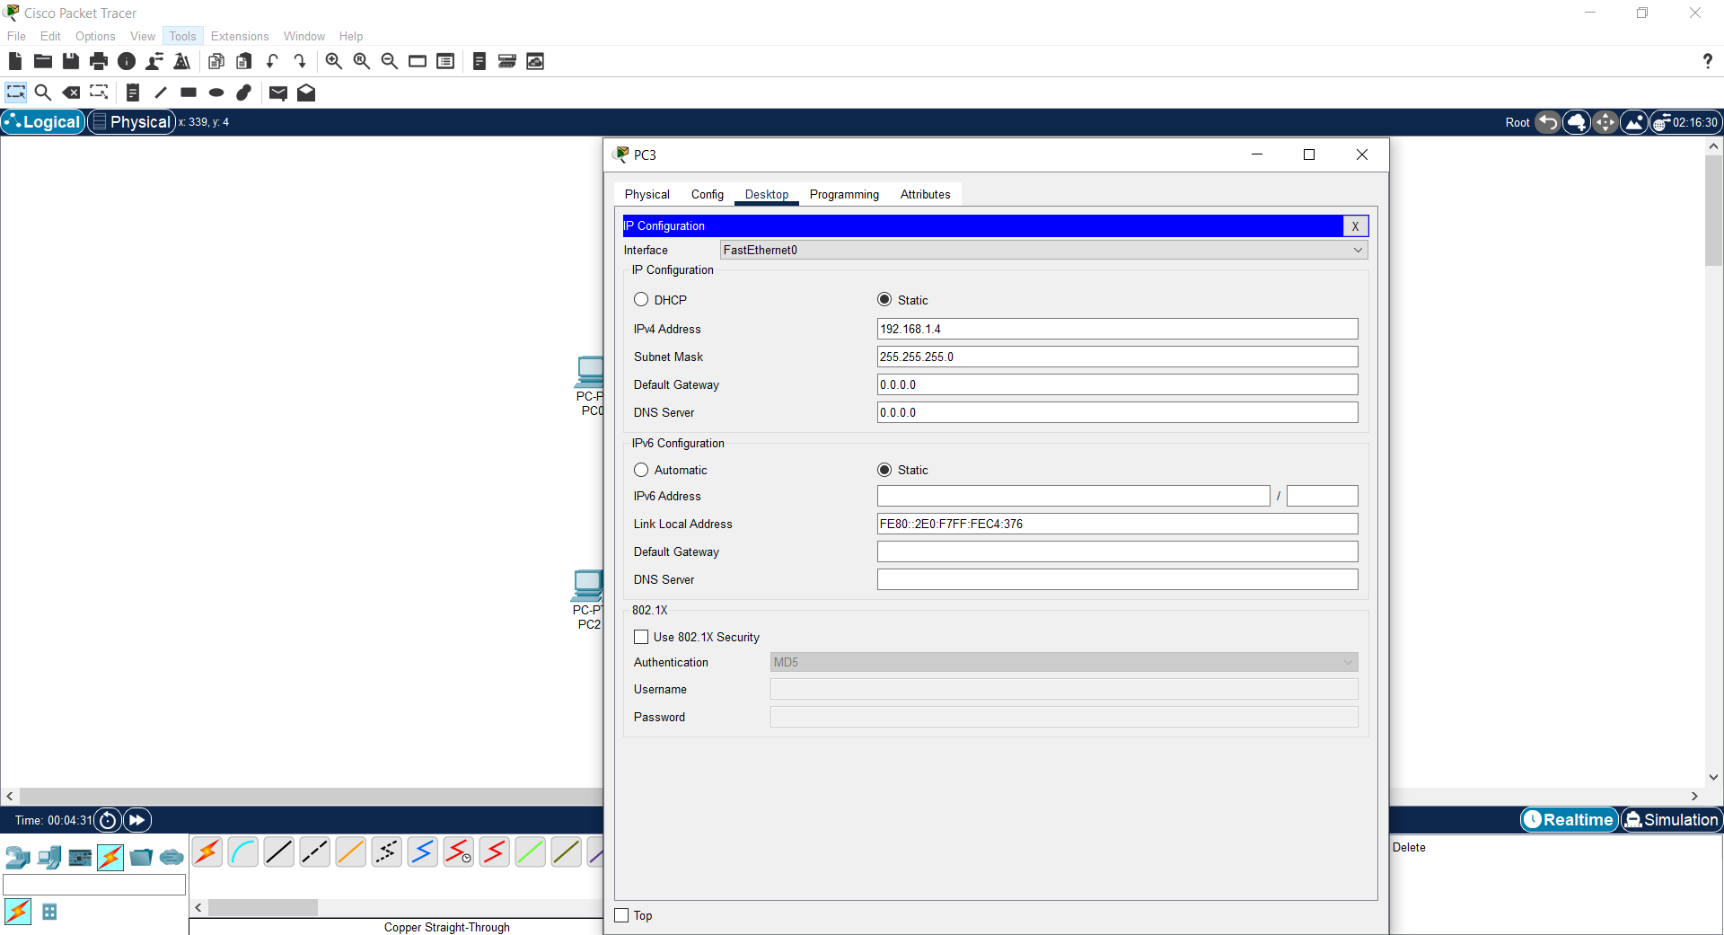

1. **Ping Tests**:  
   * Ping from PC0 to PC1 (same switch) → should work.

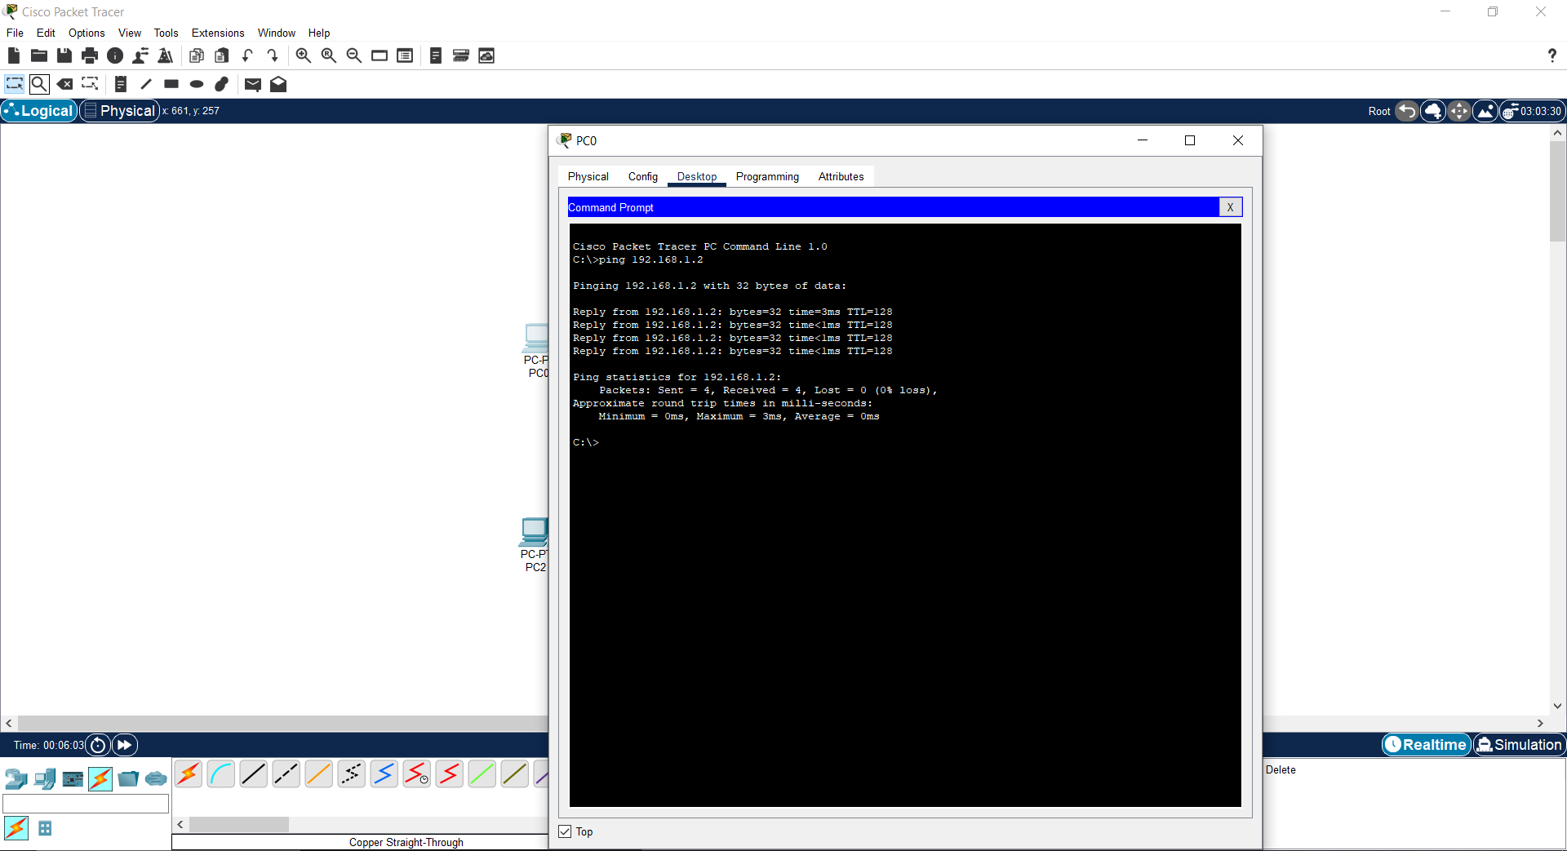

* + Ping from PC0 to PC2 → filtered/forwarded through bridge.

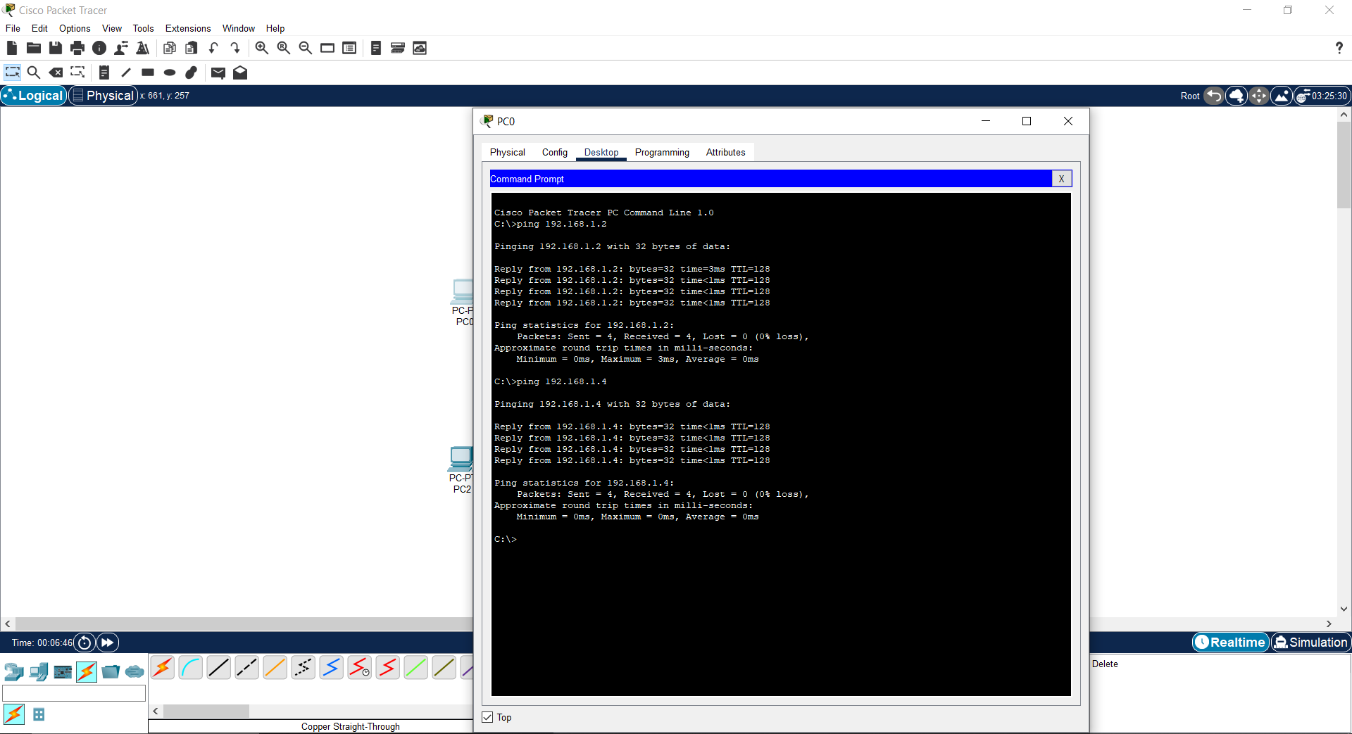

1. **Simulation Mode**:  
   * Use simulation mode to watch how the bridge forwards or blocks based on MAC address learning.

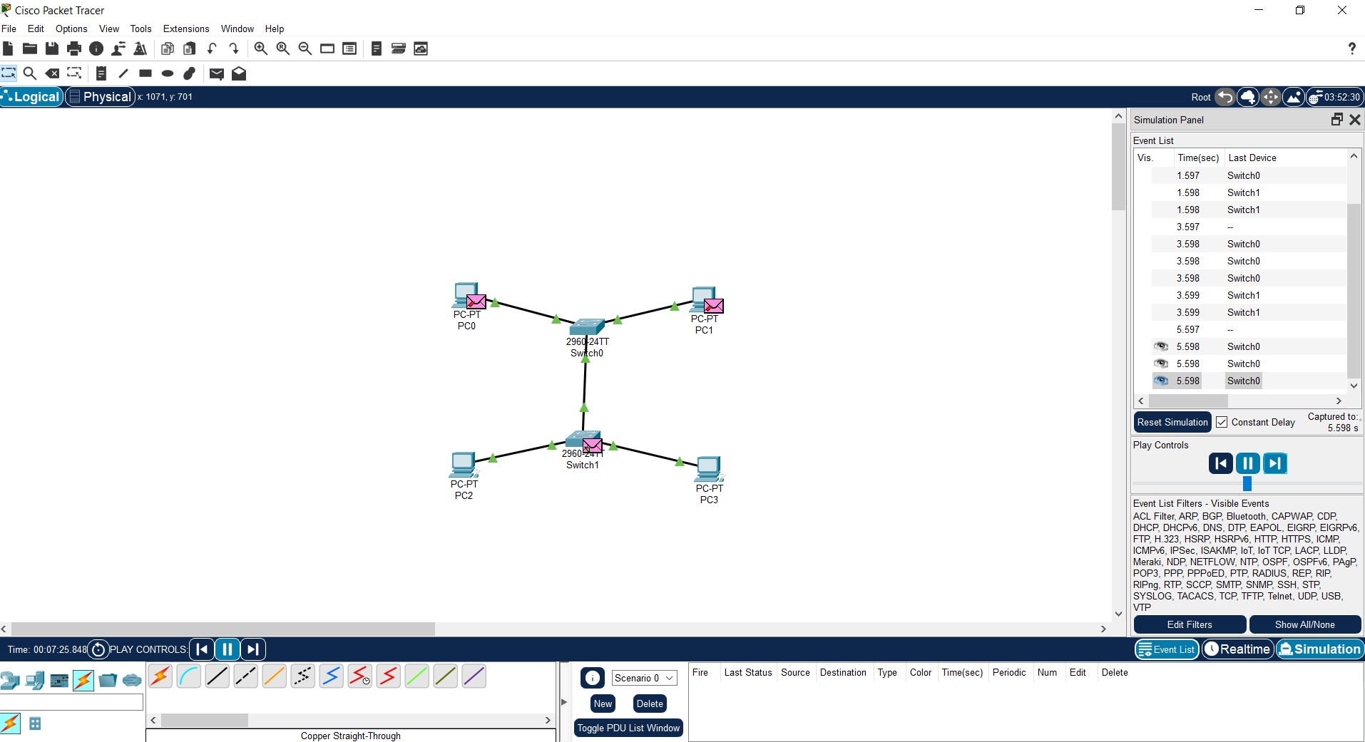

#### Part 4: Simulating a Router

#### Topology Objective

Create two different networks and connect them via a router.

#### Steps

1. **Drag and drop:**
   * 1 Router (e.g., 1841)
   * 2 Switches
   * 4 PCs (2 per switch)

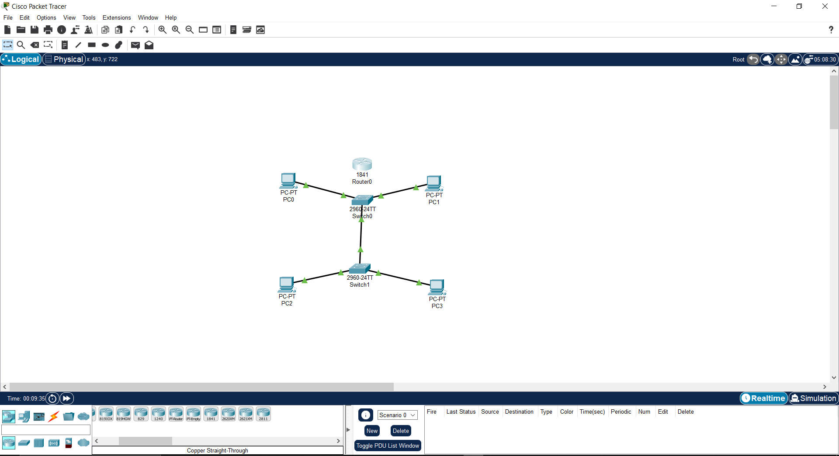

1. **Connections:**
   * PC0, PC1 → Switch1
   * PC2, PC3 → Switch2
   * Switch1 → Router FastEthernet0/0
   * Switch2 → Router FastEthernet0/1

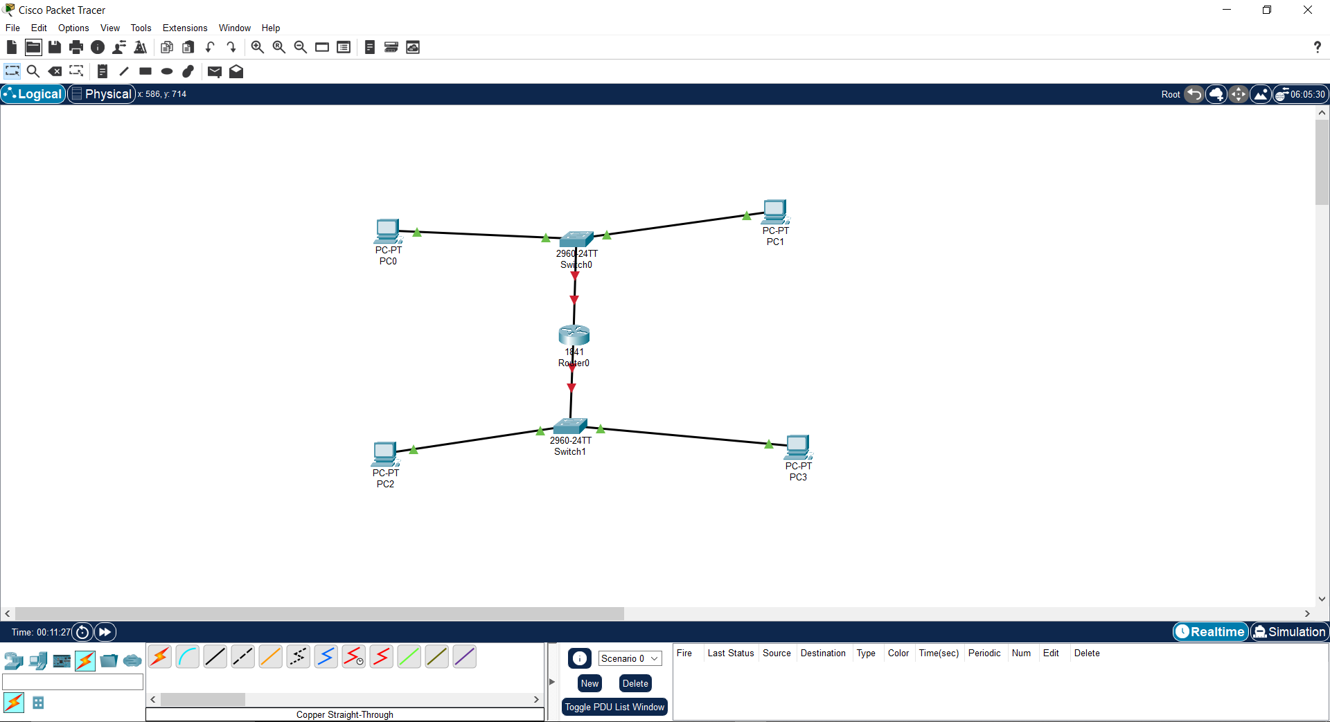

1. **Assign IP Addresses:**
   * PC0: 192.168.1.2, Gateway: 192.168.1.1
   * PC1: 192.168.1.3, Gateway: 192.168.1.1
   * PC2: 192.168.2.2, Gateway: 192.168.2.1
   * PC3: 192.168.2.3, Gateway: 192.168.2.1

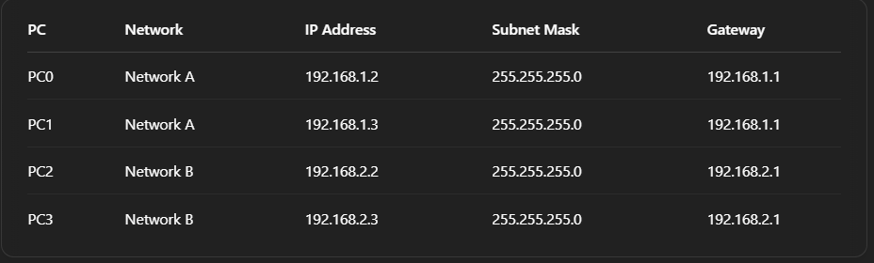

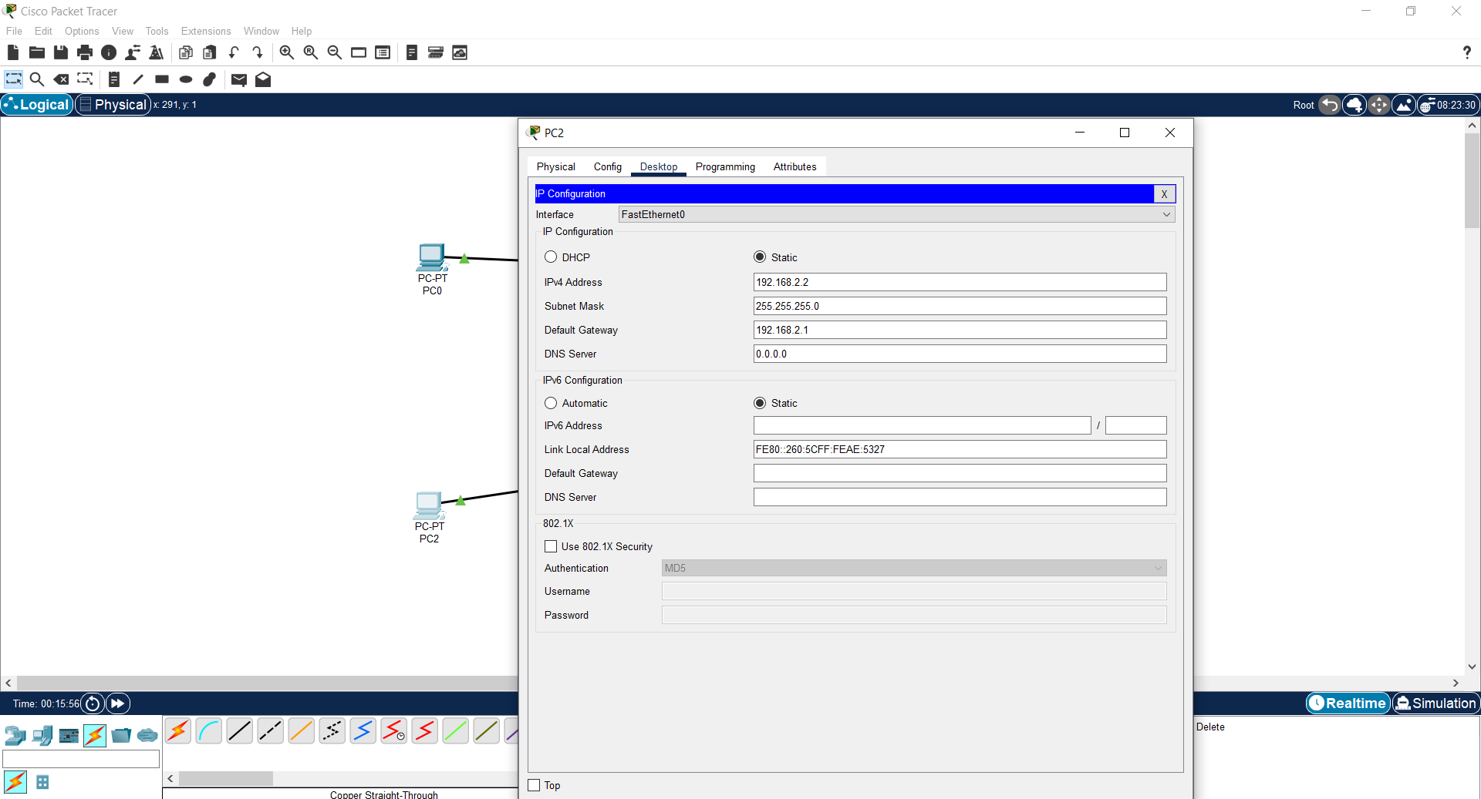

1. **Configure Router Interfaces**:  
   * Click Router → CLI:

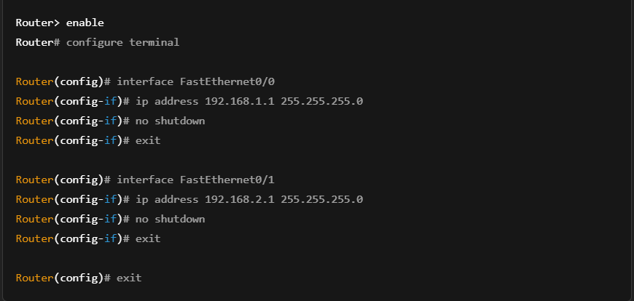

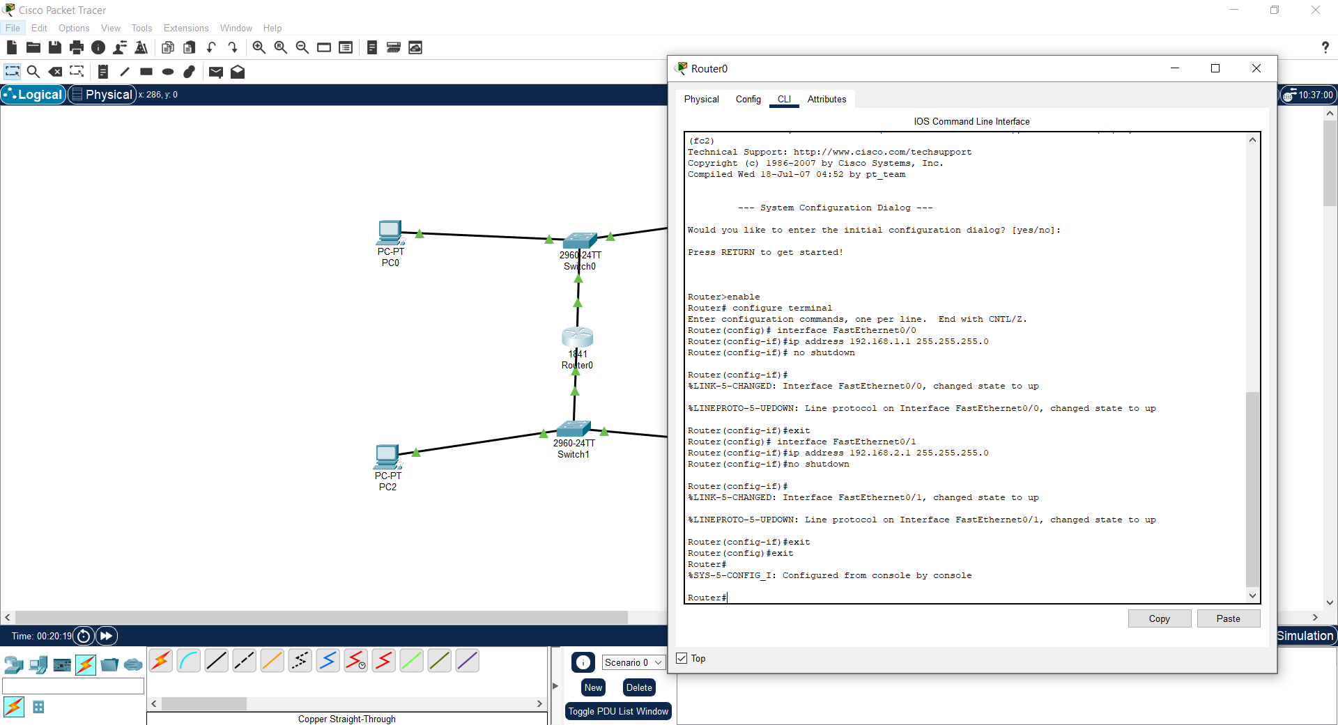

#### 5: Verify Router Interface Status

* In CLI, you can type:

Router# show ip interface brief

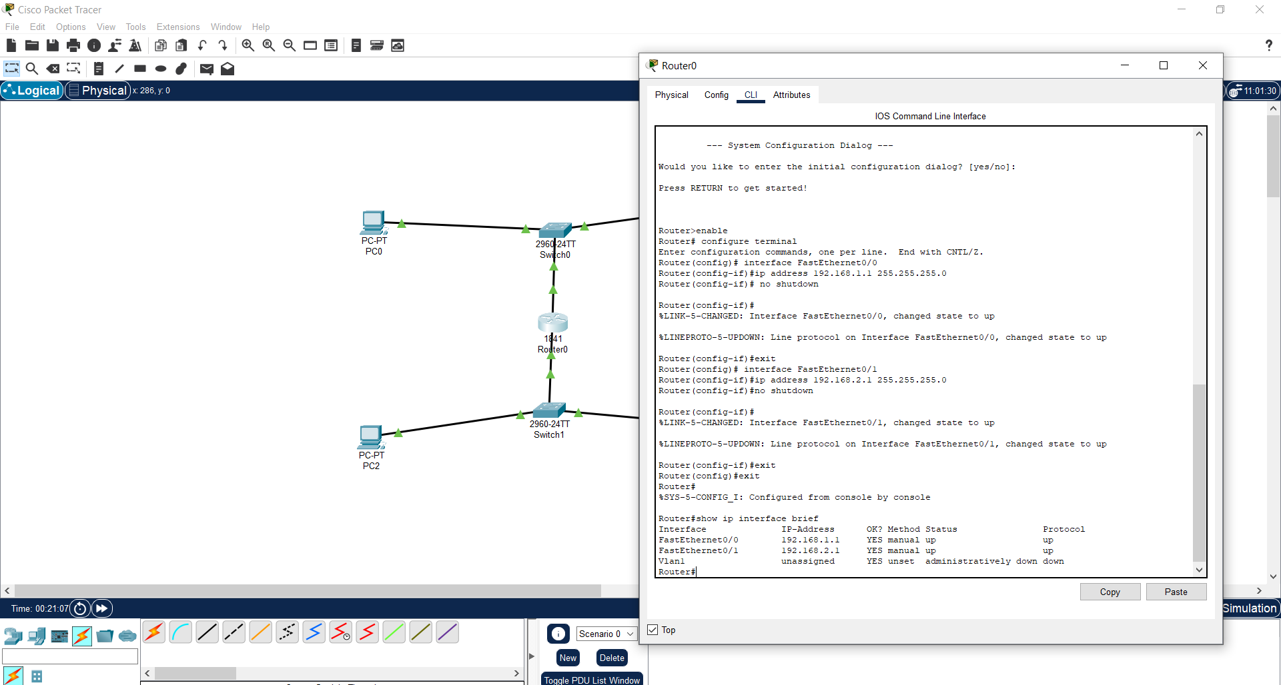

**6: Test Communication**

1. Switch to **Simulation** at the bottom right.
2. Set the filter to **ICMP**.
3. Start a ping between PC0 and PC2.
4. Watch how the **Router processes packets**, routing them to the correct network.

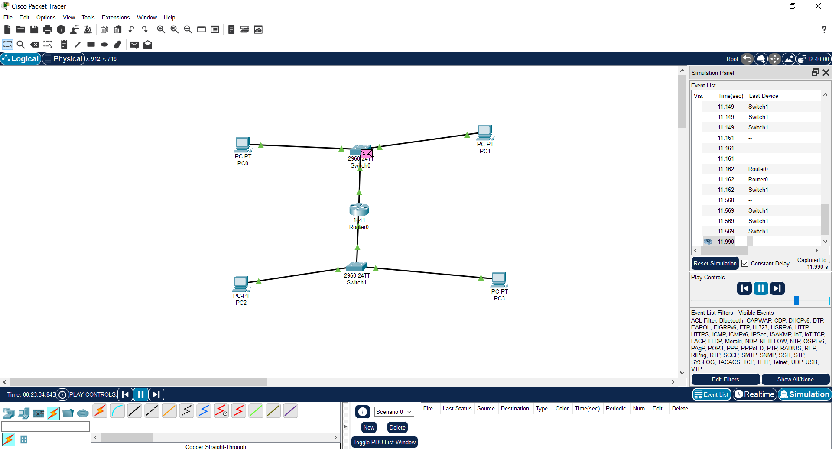

#### 

### **Conclusion**

Each networking device exhibits unique behavior. The Hub broadcasts all traffic, while the Switch filters based on MAC addresses. The Bridge divides collision domains and filters traffic. Routers connect different networks and manage routing using IP addressing. Cisco Packet Tracer provides an excellent platform to visualize and analyze these networking fundamentals.

|  |  |
| --- | --- |
| **Date: 13/7/25** | **Title** |
| **Exp. No: 16** | Create two LAN networks & configure its IP Address |

### Objectives

* To create two separate LANs using different types of end devices, switches, and a router.
* To assign static IP addresses to each device in LAN1 and LAN2.
* To verify connectivity between hosts within the same LAN.
* To test connectivity between one host in LAN1 and one host in LAN2 via a router.

### Theory

A **Local Area Network (LAN)** connects multiple devices within a limited geographical area. Communication within the same LAN is handled by switches, which operate at **Layer 2 (Data Link Layer)** of the OSI model and use **MAC addresses**.  
 When multiple LANs need to communicate, a **Router** is used, which operates at **Layer 3 (Network Layer)** and uses **IP addresses** to route packets between different networks.

### Devices Used

* **LAN1:**
  + End Devices: PC0, PC1
  + Network Device: Switch0
* **LAN2:**
  + End Devices: Laptop1, PC2
  + Network Device: Switch1
* **Connecting Device:**
  + Router0

### Instructions

# Part 1: Place Devices on Workspace

#### Open Cisco Packet Tracer.

#### Add 4 End Devices (2 PCs, 1 Laptop, 1 additional PC).

#### Add 2 Switches and 1 Router.

#### Arrange them in two separate LAN groups.

#### 

### Step 2: Connect Devices

Use the **Copper Straight-Through cable** (first option in the lightning bolt menu).

* **PC0 → Switch0 (FastEthernet0/1)**
* **PC1 → Switch0 (FastEthernet0/2)**
* **Laptop1 → Switch1 (FastEthernet0/1)**
* **PC2 → Switch1 (FastEthernet0/2)**

Now connect the switches to the router:

* **Switch0 → Router0 (FastEthernet0/0)**
* **Switch1 → Router0 (FastEthernet0/1)**

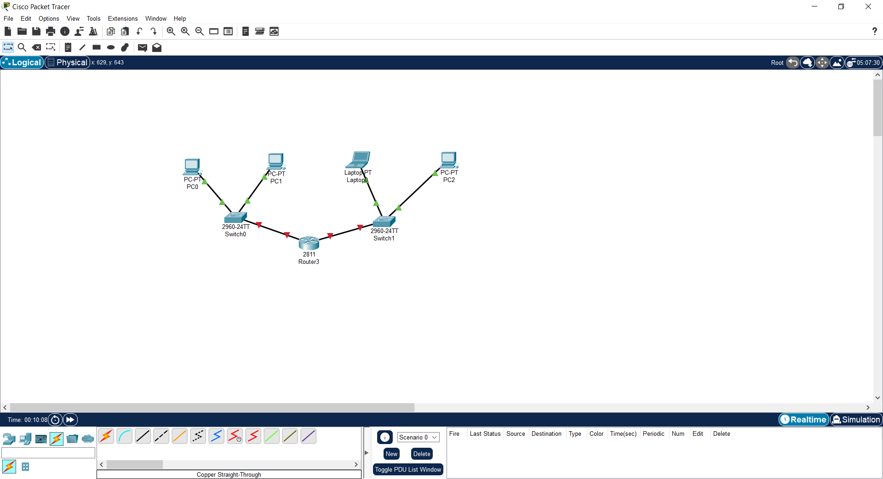

# Step 3: Assign Static IP Addresses

#### LAN1 Network (192.168.1.0/24)

|  |  |  |  |
| --- | --- | --- | --- |
| **Device** | **IP Address** | **Subnet Mask** | **Default Gateway** |
| PC0 | 192.168.1.2 | 255.255.255.0 | 192.168.1.1 |
| PC1 | 192.168.1.3 | 255.255.255.0 | 192.168.1.1 |

#### LAN2 Network (192.168.2.0/24)

|  |  |  |  |
| --- | --- | --- | --- |
| **Device** | **IP Address** | **Subnet Mask** | **Default Gateway** |
| Laptop1 | 192.168.2.2 | 255.255.255.0 | 192.168.2.1 |
| PC2 | 192.168.2.3 | 255.255.255.0 | 192.168.2.1 |

### How to configure IPs:

1. Click on a device (e.g., PC0).
2. Go to **Desktop → IP Configuration**.
3. Choose **Static**.
4. Enter the IP Address, Subnet Mask, and Default Gateway.
5. Repeat for all devices.

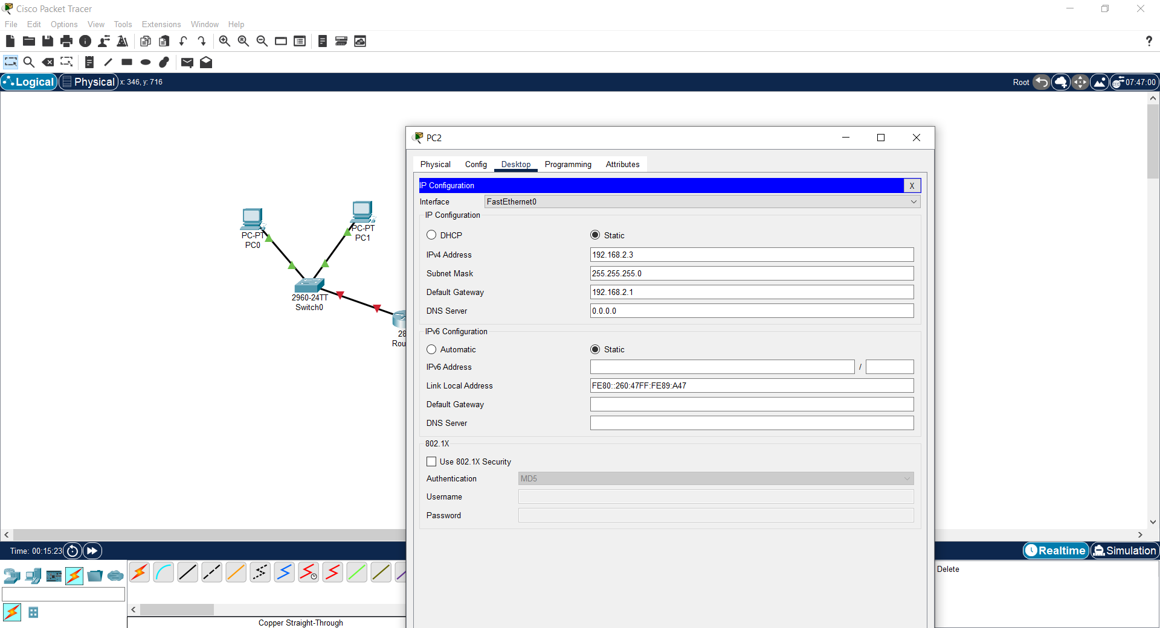

# 

# Step 4: Configure the Router

1. Click on **Router0**.
2. Go to the **CLI (Command Line Interface)** tab.
3. Type the following commands:

*Router> enable*

*Router# configure terminal*

*! Configure the LAN1 side*

*Router(config)# interface fastethernet0/0*

*Router(config-if)# ip address 192.168.1.1 255.255.255.0*

*Router(config-if)# no shutdown*

*Router(config-if)# exit*

*! Configure the LAN2 side*

*Router(config)# interface fastethernet0/1*

*Router(config-if)# ip address 192.168.2.1 255.255.255.0*

*Router(config-if)# no shutdown*

*Router(config-if)# exit*

*Router(config)# exit*

*show ip interface brief*

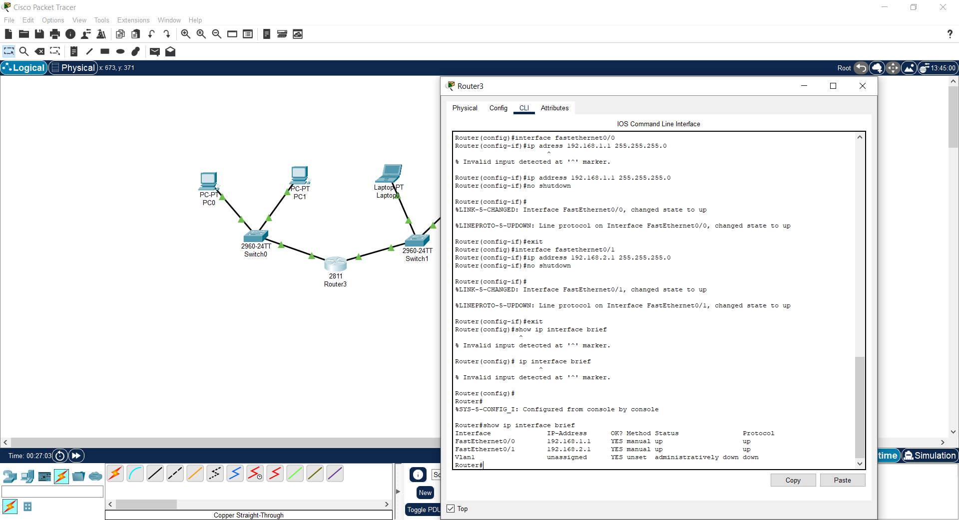

# 

# Step 5: Verify Connectivity

#### A. LAN1 internal test (PC0 ↔ PC1)

1. Click **PC0** → Desktop → Command Prompt.
2. Type: ping 192.168.1.3

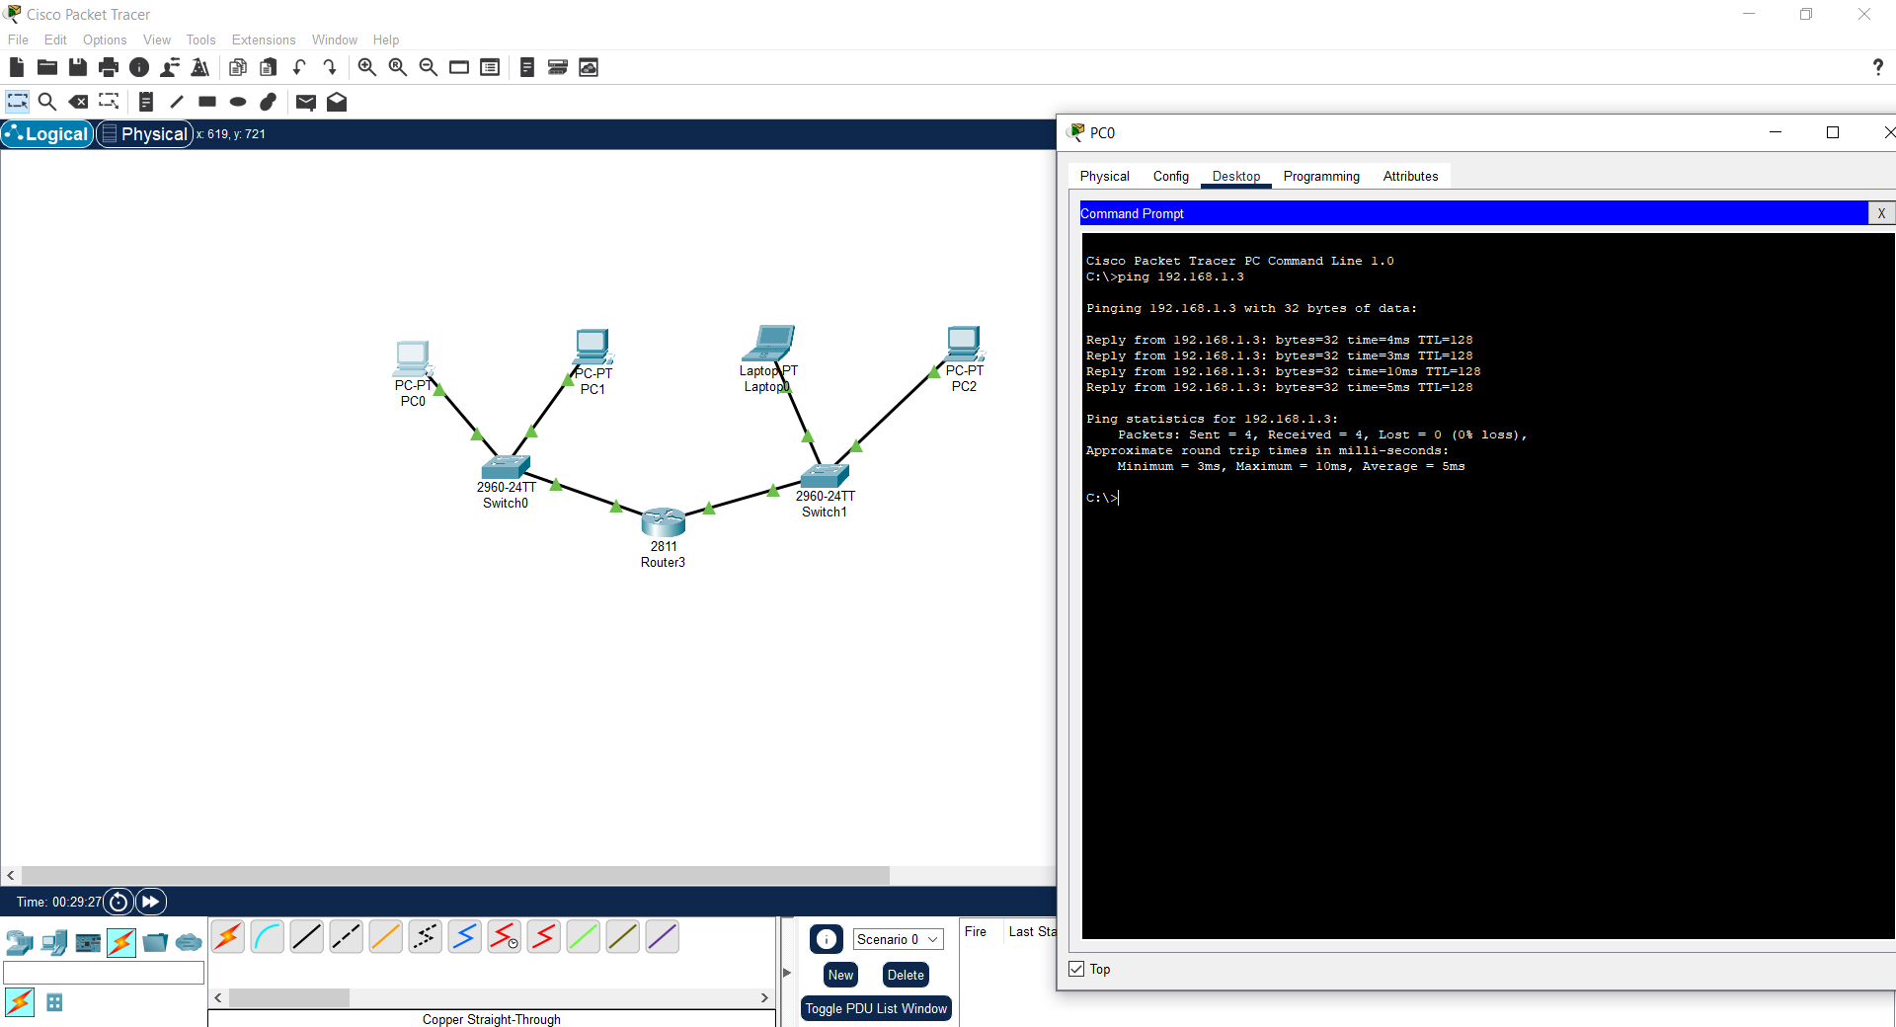

### **B. Inter-LAN test (via Router)**

**From LAN1 to LAN2:**

* On **PC0**, type:
  + ping 192.168.2.2
  + ping 192.168.2.3

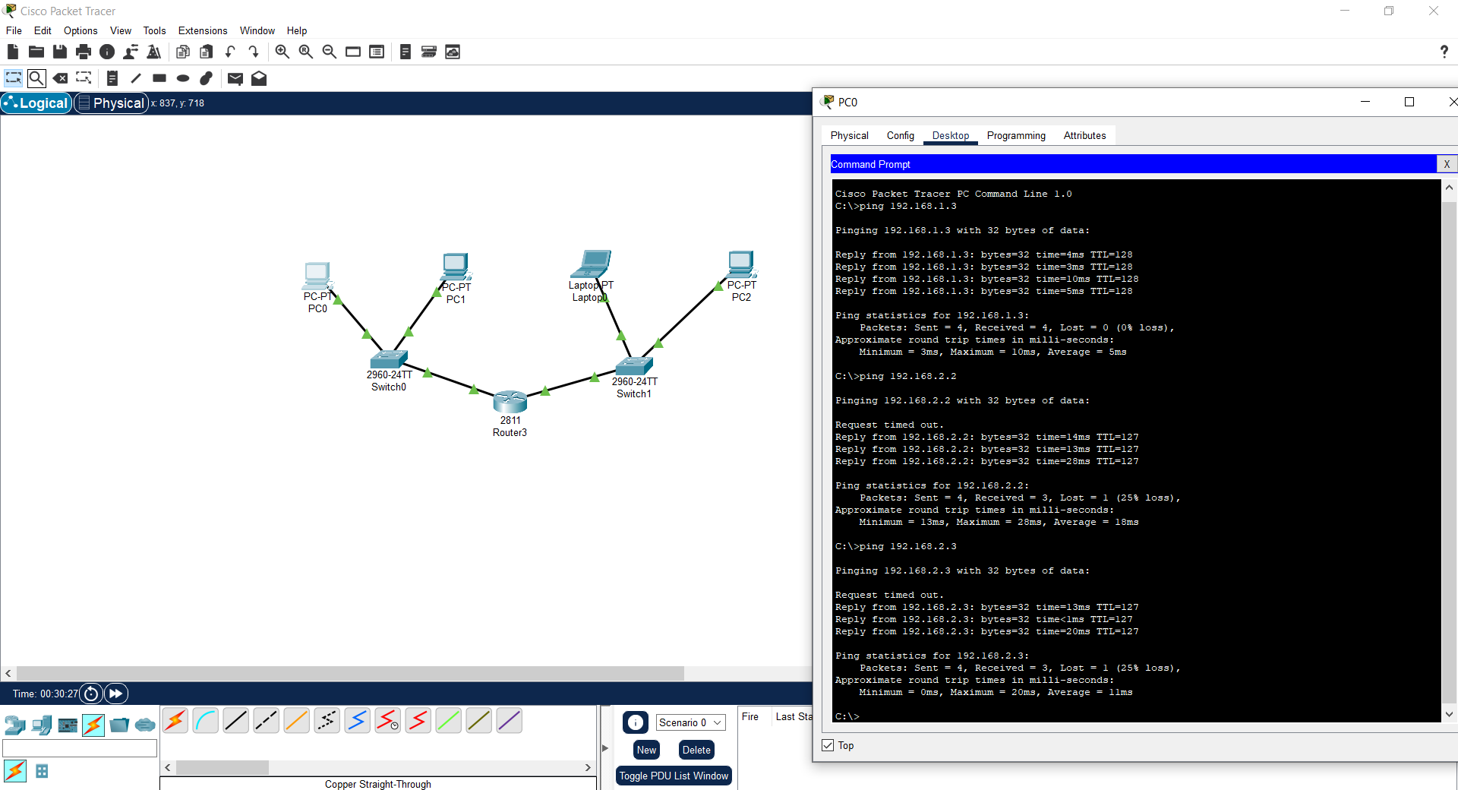

## 

## 

## 

## Conclusion

In this experiment, we:

* Designed two separate LANs using switches and different end devices.
* Assigned unique IP configurations to each LAN.
* Configured a router to enable communication between the LANs.
* Verified both intra-LAN and inter-LAN connectivity using the ping command.
* Observed how routers act as gateways between subnets.

|  |  |
| --- | --- |
| **Date: 13.07.25** | **Title** |
| **Exp. No: 17** | **To study the basic networking commands:**   * **ping** * **traceroute** * **ipconfig** * **nslookup** * **pathping** * **netstat** |

**1. ping**

* **Objective: To test the connectivity between two devices on a network, by sending ICMP Echo Request packets and measuring the time it takes for the Echo Reply to return.**
* **Tools: Command Prompt (Windows), Terminal (Linux/Mac)**
* **Description: The ping command is used to check if a device (usually a server or router) is reachable across a network. It helps diagnose network issues by measuring the round-trip time of messages sent from the originating host to a destination device.**

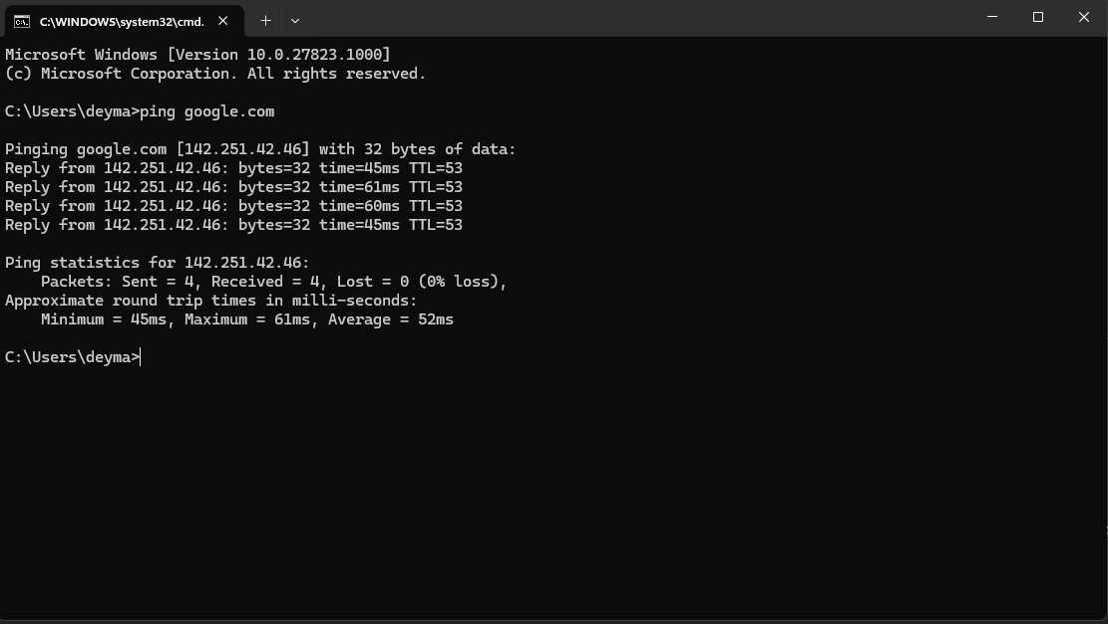

**2. traceroute**

* **Objective: To trace the path packets take from the source to the destination across the network, showing each hop along the way.**
* **Tools: Command Prompt (Windows, tracert), Terminal (Linux/Mac, traceroute)**
* **Description: The traceroute command helps to identify the route packets follow to reach a particular destination. It shows the IP addresses of routers along the path and the time taken for each hop. This can help identify delays or bottlenecks in the network.**

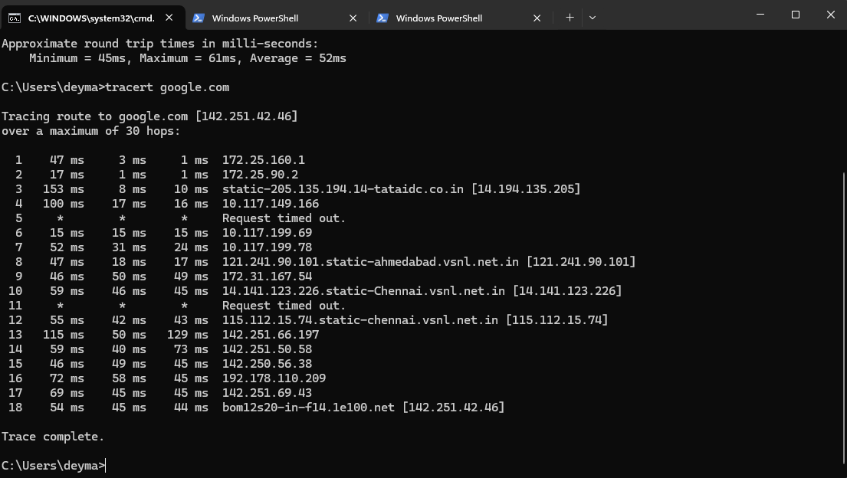

**3. ipconfig**

* **Objective: To display the current IP configuration of a device on a network, including IP address, subnet mask, and default gateway.**
* **Tools: Command Prompt (Windows)**
* **Description: The ipconfig command provides detailed information about the IP address settings on the device. It is useful for troubleshooting network connectivity issues, renewing DHCP leases, and obtaining network interface details.**

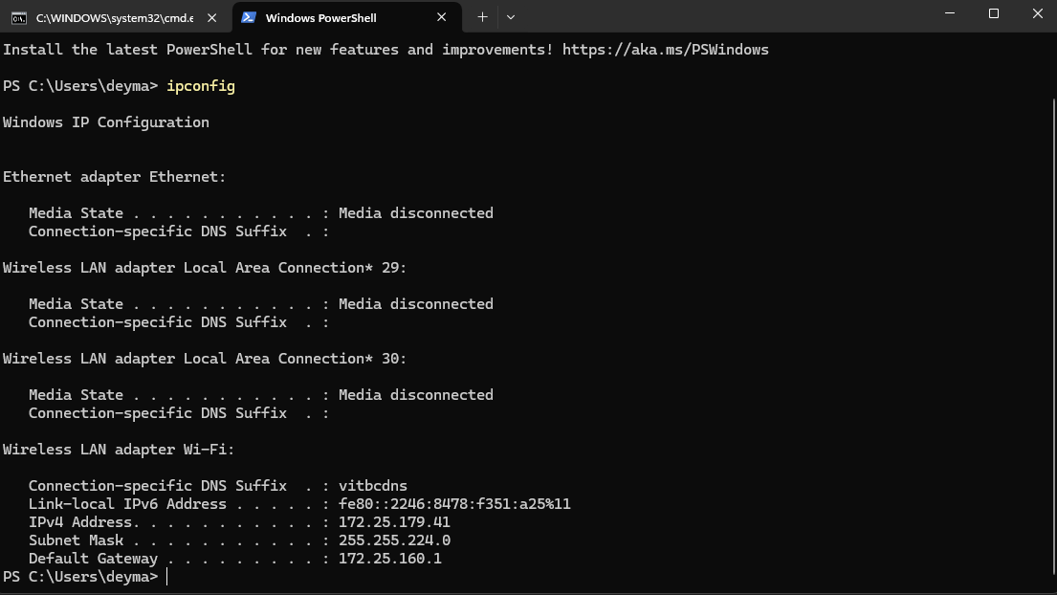

**4. nslookup**

* **Objective: To query DNS (Domain Name System) to obtain information about domain names and their associated IP addresses.**
* **Tools: Command Prompt (Windows), Terminal (Linux/Mac)**
* **Description: The nslookup command is used to resolve domain names to IP addresses and vice versa. It is helpful in troubleshooting DNS-related issues, testing domain name configurations, and verifying the DNS resolution process.**

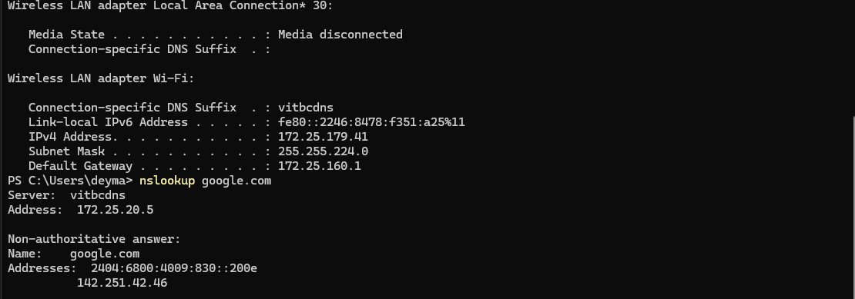

**5. pathping**

* **Objective: To provide a combination of both ping and traceroute to test the network path and determine packet loss at each hop.**
* **Tools: Command Prompt (Windows)**
* **Description: The pathping command provides more detailed information compared to traceroute by combining it with ping-like packet loss information at each hop along the path. It is useful for diagnosing network problems and identifying the exact location of packet loss or delays.**

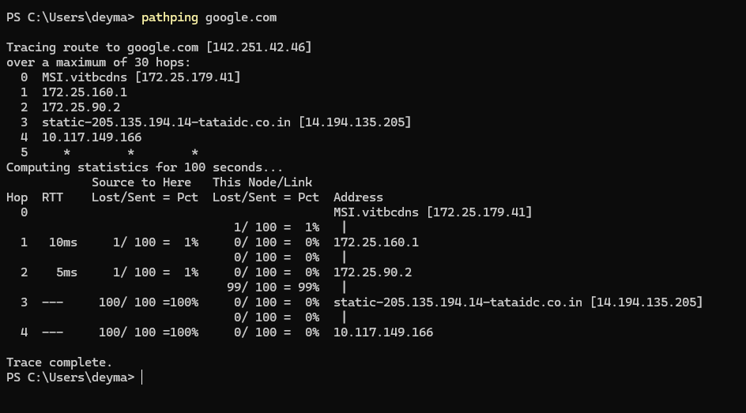

**6. netstat**

* **Objective: To display network connections, routing tables, interface statistics, and other network-related information.**
* **Tools: Command Prompt (Windows), Terminal (Linux/Mac)**
* **Description: The netstat command provides detailed information about active network connections, open ports, and associated services. It is useful for monitoring network activity, diagnosing connection issues, and identifying malicious or unauthorized connections.**

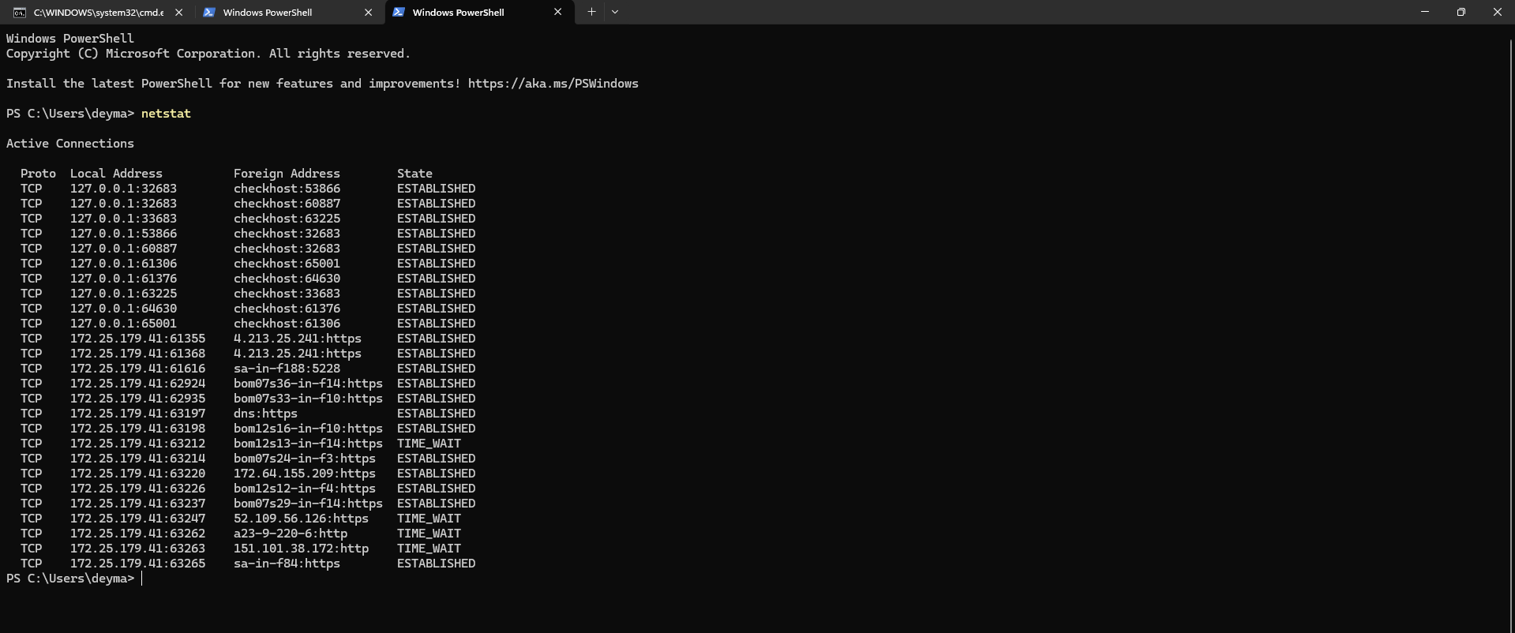

|  |  |
| --- | --- |
| **Date: 13.07.25** | **Title** |
| **Exp. No: 18** | **To study the basic networking commands:**   * **arp** * **route** * **hostname** * **ftp** * **ssh** * **sftp** |

**1. arp**

* **Objective: To display or modify the Address Resolution Protocol (ARP) cache, which maps IP addresses to MAC addresses.**
* **Tools: Command Prompt (Windows), Terminal (Linux/Mac)**
* **Description: The arp command allows users to view and manage the ARP cache, which is used to associate an IP address with a corresponding physical MAC address on the local network. It is useful for diagnosing network issues related to local address resolution, and it can also be used to manually add or remove entries from the ARP cache.**

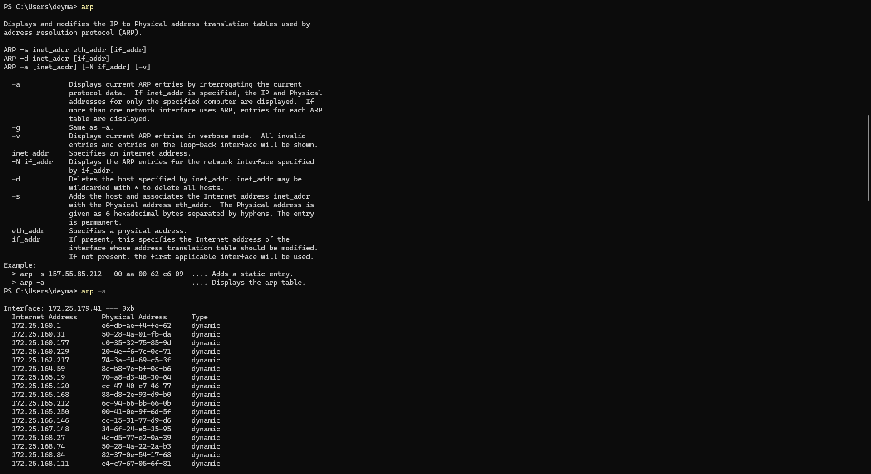

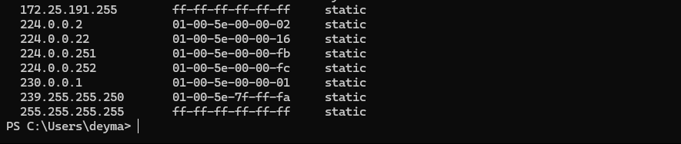

**2. route**

* **Objective: To view and modify the network routing table of the device.**
* **Tools: Command Prompt (Windows), Terminal (Linux/Mac)**
* **Description: The route command allows users to display or modify the routing table that determines how packets are forwarded across networks. It can be used to add, delete, or change routes, which is essential for managing network traffic flow, especially in complex or segmented networks.**

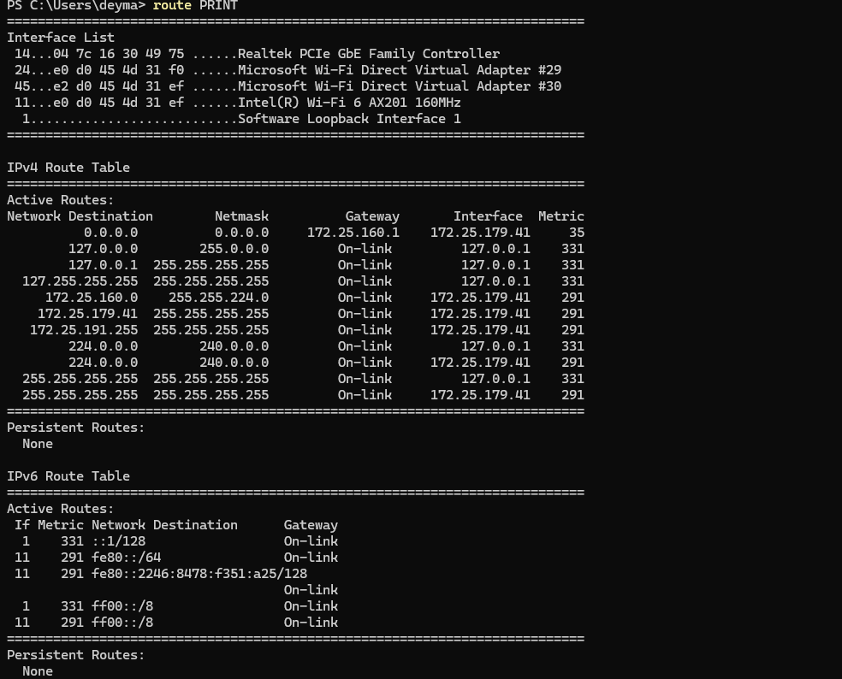

**3. hostname**

* **Objective: To display or set the hostname of the current device on the network.**
* **Tools: Command Prompt (Windows), Terminal (Linux/Mac)**
* **Description: The hostname command shows the name of the device on the network, which is used to identify the machine within a domain or a local network. It can also be used to change the hostname of the device, which can be useful for network identification or management purposes.**

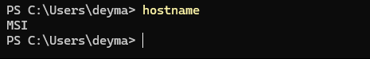

**4. ftp**

* **Objective: To transfer files between devices over a network using the File Transfer Protocol (FTP).**
* **Tools: Command Prompt (Windows), Terminal (Linux/Mac)**
* **Description: The ftp command is used to connect to an FTP server and transfer files between the local machine and the server. It supports both uploading and downloading files. However, FTP is considered insecure as it transmits data, including passwords, in plain text. Secure alternatives like SFTP are recommended for sensitive data.**

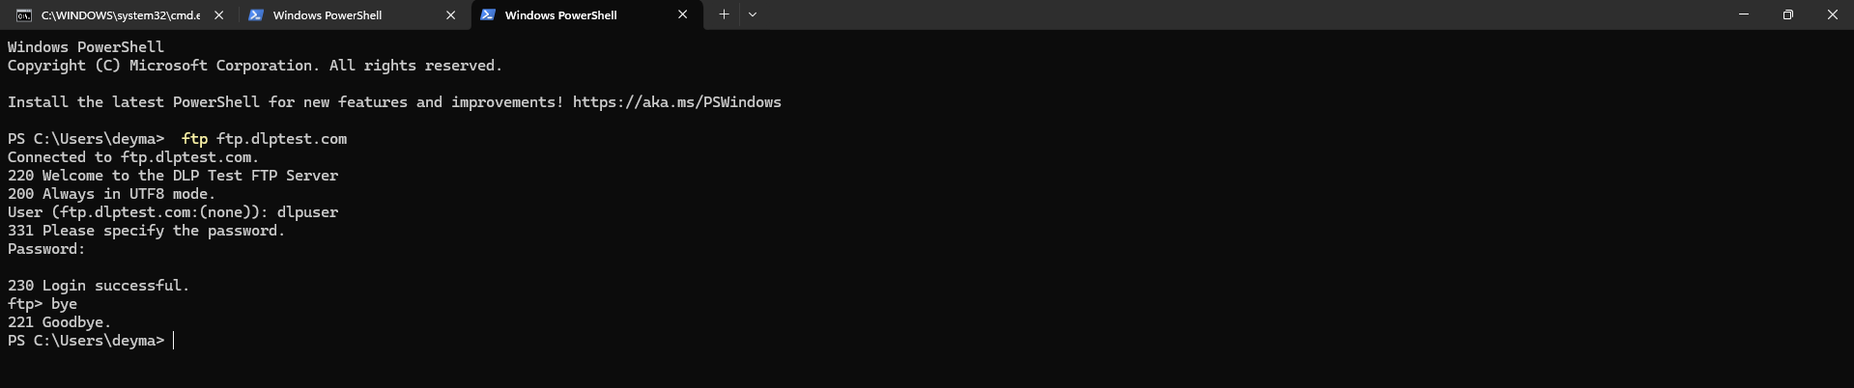

**5. ssh**

* **Objective: To securely access and manage remote devices over a network.**
* **Tools: Command Prompt (Windows, with third-party tools), Terminal (Linux/Mac)**
* **Description: The ssh (Secure Shell) command allows users to establish a secure, encrypted connection to a remote device (typically a server) over a network. It is commonly used for system administration and remote management, providing a secure alternative to unencrypted protocols like Telnet.**



**6. sftp**

* **Objective: To securely transfer files between devices using the Secure File Transfer Protocol (SFTP).**
* **Tools: Command Prompt (Windows, with third-party tools), Terminal (Linux/Mac)**
* **Description: The sftp command is used to securely transfer files over a network using the SFTP protocol, which encrypts the connection to protect data during transmission. Unlike FTP, SFTP provides a secure alternative, ensuring that files are transferred with confidentiality and integrity.**

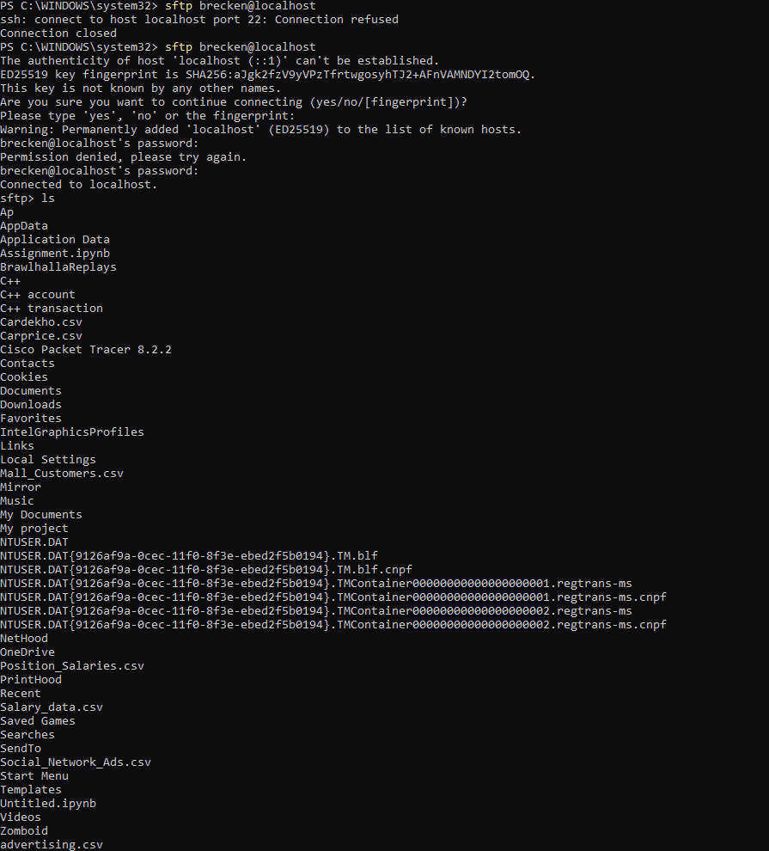

|  |  |
| --- | --- |
| **Date: 13/07/25** | **Title** |
| **Exp. No: 19** | Explore the Wireshark Software to analyse the packets of basic protocols like TCP, UDP, ARP, ICMP etc. |

# **OBJECTIVE:**

To explore and understand the packet-level behavior of basic network protocols such as **TCP**, **UDP**, **ARP**, and **ICMP** using **Wireshark** software by capturing and analyzing live network traffic.

## Simulation Tool:

* **Wireshark** (Latest Version)
  + Platform: Windows/Linux/macOS
  + License: Open-source

# **PROCEDURE:**

## Part 1: Installation of Wireshark.

## • Download the latest version of Wireshark from <https://www.wireshark.org/>.

## • Install Wireshark with the default settings.

## • Ensure WinPcap (Windows) or libpcap (Linux/macOS) is installed for packet capture.

## Step 1: Initial connectivity verification.

• Open Wireshark.

• Select the active network interface (e.g., Ethernet, Wi-Fi).

• Click on **"Start Capture"** (the shark fin icon).

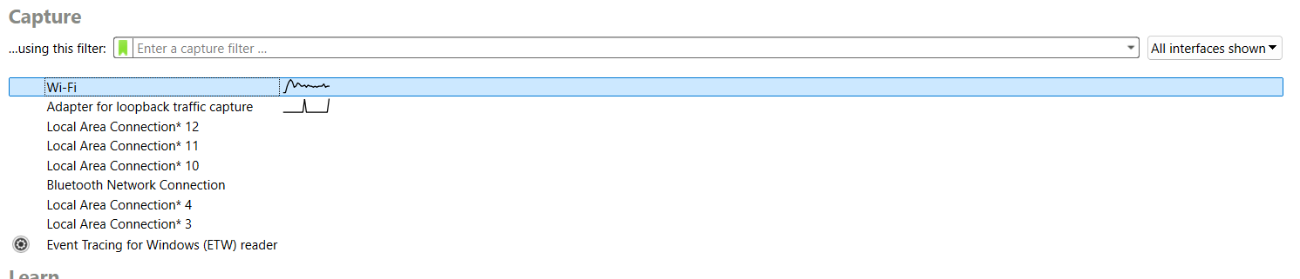

**Part 2: Generate network traffic using:**• **TCP/UDP**: Browsing websites, downloading files, streaming.

• **ARP**: Use arp -a command in command prompt.

• **ICMP**: Use ping command in terminal (e.g., ping google.com).

• Let the capture run for a few minutes.

• Stop the capture.

**Part 3: Analyzing Protocols.**

Use the filter bar to apply protocol filters:

* TCP: tcp
* UDP: udp
* ARP: arp
* ICMP: icmp

Select individual packets and expand layers to inspect:

* Source/Destination IP addresses.
* Ports (for TCP/UDP).

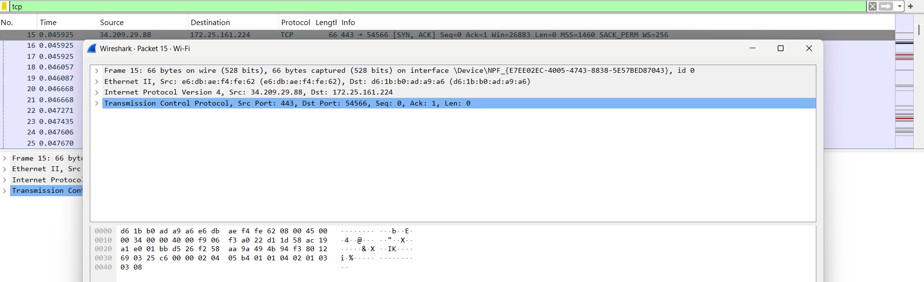

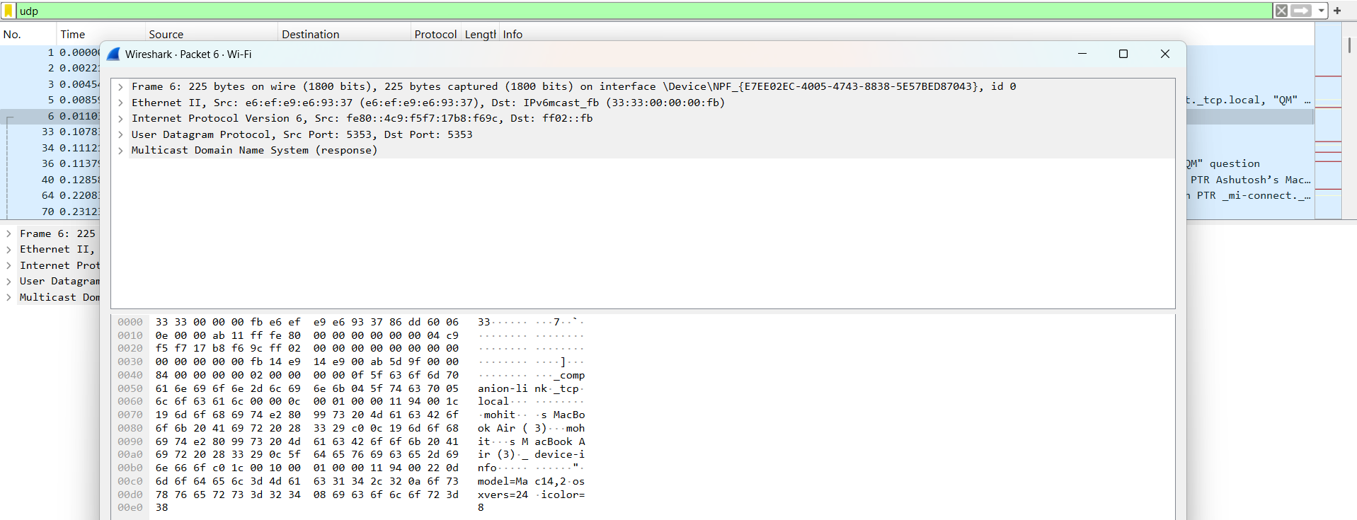

* Ports (for ARP).

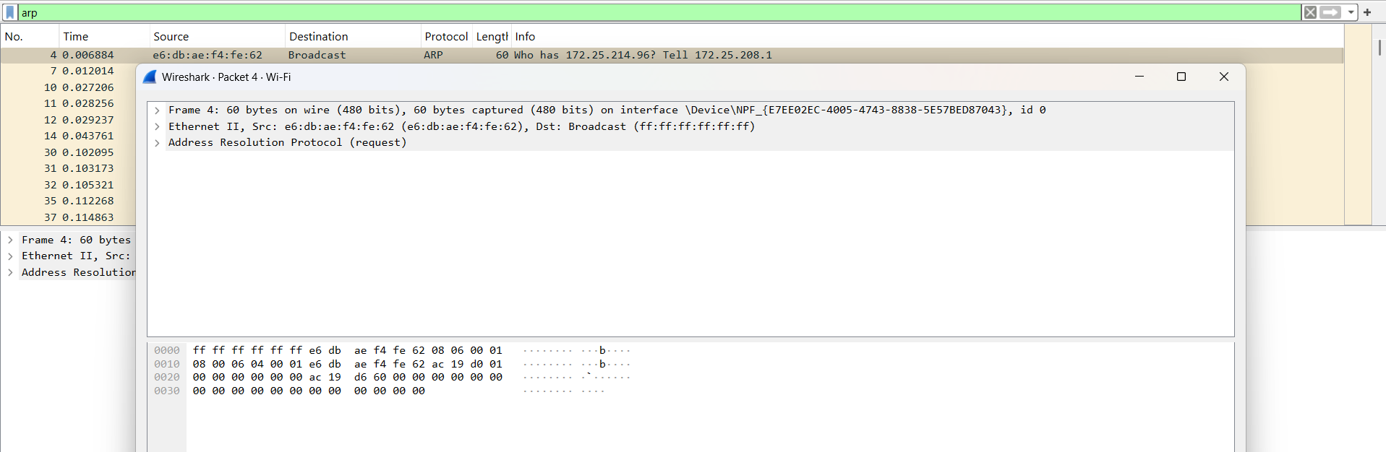

* Ports (for ICMP).

## Access the Command Prompt of the PCs without any issues.

1. Using the command **ipconfig /all**, examine the DNS server configuration on the PCs without any issues.
2. Access the **Command Prompt** of the PCs with connectivity issues.
3. Using the command **ping**, and the base ip address asking the confirmation of other ip adresses

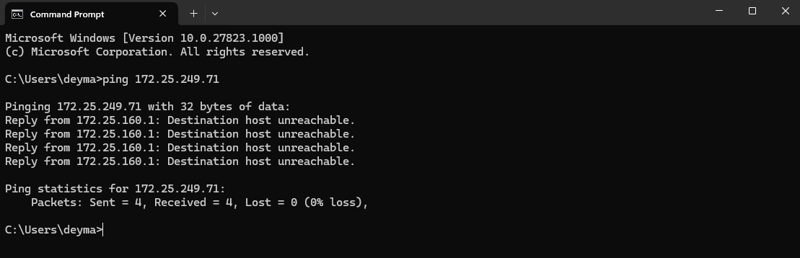

## Now searching for icmp in wireshark.

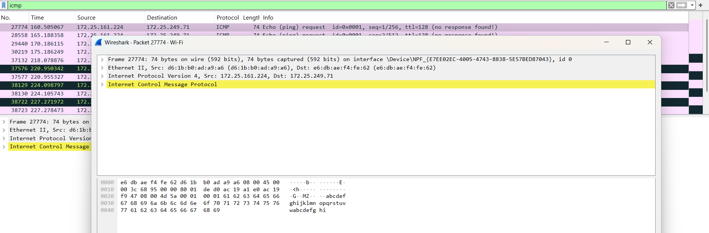

# **RESULT**

## Findings:

## TCP ensures reliable connection with 3-way handshake and ordered delivery.

## UDP is faster but does not guarantee delivery or order.

## ARP functions at Layer 2 to resolve MAC addresses from IP addresses.

## ICMP helps diagnose network connectivity issues.

## Some packets showed retransmissions or checksum errors indicating minor network issues.

## Fix Applied:

# Identified retransmissions due to network congestion.

# Changed router channel to a less congested one to improve packet delivery.

# Updated NIC drivers to ensure accurate checksum calculation.

# **CONCLUSION:**

Using **Wireshark**, we were able to effectively observe and analyze the behavior of fundamental network protocols. The hands-on packet inspection helped understand how each protocol functions within the OSI model and interacts in real-time. Wireshark proves to be a powerful educational and diagnostic tool for network analysis and troubleshooting

|  |  |
| --- | --- |
| **Date:13/07/25** | **Title** |
| **Exp. No: 20** | Wireshark Packet Analysis: ICMP and HTTP Protocols   * Use PING command to track ICMP protocol packets * Use this website for HTTP protocol packets and identify username and password in the packet * <http://www.vbsca.ca/calendar/login.asp> |

**Packet Analysis - ICMP and HTTP Protocols**

**Objectives**

1. **To use the PING command to analyze ICMP protocol packets and understand their structure and flow.**
2. **To capture HTTP packets while accessing the login page of http://www.vbsca.ca/calendar/login.asp and identify username and password transmitted in clear text (if available), demonstrating the insecurity of HTTP.**

**Simulation Tool**

* **Wireshark** (Latest stable version)  
  + Platform: Windows/Linux/macOS
  + Required for live packet capturing and analysis.
* **Command Line Terminal / Browser**
  + For generating ICMP traffic (ping)
  + For browsing HTTP websites

# **Instructions**

**Part 1: Tracking ICMP Packets Using PING.**

• Open Wireshark.

• Start capturing on the active network interface (e.g., Wi-Fi).

• Open the terminal (Command Prompt or shell) and type in the arp requesting ip address.



1. Entered ping 172.25.249.71 and ping 172.25.210.234.
2. Now stop collecting the packets and seach for ICMP in wireshark.



**Part 2: Tracking HTTP Packets and Identifying Credentials**

1. In Wireshark, start a new capture session.
2. Open a browser and go to: <http://www.vbsca.ca/calendar/login.asp>
3. Enter dummy credentials (e.g., Username: testuser, Password: testpass) and submit.  
     
     
   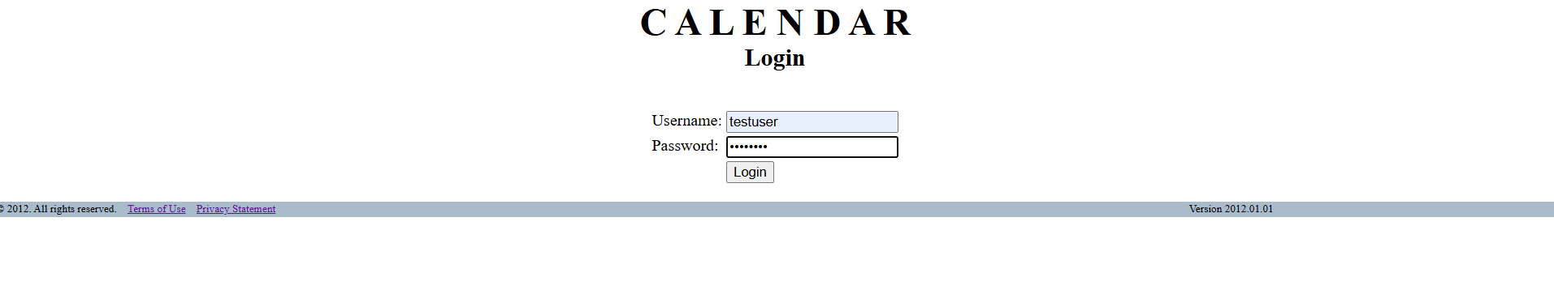
4. Stop the capture.
5. Apply filter in Wireshark: http
6. Look for **POST requests** related to login.asp.
7. In the packet details pane, inspect the **HTTP form data** in the packet payload.
8. Locate username and password fields in plain text (if sent without encryption).

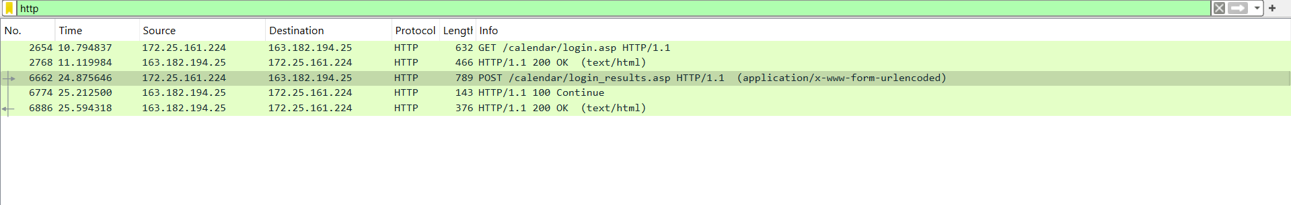

Entered username: “testuser” and password: “testpass”.

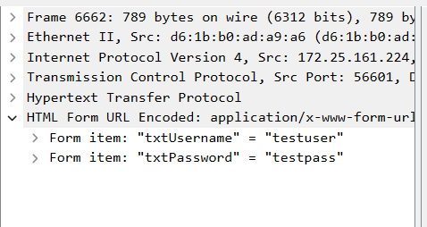

## RESULT: FINDINGS

• **ICMP**: Functions as expected for reachability test. No encryption; suitable for diagnostics.

• **HTTP**: Data including sensitive credentials is transmitted in **plain text**, making it vulnerable to **packet sniffing and credential theft**.

• No use of **HTTPS**, meaning no encryption was applied to the data during transit.

**FIX APPLIED:**

* Recommended switching to HTTPS for login pages to prevent credentials from being exposed in packet captures.
* Educated users on the risks of logging into non-secure (HTTP) websites.

**CONCLUSION:**

Wireshark effectively demonstrated how ICMP packets function and allowed detailed inspection of their flow using ping. More importantly, it revealed the security flaws of HTTP, clearly displaying user   
credentials in plain text. This emphasizes the importance of using HTTPS to protect sensitive data online. Regular audits and packet inspection are essential for improving network security and awarenes.